COME INTO MY PARLOR
BY CHARLES E. FRITCH

ILLUSTRATED BY ORBAN

* * * *

Sober or drunk, Johnny was seeing things. Like spider webs in the night sky. But as a newspaper reporter, Bennet had the job of keeping facts and fancies separate. He was good at that—too good!

I found Johnny a few blocks from our hotel ill a little bar that was nearly deserted. He was sitting alone at a table in a dark corner, staring morosely at nothing in particular, his hand limp around an almost-empty glass. He seemed perfectly sober, though his eyes stared glassily ahead.

I sat down beside him. “What do you say we go back to the hotel, Johnny? Tomorrow’s another slave day.”

His eyes shifted to me and then back to nothing. I wondered if he had actually seen me.

“We can talk about it over some coffee and a bit to eat.” I suggested, placing my hand on his arm.

“Go to hell,” he said quietly and shook me loose. He lifted his glass, drained the last few drops. He held the empty glass to the light, then set it down, regretfully. “But first buy me a drink.”

“You’d better go home,” I said. “You’ve had enough.”

He laughed harshly. “Look who’s giving me orders. I know things about this cock-eyed old world you never had nightmares about, and you’re ordering me around! Bossy newspapermen! Go to hell, then; get my own drink.”

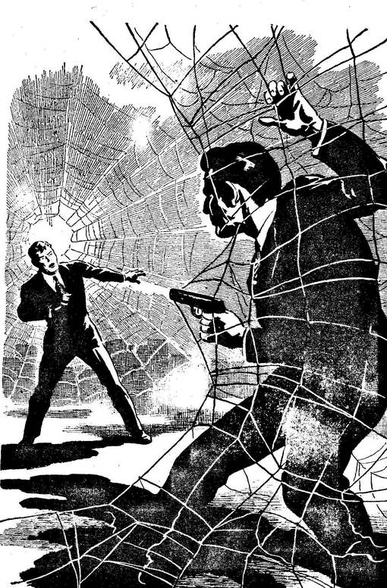

He rose unsteadily and managed his way to the bar. He came back with the glass full.

“You still here. I thought I told you—”

“You’d better lay off that stuff,” I said quietly. “You’re not used to it.”

“Boy, oh boy, you’re just full of orders today, aren’t you? Charlie Bennet, boy crusader! Well, I’ve got something you can crusade about. Anything else you’d like?”

“That’s enough for now.”

“You’re damn right it is. Now get the hell out of here and leave me alone. Can’t you see I’m brooding over the fate of the world?”

“What are you so mad about?”

He looked annoyed, and a little startled. “Brother, if you only knew—” He raised his glass, and then stopped and set it on the table. “Wait a minute. Maybe I ought to tell you. Maybe I ought to let the two of us worry about it, instead of just me. Maybe you should print it in that newspaper of yours.”

“I’m willing to listen, anyway.”

“Sure! Why not? I’m just beginning to experience that rosy sensation, that warm feeling of camaraderie they keep stoppered up in bottles. It’s the only place on this planet you can find it.”

“Don’t be cynical.”

“Maybe I should bust out laughing. The whole thing’s really funny; it’s the funniest thing I’ve ever heard.”

“We’d better go.”

“Sure, let’s go. But first—you want to see something really funny? Here.”

He took a pair of glasses from his pocket and handed them to me. They seemed like ordinary shell-rimmed glasses, though the lenses were tinted a slight blue.

“Put them on,” he prompted. “Go ahead.”

“Where’d you get these?”

“Made ‘em,” he said. “My job is optical research, remember. I was fooling around in the lab with some invisible light experiments. The right combination of lenses and coatings—and whammo! This.” He took a drink. “I should have been a lawyer or a plumber or something.” He grunted. “Or even a newspaperman!”

“What are they supposed to do—see in the dark?”

He laughed humorlessly. “That’d be a boon for a reporter, wouldn’t it? No, my friend, much worse than that. Try them on. Go ahead.”

I did. “Well?”

“Notice anything peculiar?”

“The coating makes everything here seem bluish—maybe even unearthly, if that’s what you wan t—but—”

“C’mon outside, then,” he said. This time he took my arm and steered me from the bar. I was glad of the opportunity to get him into the night air.

“Look at the sky,” he directed. “See anything unusual?” He stood waiting, expectant.

“I see stars,” I said. “Nothing unusual about that, is there?”

“Stars! Only stars?” His voice had lost its tinge of sarcasm. His fingers were tight on my arm. “Look, across the sky, see those luminous bands? All across the sky. Like a giant spider web.’

I looked again. After awhile, I said, “Sorry, Johnny, but there aren’t any luminous bands, spider webs or otherwise. I think we’d better get to the room. A good night’s rest—”

“Wait a minute,” he cried suddenly, his face pale. “You think I’m drunk—or worse. I tell you there is something up there. Shining streamers crisscrossing the sky, like—like—”

“There’s nothing, Johnny. Only stars.”

I took the glasses off. He made a quick grab for them and somehow they fell to the pavement and shattered.

For a moment, Johnny stared at the glittering fragments, his jaws working. “You’ve broken them,” he accused finally, his eyes filled more with sudden despair than hatred. “It took weeks to build them.”

“It was an accident,” I told him. “But it’s just as well they are broken. I tell you, Johnny, there’s nothing unusual in the sky. Nothing at all. Spider webs! Next you’ll be seeing pink elephants.”

Johnny stood in the cool night and stared at the sky. “They’re up there, I tell you. They’re up there, and I want to know why. And there’s one thing I want to know more than anything else; suppose they’re really spider webs—” His face was deathly white. “Are there spiders?”

He stared at me insanely in the darkness. “Do you realize what that would mean, Charlie ? Giant spiders, invisible, roaming across the Earth!” His fingers were digging into my arm again.

“Johnny, come out of it,” I snapped, shaking him. “There is no web in the sky, you hear me? And there aren’t any spiders, either. It’s just some crazy figment of your imagination. That’s all.”

“But just suppose there are,” he persisted, a little wildly. “Maybe—maybe it’s not just the glasses. Maybe it’s partly me, too; maybe I’m the only one who can see them ; maybe that’s why you didn’t see the web. Maybe—”

“Johnny, be sensible! If there were such monsters roaming around, don’t you think they’d have been discovered by now?”

“I don’t know,” he said, helplessly. “I don’t know, and it’s driving me crazy. You’ve probably wondered why I haven’t slept very well for the past couple of weeks; well, that’s the reason. I didn’t want to say anything. I hardly dared put the glasses on, I was so afraid. Not of being thought crazy, but—but afraid of what they might do if they knew they were discovered.”

“Look, Johnny. Even supposing you might be right, why wouldn’t they show themselves? Why just stay up in the sky in a large web?”

“Maybe they’re sizing us up,” Johnny said, trembling but not with cold. “After all, we’ve got a few weapons, too. Maybe a machine gun or an atomic bomb can hurt them, as well as humans.”

“Unless they’re here for some good?” I suggested.

Johnny laughed. “Spiders? Maybe they’re hungry—and they think we’re a bunch of flies down here. That’s more likely.”

“Isn’t this—rather fantastic?”

“Of course it is. Why do you suppose I’ve been keeping quiet about it for the past two weeks? Why do you suppose I’m out trying to get drunk?” He added disgustedly: “I can’t even do that.”

“C’mon,” I said, “let’s go to the room and we’ll have some coffee. We can talk about it there.”

“Sure,” he said, and his voice was suddenly subdued. “Sure, why not?”

We went to the hotel room and I made some coffee, being careful to slip enough sleeping tablets in Johnny’s cup. In a few minutes he was sprawled across the bed.

I went to the window and looked at the glowing beads of traffic below. I looked at the sky —at the stars. Spiders in the sky; what a story that would make. The editor’d slap me in the booby hatch if I ever handed in a who-what-when-where like that.

When I left for work the next morning, Johnny was still snoozing. Let him sleep it off. Do him good. He’d been working too hard at the lab, anyhow.

I couldn’t get back to the hotel room that morning, though I wanted to see if Johnny was okay. I was pretty busy writing a human interest yarn kidding the pants off some astronomer’s notion that light waves coming from certain portions of the sky were being deflected or refracted slightly for no discernible reason.

The amount of difference was microscopic, and I wrote it up to emphasize its ridiculous splitting of hairs and the fact that you can’t take some of these crackpots seriously. Here the world is on the verge of coming apart at the seams, and they worry about wayward light rays.

During the afternoon, I managed to drop into the hotel to see if Johnny had slept off the liquor and the sleeping tablets. He had, and he was sitting on the edge of the bed, looking grim —and a little perplexed.

“How ya feeling, Johnny?” I said.

“Great,” he said, though he didn’t sound it. “Things seem a lot clearer this morning.”

“Good. I thought they would. You know, you really had me going last night. I thought you meant all that stuff, but I guess imagination and a few beers can do a lot.”

“Cut the kidding,” he said grimly.

“What?”

“I said, cut it. I’m not in the mood.”

“Now what’s the matter?”

“This,” he said. He held up a pair of glasses, twins to those destroyed.

“But—how could you have made another set? You haven’t been near the lab today.”

“When I first discovered this web business, I made two pair of glasses. I figured two people could do something about it a whole lot easier than just one. But I was afraid to let anyone in on it. I thought maybe I was batty.”

“So?”

“I made this pair for you. For you, Charlie, so you could write the stuff up in your paper to let people know. That’s a laugh, isn’t it?”

“Say—that’s swell. But—”

“Stand back!” Johnny cried suddenly, as I started to move toward him. He snatched a gun from beneath a pillow and waved it threateningly. “Know what I was doing this afternoon before you came in?”

“Johnny, this is crazy! Put down that gun and listen to reason.”

“I had the glasses on,” he continued, “and I was looking out the window here. I’m getting real brave—even in broad daylight —but there comes a time when you just don’t care. I saw spiders in the streets. Huge spiders walking along the streets, mingling with human beings. And get this, Charlie—when I took the glasses off, they were like human beings. Like humans, you understand. You know what that means? They’re in disguise all around us!”

“That’s not true, Johnny,” I insisted. “There are no webs in the sky. There are no spiders. It’s your imagination. The strain. Working in the lab—”

“No,” he cried, and the gun never wavered. “You know what else I saw? A few minutes ago. I was looking down into the street, and a spider got out of a car just in front of the hotel here and started coming in. I took off the glasses to see if it might be someone I knew.”

He began to laugh hysterically. “You know who it was, Charlie—”

I leaped forward, trying to knock the gun down. But Johnny’s hand came up, and the gun jumped, spurting noise and flame. The bullet slammed into my body.

Desperately, I drove forward. My arms went around him. The gun went off again, before I could prevent it. A furrow of pain shot across my stomach, and I shrieked out in sudden anguish.

“Johnny, Johnny. Stop it. Stop!”

I struck his hand. The gun clattered to the floor. He was struggling frantically, striking out against me with doubled fists. His shirt was splattered with my blood, He gasped, clearing his lungs for a scream.

There was nothing else I could do. The life was draining from me.

I held his arms and legs together and tried not to look into the terrified expression crossing his face. I held him tightly while he squirmed in helpless frustration.

And with my two remaining arms I strangled him!

