

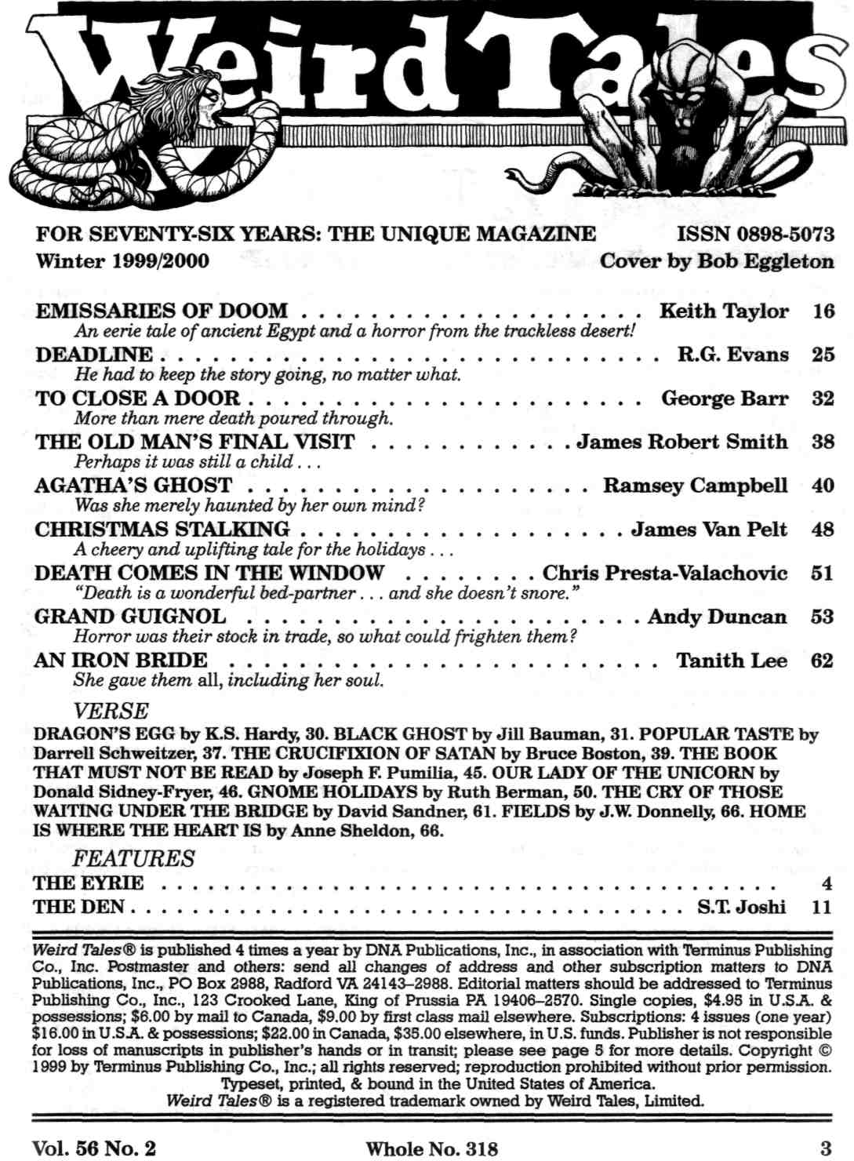
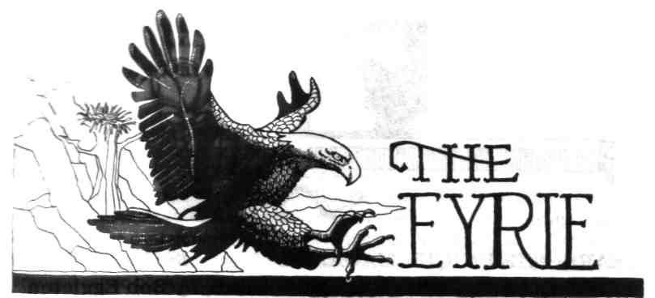

The Eyrie needs letters! We mention again that we really do want to hear from you. You can send e-mail to us at owlswick@netaxs.com. Make "weird letter" the topic line of your e-mail.
However, do not send story submissions this way. They will not be read. Be sensible: if we got 200+ submissions a week, around 5000 words each, via e-mail, our server would crash. But we do want your letters.
Is Horror Coming Back? Everyone, ourselves included, has been so gloomy about the state of the horror field for so many years now, that it's something of a surprise to be able to notice some signs of resurgence. A bookstore clerk we were talking to recently told us that horror is starting to sell again. She had twice within recent weeks expanded the horror section in her store. Sales were that much better. She guessed that the kids who grew up on such authors as R.L. Stine are now college age and ready for adult fiction.
This is more than an interesting point of demographics. It represents, we think, a crucial moment. Now is our chance to re-establish Horror with an audience which has, basically, no memory of the great Horror Boom of the '80s and the subsequent bust. We may reasonably ask: are we going to repeat the mistakes of the past, or has somebody learned something?
The answers aren't in yet. One further encouraging sign is the presence of a large horror anthology from Avon books with the title 999. It's edited by Al Sarrantonio (hardcover, 665 pp. $27.50), and is a deliberate attempt to recreate the impact of Kirby McCauley's monumental Dark Forces (1980) which ushered in the previous horror boom in precisely the same way, by serving as a sampler of what's available in the field. The lady from the bookstore reported that 999 is doing very well for her. Readers who know only two or three Horror names — King, Koontz, Barker, perhaps — can be told, "Look, here's a way to find out about a whole lot of other writers you might like."
It's a good book, and it will doubtless clean up all the awards. It does such a service to the field that we are even willing to congratulate Mr. Sarrantonio in advance on his awards, and forgive him for somehow implying that there has been no professional horror magazine around since Night Cry folded back about 1988.
We hasten to point out that since then Weird Tales® has published stories by eight of his contributors and devoted special issues to five of them.
As of this writing, we haven't read it all, but so far our favorite is the Joyce Carol Oates novella. There are also very serviceable stories by Ramsey Campbell, Stephen King, Thomas Ligotti, Kim Newman, Gene Wolfe, F. Paul Wilson, T.E.D. Klein, Thomas Disch, and several others, stories which any editor might look upon with envy.
We confess we couldn't make any sense out of the Tim Powers story, and the Edward Lee, once one gets past one real howler of a line ("Paone squinted through grit teeth; without his glasses he couldn't see three feet past his face," which seems to imply that his eyes are in his mouth...) proves to be a fast-moving, decently written, quite gory crime story of the hardboiled type, but not weird or supernatural at all.
So here we are at the crossroads once again, as we were a decade ago when some folks tried to turn Horror into something they called Dark Suspense: are we going for the Ominous and Magical, the imaginative side of Darkness, or are we going to (in Stephen King's words) "go for the grossout" all over again?
We think you can guess where Weird Tales® stands on this. We prefer Thomas Ligotti's (or Joyce Carol Oates's) suggestive shadows to Mr. Lee's explicitly popping viscera.
It's a matter of aesthetic choices, which are then borne out by economics. The marketplace will ultimately decide what kind of horror is to continue. We're convinced that we've made the right choice with Weird Tales®, which is one reason why we're one of the few survivors from the previous period of Horror ascendancy. We've been at it for twelve years now, which in this field is a very long time.
At the same time we can't deny that readers of the popping-viscera school propelled the career of, say, Rex Miller of Slob on to some success, though readers today might well ask, "Rex who ?" These thing run in cycles. The Friday the 13th movies ran their course, and movie and TV horror then evolved into a form of specialized, knowing parody, as exemplified by such films as Scream and the phenomenally popular Buffy the Vampire-Slayer TV series (which we admit being fans of).
But it isn't all cycles, inevitable and impersonal as the tides, which no one may command. Artists, writers, and directors can choose.
So, which shall it be, a chill up the spine or a swift upchuck?
We even notice that Hollywood is, in its own faltering way, rediscovering the horror film. This, too, says something interesting about demographics, but otherwise the results are mixed. If you haven't seen the recent remake of The Haunting, avoid it at all costs. It is worse than a travesty; it's a two-in-one desecration of a great book {The Haunting of Hill House by Shirley Jackson) and a great film {The Haunting, directed by Robert Wise) perpetrated by a director whose previous credits include Speed 2 and who, demonstrably, has no understanding whatsoever of how to make a supernatural horror film.
The new Haunting is a virtual textbook case of how not to do it, aimed, apparently, at those people who were too coarse in their sensibilities or just plain too dim-witted to appreciate the real (Robert Wise) version, arguably the finest ghost film ever made.
It's very much like saying, "Duh ... what The Turn of the Screw needs is some raw sex, lots of explosions and chases, and a big rubbery monster." Well, Hill House has now acquired most of the forgoing. It's become a special-effects movie, full of attempted thrills-and-chills. Shirley Jackson fans may leave the rest to their horrified imagination when we mention that there's a very contrived, very stupid, on-screen decapitation. We may be glad that Jackson didn't live to see this, even as she mercifully escaped the awful TV movie-of-the-week version of "The Lottery" a couple years ago. Like that awful botch, the new Haunting manages a total gutting of the story's logic and psychology. Details which had been profoundly and suggestively meaningful in the original (both novel and film) are turned into absurd coincidences. Brilliant writing has become fluent cliche. If the new version were only, as with the new Psycho, a reverential copy of a past masterpiece, it would be, at least, harmless, useless, and swiftly forgotten. But we're not so lucky.
In this case, for all Horror may be making more of a comeback, it would seem that Hollywood has learned nothing.
But next on the agenda comes The Blair Witch Project, an astonishingly successful low-budget film which may well be the Night of the Living Dead of the '90s. This is an interesting amateur film, a pseudo-documentary shot with hand-held cameras with a cast of unknowns, about three film students who go out to make a documentary about the legendary (i.e. made-up) Blair Witch and come to an awful end.
The film is allegedly the footage they shot, found after their mysterious disappearance. The minuscule budget (about $35,000), the total absence of special effects, and lack of professional actors are all turned into assets. The Blair Witch Project really looks like an inadvertently compelling, student effort, a Zapruder film of the supernatural. It is quite convincing as a hoax, to the point that there are apparently now whole web sites devoted to the proposition that the documentary is real. But the success of the hoax undermines the story. There is no conclusion, no revelation. The film just stops as the character holding the camera, presumably, dies.
The best compromise, in the hands of a more professional crew, would have been to condense the "documentary" part down to about forty minutes, have the lost film be found and viewed by other characters, and then tell the rest of the story. But never mind. What is intriguing about The Blair Witch Project is not so much the film itself, but the way audiences are responding to it. Of necessity, this is a movie which must work by suggestion. Audiences love it. It excites the imagination, which is what such movies are all about. After a generation of slasher films, horror is actually being reinvented.
The strongest sign of this re-invention is M. Night Shyamalan's The Sixth Sense, which is simply splendid. Bruce Willis proves that when he's not running around and shooting people, he can give quite a sensitive performance. He plays a child-psychologist alongside an absolutely phenomenal little boy (Haley Joel Osment), whose character's problem is that he sees dead people. It's a ghost story, of course, which could be taken as "realistic" if you believe in the psychic, but in any case it is absolutely convincing emotionally, both genuinely frightening and quite moving.
There's precisely the right balance of explicit-ness and restraint, and a whopper of a surprise ending (which we refuse to give away), fulfilling Lord Dunsany's requirement that such endings should make us react, "What? . . . Why, of course."
So there it is, the best supernatural film in thirty years, by our reckoning (since Rosemary's Baby, 1969), and it is successful. The horror aesthetic which we've been promoting all along in Weird Tales®, and which goes back a whole lot farther—to Le Fanu and M.R. James and Arthur Machen and Lovecraft — has not merely survived, but has, in at least a limited way, triumphed.
That we think to be a good thing. Now all we have to do is figure out how to get that new and ravenously hungry Horror audience to read Weird Tales® ...
We actually got some letters at last, which will enable us to have a more lively and interesting letter column. The editorial last time, about Weird Poetry, drew a lot of response, much of which was like that of Mike Barnhill of Orlando, Florida, who writes: Yeahhh! Finally, a magazine that treasures weird poetry. Like many baby-boomers I was bored and bred on poetry in high school English class. Dissecting the classics for hidden meanings left me dazed and confused. My reaction to too many 'great' poems was "Huh?" . . . What a pleasure, then, to find a clear and present dangerous poem like Steve McComas's "anybody home?" where my reaction was a more appropriate "Aghhh!"
While we're unsure of the precise definitions of some of the critical terms Mr. Barnhill uses, we tend to agree, and recall Archibald MacLeish's comment that a poem "should not mean, but be," which we understand as saying that its impact should be emotional first and foremost, rather than as a dry intellectual puzzle to be deciphered.
Nicholas Ozment of Lanesboro, MN, follows this up with praise for The Den in the same issue: I read S.T. Joshi's column with growing enthusiasm. Joshi perceptively addressed poetry's decline over the past eighty years.
It can hardly be put more bluntly than Joshi puts "The 1920s are currently remembered as the era of Modernism; one would like to think that in the distant future it will be judged as the period when literature and perhaps other arts took a wrong turn that has condemned entire branches of aesthetics to irrelevance. Poetry is one of these."
Why wait for the distant future?
Modernist and Post-Modernist writers have tried to work their spoiling on prose fiction as well, but the reading public would not surrender all its literature to the exclusive domain of the literati.
Weird Tales is indeed a bastion that has held up the standard of well-written poetry. Perhaps one reason why weird poetry has continued to build on traditional roots is this: since the subject matter of a weird poem is necessarily unfamiliar, bizarre, or strange, it must be couched in the familiar and concrete. If both form and subject matter are bizarre, you have not a weird poem, but one that is surreal. And there is a marked difference, as different as the "story" off a Bob Dylan record sleeve is from a story by Thomas Ligotti.
Thus weird poets have carried on poetic traditions which Post-Modernist and contemporary poets have rejected—if they studied them at all.
We suppose that the main tradition is content, as opposed to "word salad," which is the equivalent of throwing a bunch of metal spoons into the air in hopes that the resultant clatter will turn into a musical composition.
But the legendary fanzine writer Richard E. Geis recently took us to task in a review of that same issue (WT #317) for "lazy" poetry, which seems to imply that he wants everything to be rhymed and metered, with no exceptions. That's a position we are not willing to take or defend. We will admit even to admiring some of the work of T.S. Eliot and Allen Ginsberg, and while we like some clear content in a poem, we refuse to restrict the form. There is indeed some use for unrhymed, unmetered verse, for all that Mr. Geis would doubtless agree with the sentiment that:
Anybody, just ANYBODY, can chop up language into tidy, bite-sized bits, and string it out, and call the result a poem.
But then, what is the above? It's surely not prose. There is some poetry where the "music" is reduced to the single device of the line, that chopping up into tidy bits being a very powerful form of punctuation, used for emphasis, or even irony.
One further note on this subject comes via e-mail from Sholder Greye, who writes: I am moved to write to you by your recent obnoxious editorials concerning what is "correct" in literature. You are promulgating the same old snobbery and self-righteous provincial bullshit that for some reason plagues so many practitioners of genre-writing, and I'm just tired of it....
And who, please tell me, bestowed on YOU the blazing white torch of empyrean judgment with which to set aflame anything that doesn't pass the muster against your infallible aesthetic?... it is sheerest nonsense and Victorianism and arrogance to assert an absolute "definition" of literature against which all that makes claim to it must be measured....
The whole idea of Modernism at the beginning of this century (and, to an even greater degree, Post-Modernism in the mid-to-late portion) was that literature is a PERSONAL experience, a psychological one; a book speaks to each reader in a different way because that reader brings his own experiences and views to it....
Your dismissal of anything you don't personally understand as "word salad" is an insult to our entire culture and it certainly illuminates a source of... the inbred mediocrity that calls itself "horror" or even "weird" in your pages season after season—
Reading fiction is a simultaneous personal and social activity; it is something done in private, a kind of masturbation, but it is also something shared with others, a kind of sexual union; and like sex, everyone's got his or her own fantasies, and everyone's looking for a unique someone to fulfill them: and we've each and every one of us got our own ideas of what that someone looks like. So don't presume to tell ME what "makes sense."
All colorful metaphors aside, we can only say it's a dirty job, but someone's got to do it. Someone's got to begin to do it.
We do not claim that the Revolution achieves fulfillment here. But we do hope to start something, by, quite explicitly, rejecting Modernism and Post-Modernism and Post-Post Modernism, and Deconstruction ("You know what the Mafia does when they discover Deconstructionism? Why, they make you an offer you can't understand."), and if we have to clear away the rubble (and rubbish) all the way down to the Victorian level before it is possible to rebuild, well, it's got to be done.
In the Victorian Age, poetry was widely read.
Kipling, Swinburne, Hardy, Tennyson, and many more had real cultural impact. Poetry was a public medium, within the reach of any literate person. Today it is an esoteric pursuit of a few specialists, dead in the general culture for generations, except maybe in song lyrics.
You have defined the problem of Post-Modernism very neatly: a total absence of standards. If any piece of writing has its own unique, subjective value, depending on what the reader brings to it, then the scrawlings of an illiterate schoolboy are just as valid as Yeats (our favorite poet), so why bother to learn to write like Yeats? On what basis, then, can we reject a manuscript, since according to Post-Modernism all stories are equally (subjectively) valid?
We do not think that a magazine edited that way would last very long, and we think that poetry published that way is precisely why, as Joshi put it, the entire form has been by and large condemned to irrelevance.
We respect your view and thank you for expressing it so vividly, but we still think that Post-Modernism is the problem, not the solution. The solution, we are still trying to work out.
But, lest someone coming in on the conversation late think they've wandered into The Journal of Poetic Theory, here's a letter about something else. Anne McCombs of Cherverly MD comments about our "Scary Places" editorial, and specifically about the Winchester Mystery House: It was the haunted house of my youth, as I grew up in neighboring Santa Clara. Back in those days, 30-40 years ago, the proprietors emphasized the "haunted" nature of the house much more than they do now— their billboards showed the house in black silhouette, with a skull formed from the central windows and doors. The impression was reinforced by the fact that at the time, little restoration or refurbishing had been done, so the place was dusty, cobwebbed, and (aside from the daily tours) seemed abandoned.
The tour guides told the story you summarized in your essay, adding that the medium had claimed that as long as construction continued twenty-four hours a day, Mrs. Winchester would never die, and that when the hammers finally fell silent, so did her heart.
I could not tour the place without being wracked by nightmares for weeks afterwards, even in my late teens. I remember the vivid terror of one room in particular. In the Winchester House, as you may recall, there is a ballroom with two stained-glass windows, each bearing a quotation from Shakespeare. One reads (if I recall correctly), "These same thoughts people this little world," and the other says, "Wide unclasp the tables of their thoughts." The windows were placed so that sunlight can never shine through them, and nobody knows what their significance to Mrs. Winchester might have been. All I can recall of my nightmare was that the meaning of the windows was revealed, and the horror of the revelation — a classic Lovecraftian "Things Man Was Not Meant to Know Moment" — brought me to consciousness paralyzed with terror. Of course, once I was awake, I don't remember what the meaning itself was!!!
But, coexisting with the house's prototypical tale of eeriness, is the other story I heard in my youth. When I was 8 or 10, my parents happened to volunteer to chauffeur the widow of Mrs. Winchester's personal physician, the night the old woman gave a talk to the local PTA. According to her, the stories of Mrs. Winchester were sadly distorted.
True, Sarah Winchester held seances and believed in spiritualism, but such beliefs were very common in her day. (Arthur Conan Doyle, for instance, was a well-known spiritualist.) And she was, without question, reclusive in the extreme. But the real reason for the unending building project was not to appease restless spirits, but to offer aid and comfort to the living.
There was a severe economic depression in California at the time. Victorians believed strongly in Good Works (probably more so than contemporary society), but they preferred to assist the needy by helping them to make themselves useful, rather than simply putting them on the dole. Sarah Winchester, who had essentially unlimited wealth, was able to give honest work to a great number of people in the building trades... and (again following Victorian mores, as well as her aversion to the public eye) she did not want any sort of credit for her philanthropy, so she made no effort to squelch the bizarre rumors that arose from her strange project.
So there you have two stories, one of a "grim, sorrowful woman's utter obsession with herself," and the other, somehow equally sad, of a recluse, unconcerned for her own reputation, who nevertheless reached out to help others less fortunate than herself. Perhaps both tales are true.
But we want to know what awful secret was revealed when you understood the mystery of the windows, in your dream . . . what a story that would make!
Author Andy Duncan has suggested another "Scary Place" which is much closer at hand, which somehow we've never visited:... the ruins of Eastern State Penitentiary in Philadelphia. I cannot recommend too highly a self-guided tour of this monument to folly and inhumanity, which is open to anyone willing to don a hard-hat and sign her life away. It was built in the early 19th century as a grand reformers' experiment, the embodiment of Bentham's spoked-wheel "Panopticon" plan for the modern prison.
De Tocqueville and Dickens visited it, as it was the most expensive public building in the United States to that date... crammed full of unfortunates as recently as the Nixon administration. Amazingly the thing has been neither maintained nor demolished since. It has been allowed, like Hill House, to go its pestilential ways undisturbed.
There it squats, a short walk from the Museum of Art and the cheery, sunny green acres along the Schuykill, its massive gray walls a rebuke to all that. Chattering tourists stop talking and avert their eyes as they hurry through its shadow, and locals give it wide berth. Locked inside are acres of crumbling corridors, dank cells, rusted bars, flaking red paint, rickety stairs, all permeated by a nearly visible Usher-like miasma of gloom and sourness and walled-up despair.
But most disturbing of all is the exercise yard, which is technically off-limits to visitors, but, like all other off-limits areas, is easily reached by walking around a saw horse, or clambering over a sodden pile of detritus, or ducking low. Here, in the psychological center of the labyrinth, the eye of the swirling stone, is a nightmare garden of waist-thick Lovecraftian weeds, thirty feet high, their great greasy leaves the size of hammocks, standing preternaturally still even in violent weather, obviously fed not by rain or the soil beneath the pulverized tarmac but by damned souls and tears.
Wandering Eastern State Penitentiary for a few hours is an unforgettable experience, especially if you lose track of time, as I did, and have to hurry to retrace your steps to get out of the maze by lock-up.
This is one tourist attraction you do not want to be trapped in overnight.
Almost back to poetry for a moment, here's a odd, belated comment we just got from Lisa Becker who actually lives in a Dunwich Township in Ontario: "A Dunwich School Primer" just freaked me out (This is a good thing.) I bought a copy of the Necronomicon when I was twelve, not knowing what it was. It just looked cool, like something that would give my mother a stroke and me some late-night willies.
When I finally began reading Lovecraft at fourteen, I was hooked. I have the dog-eared books that I read over and over, and the "good copies" that are kept on the top shelf in the library and dusted with the reference afforded the Bible.
Two nights ago, while my husband was at work, I was sitting here in the trailer with my laptop when a severe storm hit. The power went out and my battery went dead. So I lit a candle and grabbed the first thing I could find which coincidentally (Ha!) happened to be Weird Tales #315. The poem is bad enough on a sunny day, but in the middle of a storm, by candlelight... well, it may have been the wrong thing to be reading.... Just thought you'd like to know you scared the crap out of me. Many thanks!
Which is very odd, because we thought "A Dunwich School Primer" was funny...
And yet another letter on matters poetical, from Mark Francis of Medford MA, who writes: The causes for poetry's general diminishment suggested in "The Eyrie" and in S.T.Joshi's essay . . . are perhaps a wee bit pat and narrow. Not all con temporary mainstream poetry is enigma tic, prosaic, or lacking in fire and imagination. That poetry is not much bought, or read or quoted in this country — not necessarily the state of things abroad — may have more to do with the nature and biases of contemporary American education and the media; the decline of traditional arts, and of literacy... and the consequences of ever more mindless consumerism ("a nation of shoppers"). Poet-critics themselves have declared poetry's co-option by the academic establishment — as social and economic phenomenon —has had a large and telling impact on the form's confinement
Yes, indeed. We are interested in arranging the form's jailbreak. We know there are good poets out there. But finding them is the difficulty. We'd like to use Weird Tales® as a platform for bringing some of them together.
A moment of silence as word has come (though it will be old news by the time you read this) that Marion Zimmer Bradley has just died. She will be sorely missed. She was not only a noteworthy and enormously popular novelist, but a genuine patroness of the arts, who did her best to contribute to the field which made her so famous, by editing her various anthologies and by editing and publishing Marion Zimmer Bradley's Fantasy Magazine, which provided encouragement and support for many new — and many established — writers, and which will, we hope, continue her legacy.
Yes, we really got a lot of letters about the Stories in the last couple of issues, and these are very much appreciated. The "I liked this/I didn't like that..." letters are street lamps for editors, lighting the way by which we can steer the magazine. They may not always get printed in the letter column, but they do enable us to compile the Most Popular Story listings.
There were enough votes this time to give us a winner, and the winner is . . . (Unearth the casket, please . . .) "Webmage" by Kelly David McCullough, which is a very impressive showing for a first-time author and what we hope will one day be seen as the launch of an illustrious career. Many readers compared the story to the work of the late Roger Zelazny, which is high praise indeed in these parts.
Runners up (close behind) were (tied) Andy Duncan's "From Alfano's Reliquary" and Brian Stableford's "The Secret Exhibition." And one reader insisted that the Stableford is the best story we have ever published, and hopes it will be nominated for a Nebula.
Not a bad idea, we think.
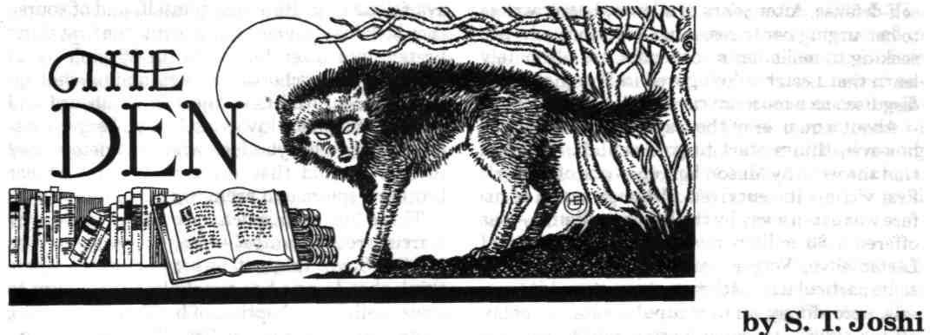
Several recent works by some of our best-known writers bring to the forefront the vexing question of whether a work that eschews the supernatural can properly be classified as belonging to the horror genre. It was not so long ago that some of our pundits were looking forward, either with glee or with dismay, to the demise of supernaturalism: "horror" would no longer exist, but in its place would come some new amalgams — psychological suspense, "dark suspense," or merely suspense. In spite of the perennial (and, to my mind, inexplicable) popularity of the vampire tale, the terrors of the real world — serial killers, child pornographers, terrorists, and such like — would now be the focus of our little realm, and those authors who refused or were unwilling to follow along would simply be left behind.
It hasn't turned out that way. To be sure, "horror" has lately been shrinking as a marketing category, but the shrinkage has affected both the supernatural and the non-supernatural tale. The serial killer subgenre seems utterly played out (as early as 1991 Ramsey Campbell played a pungent riff on it by writing his comic serial killer novel, The Count of Eleven), and the former cutting-edge category of "dark suspense" has gone the way of dark fantasy and splatterpunk. But non-supernatural terror is not about to yield without a fight, and two best-selling writers have recently tried their hand at it.
First on the docket is Thomas Harris's Hannibal (Delacorte Press, 1999). Harris, of course, has never written supernatural fiction: after abandoning journalism, he began his literary career with a dreadful potboiler, Black Sunday (1975), followed by the admirable Red Dragon (1981) and The Silence of the Lambs (1988), to which Hannibal is a much-awaited sequel. In refreshing contrast to the dreary prolificity of some of our other best-selling authors, Harris has habitually taken years to write his novels, and on the whole they are rather good. They will by no means enshrine him in the higher echelons of the literary pantheon, but they are among the more engaging works of popular fiction in recent years.
To my mind, however, none of his works falls into the realm of the horror tale, chiefly because Harris deliberately chooses to emphasize detection rather than the psychological aberration of his villains. The serial killers in both Red Dragon and The Silence of the Lambs are, to be sure, quite perverse; but because Harris is determined to keep their identities (and, largely, their motivations) a mystery until the end, he only infrequently allows himself the opportunity to depict their twisted psyches — as, say, Robert Bloch does in Psycho, making that work an authentic tale of horror. It need hardly be pointed out that this decision by Harris has no bearing on the qualitative evaluation of his novels; it merely affects the works' genre classification.
Hannibal is an avowed sequel to The Silence of the Lambs, and it features many characters familiar from its predecessor. Dr. Hannibal Lec-ter, the psychiatrist-turned-serial-killer (and occasional cannibal), was a shadowy figure in Harris's two previous novels, but is very much at center stage in this one; so is Clarice Starling, the FBI operative who hunted down the serial killer in Silence. Hannibal opens superbly, with a gripping confrontation between Starling and some drug dealers in Washington, D.C.; the resulting loss of life, fueled by biased press reports, causes Starling to be vilified, even though she acted in self-defense. After years of silence, Lecter writes to her, urging her to resist her superiors, who are seeking to make her a scapegoat. We ultimately learn that Lecter is living well in Florence, Italy, disguised as a museum curator.
About a quarter of the way through the novel, however, things start to go downhill. We learn that the wealthy Mason Verger — one of Lecter's first victims (he survived, although much of his face was eaten away by the hungry villain) — has offered a $3 million reward for the capture of Lecter alive; Verger naturally wishes to exact some particularly loathsome revenge on his nemesis. Accordingly, an unscrupulous Italian police officer strives to catch Lecter, whose disguise he has seen through; but he ends up being Hannibal's next victim. This entire Florence segment reads rather like an overenthusiastic travelogue: Harris cannot resist including every possible bit of information he has soaked up about Italy, going well beyond the bounds of verisimilitude and sounding on occasion like an encyclopedia.
But if the first half of Hannibal is somewhat of a disappointment to those who admired Harris's two previous works, the second half plummets into realms of dreadfulness not seen since the heyday of Harold Robbins and Irving Wallace. Several flashbacks portray Lecter's childhood in Lithuania; and we are asked to believe that he became a serial-killer-cum-cannibal because he saw his sister caught, killed, and eaten by starving soldiers in World War II. This may be bathetic enough, but the ending of the novel is worse still. It was only to be expected that Verger's cohorts would suffer the very fate — being eaten by a herd of man-eating wild pigs — they had outlined for Lecter; but Harris goes on and destroys the uneasy relationship between Lecter and Starling that lent such vivid tension to The Silence of the Lambs. Lecter, it appears, sees in Starling a kind of replacement for his devoured sister, and so he rescues both himself and her from Verger, drugs her, and hypnotizes her so that she becomes his companion (and presumable lover). At the conclusion of the novel we see them enjoying an opera in Buenos Aires.
All this is really too preposterous. Would Starling be so amenable to hypnotic control? And could Harris really have thought that this conclusion would prove satisfying to the readers of his previous novels? It has become obvious that Harris himself has, after a fashion, fallen in love with Lecter: he takes care to portray Hannibal's enemies as even more repulsive, hypocritical, and avaricious than Hannibal himself; and of course they lack his elegance, refinement (the first thing Lecter does after he settles in Virginia is to purchase a clavichord), courage, and psychological fortitude. And then there is an absurd and irrelevant subplot involving Mason Verger's sister, a lesbian bodybuilder who is so determined to bear a child that she secures some of her brother's sperm and promptly kills him.
There has been much speculation as to why Harris wrote Hannibal — or, rather, wrote it as he did. Some think it is a self-parody; others think that Harris has simply lost the ability to write well. I am skeptical of both these theories, especially the latter: the first 100 pages of Hannibal are scintillating, not only in their brisk action but in occasional flashes of tart wit ("There is a common emotion we all recognize and have not yet named — the happy anticipation of being able to feel contempt"). Another theory — that Harris wrote this book merely to fulfill a contractual obligation to write a sequel to The Silence of the Lambs — is more plausible. I have no evidence of its truth, but it seems likely to me. One can only hope that, within the next decade, Harris produces another novel that eliminates the bad taste this one has left in our mouths.
The plot of Harris's Hannibal is so involved as almost to defy description. By contrast, the plot of Stephen King's The Girl Who Loved Tom Gordon (Scribners, 1999) can be summed up in one short sentence: A girl gets lost in the woods but eventually finds her way out. This doesn't sound like a prepossessing theme for a novel, and it is not: this little book begs comparison with Cujo as perhaps the very nadir of King's work. It is not surprising that Cujo is also non-supernatural: King seems to have much difficulty with this form. (He has troubles with the supernatural as well, but that's another matter.) While there is some merit in Misery (1987) and considerable merit in Gerald's Game (1992) and Dolores Claiborne (1993), The Girl Who Loved Tom Gordon is a work we would be much better off without.
Nine-year-old Patricia (Trisha) McFarland gets lost with remarkable ease in the Maine woods when she deliberately falls behind her quarreling mother and brother (the novel provides much opportunity for King to wring his hands about divorce, the breakup of the family, and such), and suffers a variety of other indignities — continual mosquito and wasp bites, shortage of food (she lives for more than a week on nuts and berries), exhaustion that leads to hallucinations, and on and on. What carries her through her ordeal, apparently, is her devotion to Tom Gordon, a (real) pitcher for the Boston Red Sox, whose performances she hears on her handy Walkman.
The first problem with this novel is that King takes too many literary short-cuts. Early on, Trisha falls head over heels down a precipitous incline, and much of the contents of her backpack — food, a video game, etc. — are seriously damaged; but of course her Walkman survives intact. King knows that the advancement of the plot—at least the plot he has in mind — depends on the operation of the Walkman as a radio, so he defies plausibility and simply decrees that the Walkman will work. King immediately compounds this error by another one: the moment Trisha turns the Walkman on to check its condition, she hears a news report of her disappearance! This is simply laziness on King's part: the coincidence here strains credulity to such an extent that the entire novel from this point onward seems unreal. We know we are only reading a book, not an account of something that might actually have happened.
Trisha gains the feeling that if Tom Gordon (a "closer") gains a save at the end of a game she is listening to, then she will herself be saved. Sure enough, he does, and so is she — although not for another week or so. King is straining hard to make a variety of baseball elements stand as metaphors for real life; and the most egregious one occurs toward the end. The religiously devout Gordon has evidently stated (and King presents his utterance in pompous italics): "It's God's nature to come on in the bottom of the ninth." This kind of TV-commercial philosophy may be entirely appropriate for a writer who has himself become a brand name; but to any serious reader it will seem shallow and implausible to the point of grotesquerie. And yet, King intends us to see this as the guiding metaphor of the entire book. In a fatuous letter that accompanies the novel as a press release, King states: "The Girl Who Loved Tom Gordon isn't about Tom Gordon or baseball, and not really about love, either. It's about survival, and God ..." How so? How, exactly, has God "come on in the bottom of the ninth"? A bear threatens Trisha just as she is about to be rescued; are we to think that the hunter who clips an ear off the animal, and so drives him away, is a manifestation of God? The very notion that God has somehow intervened to assist Trisha is an unintentional insult, for it is abundantly clear that Trisha has survived entirely through her own determination and willpower. It would be a good idea if King were to refrain in the future from ludicrous theologizing and stick to telling a good story. And it would be even better if he actually came up with a good story to tell.
Ramsey Campbell has long felt comfortable working without the help of the supernatural, as such grim but masterful works as The Face That Must Die (1979) and The Count of Eleven testify. His two most recent works — The Last Voice They Hear (Tor, 1998) and Silent Children (Tor, forthcoming in early 2000) — continue the tradition ably. They may perhaps not rank among the very best of Campbell's works, but even middling Campbell is better than the best that nearly anyone else has to offer. Campbell has told me that the two novels comprise "a pair ... in terms of shared themes"—specifically, the theme of the peril that can so easily befall children.
The Last Voice They Hear weaves several seemingly unrelated narrative strands together into a unified and gripping climax. The bulk of the novel focuses upon Geoff Davenport, the host of a TV news show whose half-brother disappeared when he was eighteen. Throughout the novel we are provided with glimpses of the shoddy, abusive treatment Ben received from his parents, who clearly preferred Geoff. Ben begins to make enigmatic phone calls to Geoff and also to leave him a succession of envelopes at various locations, usually containing photographs of sites associated with their childhood. Things take a sudden turn for the worse when Ben causes Gail's parents' car to crash in Scotland. He then performs the sadistic ploy that he has used on the eight elderly couples he has previously killed: he uses glue to bind their arms around each other and to seal their lips in an everlasting kiss — a grotesque parody of the affection he himself failed to receive from his own parents and grandparents.
Ben then contrives a still more heinous act: pretending to be Gail's father, he kidnaps Geoffs three-year-old son, Paul, from the television station's day care center in London and takes him back to his home town, Liverpool. Geoff eventually tracks Ben and Paul to an amusement park in Blackpool; Geoff manages to save Paul, but Ben jumps off a tower to his death.
The Last Voice They Hear manages, without overstating the matter, to convey a variety of social messages at once, but its central point is clear: the abuse of children can have lasting and catastrophic effects, and can engender psychopathic behavior years later. Some readers might perhaps wish a more exhaustive dwelling on Ben's ill-treatment during his youth, but in a few deft strokes Campbell portrays the humiliation a boy must feel when his own parents or grandparents — figures whose authority he has been brought up not to question — display contempt or loathing for him.
Silent Children is a still finer work than its predecessor and ranks close to the summit of Campbell's non-supernatural work. The novel deals largely with Hector Woollie, a handyman who has murdered several children; one of them Woollie had buried under the floor of a house in the suburb of Wembley, which he was renovating. The house was owned by Roger and Leslie Ames, a married couple who subsequently divorced. After months of trying to sell the house, Leslie and her thirteen-year-old son Ian decide to move back into it, despite the unsavory reputation it has now gained throughout the placid middle-class neighborhood.
She takes in Jack Lamb, an American horror writer, as a roomer. At this point we are led to expect a hackneyed romance between Jack and Leslie, and sure enough they become attracted to each other and engage in sex not long after Jack moves in. Leslie envisions marrying Jack, who might also provide an adult male authority figure for her wayward son.
But Campbell has lulled us into a false sense of security. Jack, it turns out, is none other than the son of Hector Woollie. Although by no means afflicted with Hector's psychosis, he is haunted by the possibility that, as a teenager, he may on occasion have unwittingly helped Woollie dispose of children while assisting in his father's renovation work. Much of the tension in the novel arises from repeated attempts by Hector — who is believed dead, having staged his own apparent death so as to escape the police—to contact Jack. At one point Hector voices Jack's most deep-seated fear: "I wonder how much like your dad you really are deep down." Later Woollie kidnaps seven-year-old Charlotte, daughter of the woman Roger Ames has now married, as well as Leslie's son Ian; the rest of the novel is devoted to efforts to rescue the children.
The one overriding feature of Silent Children — above its smooth-flowing prose, its tense moments of suspense, and its revelations of a diseased mind — is the vividness of its character portrayal. Even minor characters are rendered so crisply and vividly that they immediately come to life. Major figures such as Leslie and Jack are fully formed, complex personalities who are etched with increasing subtlety with each passing chapter. Campbell has depicted the teenager Ian Ames with especial felicity, capturing in all its paradoxical confusion the burgeoning character of a boy on the verge of young manhood. A distinctly satirical edge enlivens many descriptions of character and incident: Campbell is relentless in exposing the pettiness, hypocrisy, and selfishness that can typify middle-class suburban life. Few characters in the novel emerge as wholly admirable. Although the reader's sympathy resides chiefly with Leslie, and secondarily with Jack and Ian, even they are flawed individuals struggling as best they can to live up to their own ideals.
Oddly, Hector Woollie seems somewhat cloudy, specifically in regard to the psychological aberrations that led him to his multiple murders of children. There is, by design, no such intense and relentless focus on his psychotic mentality as there is on Horridge in The Face That Must Die or even on Jack Orchard in The Count of Eleven: Woollie is merely one of a network of characters whose accidental intermingling has produced the chilling scenario.
I have not left myself much room to study the question of whether any of the works under discussion actually qualify as tales of horror. To my mind none of them really do. H.P Lovecraft's well-known remark — that genuine weird fiction "must not be confounded with a type externally similar but psychologically widely different; the literature of mere physical fear and the mundanely gruesome" — seems to me to hit the nail exactly on the head as far as the current batch of books is concerned. Hannibal is merely a novel of the "mundanely gruesome," while the others are novels of adventure, suspense, or crime. Genre distinctions can occasionally be excessively rigid, and some of our finest works — from Lovecraft's At the Mountains of Madness to Thomas Tryon's Harvest Home — are those that defy convenient categorization; but distinctions are still important, lest anything that contains a little blood or a madman or a serial killer be deemed a tale of horror.
Harris has worked entirely in the realm of psychological suspense; both King and Campbell have alternated from supernaturalism to non-supernaturalism, but both show signs of inclining toward the latter. In Campbell's case a definitive shift over to the non-supernatural camp would be particularly regrettable, if the scintillating brilliance of some of his recent work — notably The House on Nazareth Hill (1996), the finest haunted house novel ever written — is any sign. It may perhaps be easier to create a sense of
unease in the reader by depicting children in peril — whether in the woods or in the hands of a maniac—but the particular type of skill that can create a convincing supernatural scenario is not widely distributed among literary figures, and its successful manipulation brings great rewards. Let us hope that there are enough writers out
there, whether veterans or novices, who can carry on that tradition. Q
EMISSARIES OF DOOM
by Keith Taylor illustrated by Stephen E. Fabian
I
The land of Egypt was overthrown. Every man was his own guide; they had no superiors. The land was in chiefships and princedoms, each killed the other among noble and mean.
— Papyrus of the late Nineteenth Dynasty
"The noble Tayo, emissary of the King of Kush, brings submission and tribute to the Living Horus!"
The Kushite retinue hardly did honour to the Living Horus, Setekh-Nekht, Pharaoh of Egypt. Among the many courtiers, officials, scribes and priests who watched it approach, none was impressed.
The southern ruler had sent an offering so scant it amounted to a direct insult.
Among the greater priests, but a little aside, stood a tall man with narrow Syrian eyes and a pointed chin-beard. His pleated, folded robe of snowy linen was the conventional vestment. Above it and across his chest, he wore a black garment which imitated the pelt of a jackal, the beast sacred to Anubis.
For two hours he had been using considerable discipline not to yawn. Now it appeared the tedious routine might be broken a little by a display of Pharaoh's anger.
He was right.
Setekh-Nekht's eyes flashed beneath the Double Crown. He said wrathfully, "Take this trash away!" said the Pharaoh. "Let the savage return alive by my grace to his master. Tell him Pharaoh bids him send gold from the mines between the Second and Third Cataracts. Egypt's ministers will inform him of the amount. Egypt's Viceroy in Kush will see to its collection."
Tayo stood upright, his eyes burning with a malevolent, prideful glare.
The bearded priest sighed very slightly.
Seven feet tall and muscled like a lion, he had many times the physical presence of Setekh-Nekht, but those watching reckoned him foolish to display it. His voice boomed like a conch. "O mighty Pharaoh! The Viceroy appointed by you died on the day I left Mi'amh. Another, it seems, must be set in authority over Kush. My master and I will revere him —" Tayo paused, and went on with an open sneer, "— as we do the Living Horus."
The bearded priest of Anubis released a tiny sigh. This savage was foolish indeed. His chances of living out the day grew smaller with each word he uttered — with each haughty look.
Setekh-Nekht sat like a carven image for a moment. The real carven images on the back-rest of his throne, the goddesses Nekhebet and Wazt, vulture and cobra, protectors of the king, seemed to wait on his sacred words.
He soon uttered them. "Take this Kushite and beat him with rods! That he may bear Egypt's commands to the King of Kush, let him live, yet beat him most soundly. Pharaoh has spoken."
Six soldiers converged on the barbarian giant. Roaring like the beast he resembled, he broke the arm of the first with his ebony sceptre of office. Seizing another by the throat, he lifted him into the air and hurled him at two more, while courtiers darted back and additional soldiers rushed forward.
The bearded priest remained where he was, amused at this latest show of men's madness. Then a flash of concern crossed his lean face. Rameses, the Crown Prince, had taken a sword as though to subdue the lunatic in person. The Queen stretched out her hand and called him back.
The priest, being closer, closed his own hand on the prince's strong arm. "Be guided, Great One. Egypt needs you, and see, there is no reason for you to dirty your hands."
Young, soldierly, and deeply aware that he carried a great name, Rameses would not have listened, but the priest's touch rooted him to the floor somehow. Tribute fell from the hands of the Kushite retinue, and its bearers wailed on their bellies. An elephant tusk crashed to the floor, logs of black wood bounced and rolled, and a curious red-haired ape scuttled for safety. The keepers of two fine leopards alone held to their wits — and the leashes of the snarling animals, since letting them loose in the throne room would mean dying in quick lime.
Three soldiers dove for the envoy's legs and pulled him down. Two more gripped his arms. Another two levelled spears at his sweating chest. It required the whole seven to hold him quiescent.
Setekh-Nekht said harshly, "Impale him! When he is dead, send his head back to Kush in a sack of salt."
Taking advantage of the uproar, the bearded priest spoke softly to his attendant, a young lesser priest. "Go. Observe the execution and describe it to me later."
"Yes, holy one."
Frowning, the man in vestments of Anubis watched the envoy hustled from Pharaoh's presence. His somewhat oblique eyes widened in speculation. Prince Rameses was looking at him in much the same way, as he noticed in a moment.
"Pardon my meddling, O heir to Pharaoh."
Rameses said dryly, "You did not merely meddle. You presumed to use sorcery on me, Kamose, for I could not stir in spite of wishing it. I shall ask you to explain that later. For now, tell me why you are so interested in how that man will die."
"I think he is more than he seems, Great One." The priest named Kamose tugged pensively at his chin-beard. "And I should like to know if it is true that the Viceroy of Kush died on the very day this Tayo set forth. Also, how it happened."
Prince Rameses shrugged. "This is the first I have heard of it."
"And I."
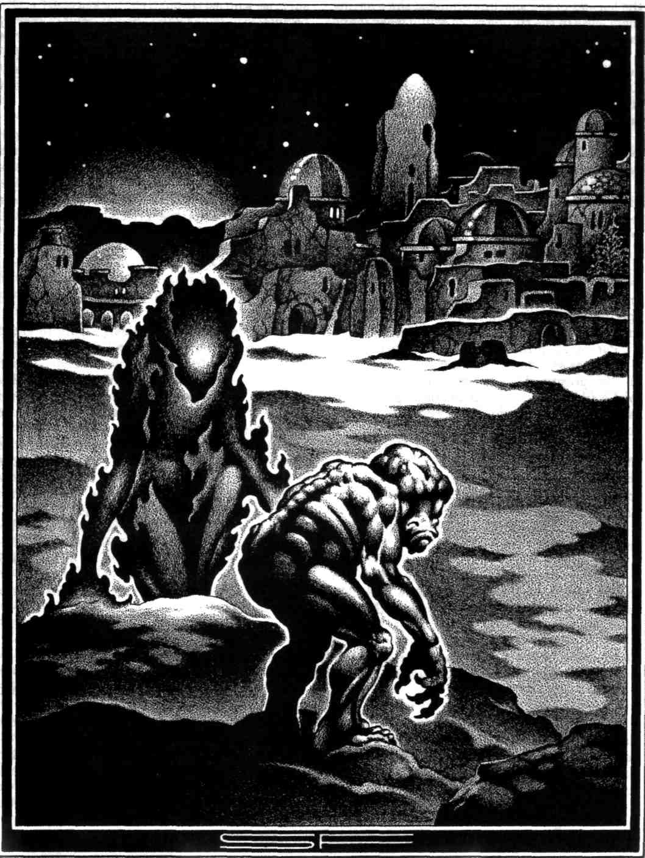
A quarter-hour later, the one Kamose had sent to observe the Kushite's death came back. His forehead and cheeks dripped sweat. Soldiers came closely behind him. Eddies of gossip and surprise whirled through the packed courtiers, to be quelled at once by the ancient habit of gravity in Pharaoh's presence. The news, whatever it was, travelled as far as the feline-faced Royal Secretary and Butler before he stopped it. Kam-ose's ears and brain extracted three significant words from the murmurs. Kushite .. . magician . .. escaped.

The second word touched him most sharply. Kamose himself was widely known as Egypt's greatest magician. Some of those who said it were even fit to judge. Certainly, if there were other contenders, their names escaped him. To their jealous fury, even the priests of Thoth could supply none.
"Is that true?"
"Yes, holy one."
"Tell me everything later."
"Tell me with him," Prince Rameses added grimly.
He mounted the throne-dais again, to stand beside his parents. Protocol swallowed embarrassment. Although Kamose behaved with the rest as though nothing had happened, his thoughts were seething — and they reached deeper than sensation or outrage. These events had significance.
The affront from Kush was not astonishing in itself. When Egypt lay divided, or beset by foes from elsewhere, the vile Kushites had always taken the opportunity to revolt. This time around, they seemed to be testing the spirit of Egypt first. The envoy had provoked Pharaoh's anger on purpose. He had expected to be condemned, and he had expected to escape Pharaoh's justice. That appeared clear.
The important thing was to learn what further plans he had made.
II
The advance which thou hast made towards the House is a prosperous advance; let not any baleful obstacle proceed from thy mouth against me when thou workest on my behalf.
— The Overthrow of Apep

Although he came rarely to the royal court, Kamose stood well in Pharaoh's favour. Thus he had been granted apartments of his own in the palace. He summoned his shaken acolyte there to question him.
"Tell me what happened, as the gods live, with no vapouring."
Two other persons were present; the Crown Prince, Rameses, and a well-shaped woman in the robe of a priestess, seated to one side on a couch, demure and silent.
The acolyte gulped. A rotund young man named Serkaf, he did not easily withstand shock or surprise. Being careful in duty, though, he applied himself to tell the story as his master ordered.
"Holy one, they took the Kushite out to destroy him, even as Pharaoh said. He was bound with strong cords and surrounded by spears. Then he spoke words in his devilish tongue, and the spears became lethal snakes! They turned on the men who held them! Being bitten, they fell down, writhing, and shortly they died. Then the serpents attacked the other soldiers, and in the confusion, the Kushite magician vanished. He was free of his bonds when men saw him last."
"Vanished?" Kamose said angrily. "He's seven feet tall and the hue of dates! However he escaped, he will not stay hidden long."
"Is that sure?" Rameses asked. "Clearly he's a magician of some power."
"Oh, Great One." Kamose softened his voice in respect. The prince might be a valiant soldier, but like most men of action he was too easily impressed by magic. "Clearly. Yet changing staves to serpents is not a monstrous feat. The priests of Thoth can do it. Serkaf here, my greenest acolyte, can do it. I'll have him demonstrate, if you wish."
"There is no need." Rameses drank wine cooled in the palace lake. "Well, was there more?"
Serkaf nodded jerkily. "A thing foul to repeat, mighty prince. Before he disappeared, the Kushite shouted threats against your sire, the Pharaoh. He declared the Royal Falcon would — would fly to his horizon — within the month."
Rameses hurled his wine-cup across the room with a blistering curse. "Words! Bluster! Vile and blasphemous, yet nothing but bluster! Who is this Kushite pig?"
Kamose nodded, bleakly speculative. "That is what I should most like to know, Great One. Who is he? Not a fool. He staged that outrageous brawl in the throne room so that none should forget him, knowing he would escape later — and he spoke words that none should forget, also. How if, unthinkably, he does plot the death of Pharaoh? And if it came to be? All would then know his end came from Kush."
"It must not happen!" Rameses had turned pale. "This miscreant — can he be human? Perhaps he is a demon, O Kamose."
The woman in the background lowered her eyes. Her lips moved in a very slight smile.
"Mortal or demon, he must be found quickly," Kamose said, "and thy father, Great One, must be protected day and night until that is achieved."
"What spies and bronze swords can do, will be done," Rameses vowed. "But you, wise Kamose, can you defend him with magic,if he should come under attack by magic?"
"That is a fearful trust to bear, Great One," Kamose said, "yet I will undertake it. If you and Pharaoh are prepared to calm the priests of Thoth for me. They will have fits with their legs in the air when they hear."
Rameses laughed shortly. "We will deal with the priests of Thoth, believe me."
When priest and acolyte had gone, Kamose sat scowling, barely noticing the cup of wine the woman placed before him. She seated herself and watched him from formidably deep black eyes. At last he stirred and tasted the wine.
"Guarding the Pharaoh against a wizard," she observed, "is a dangerous charge. One might fail."
"The priests of Thoth would like that." Kamose smiled darkly. "So might you. If I were destroyed, you would be free, lustful and voracious one."
"I'm sufficiently content in your service. I have lovers enough, and victims enough. That organisation of tomb-robbers —" She smiled. "Perhaps I can help in this matter too? You must discover where the Kushite hides, and I know the Delta well."
"You were its haunting terror until I curbed you, Mertseger. No, this I shall do without your help. It brought me much credit to rid the Delta of your depredations. I do not wish rumours to spread that the lamia has returned. Keep to your human shape and be discreet — or I shall be angry."
"This man changes rods into serpents," Mertseger said, and laughed a little. "I could show him a serpent." Opening her lovely mouth, she extruded a long forked tongue and hissed loudly.
"Do not so," Kamose ordered, adding ironically, "You are human, a priestess, and a woman of virtue. No, others may search for Tayo. I shall devote myself to protecting Pharaoh from whatever petty spells the Kushite may use against him. Two demon-spirits from the Duat whom I control can do that best; the Green Flame, and the Bone Breaker."
"Set them to stalking the palace halls and Pharaoh will surely die," Mertseger said maliciously, "not of spells, but of horror."
"Oh, they shall walk unseen," Kamose said, "and chase baleful influences from the Pharaoh's vicinity, since other beings of darkness fear them. Nearly all others," he amended, "as they in turn fear me."
Mertseger did not deny it. "What is the Living Horus to you, that he should continue living?" she asked idly. "You know he is not a god. You know the Nile would rise each year without him."
"The men who work the land do not," Kamose answered, "and there is too much disorder in Khem now. I dwell here too. My footsteps have been printed in enough foreign countries."

III
"You cannot escape me for I am your fate! There is only one means of escaping me and that is if you can dig a hole in the sand, which will remain full of water, and then my spell will be broken. If not death will come to you speedily, for you cannot escape."
— Story of the Doomed Prince
Kamose's eyes glittered with impatience and irritation. The man facing him also wore the vestments and regalia of an archpriest, though not the conventionalised black jackal's pelt which characterised the Temple of Anubis. On the contrary, he carried a gilded staff with a carved ibis-head. Despite the dignified finery, his face expressed little character, its most memorable feature being a soft, heavy mouth, on which rested a smug expression.
"You are a fool, Beba," Kamose said sourly. "You, and most of your priests of Thoth. But clearly you have gained the ear of Pharaoh in this matter, so if that is a triumph, enjoy it. I only beg that you will waste no more of my time."
Beba chuckled. "You may indeed have little left, O Kamose. If so, it is well. Did you suppose you could hide your evil magic from me, the chief servant of magic's ibis-headed lord? Long ago, unlawfully, you gained your own knowledge by stealing the scrolls written by Thoth himself! For that you were punished, and yet you learned not —"
Kamose took three forward steps, his face black with fury, and caught Beba's throat in the fingers of his right hand. Very softly he said, "Little man, do not speak of that again. You might find out what punishment is."
Beba pulled himself free, choking and alarmed. He retreated from his rival and answered between coughs, "Yes, you speak — like a man of violence, a worker of evil. You summoned demon-spirits into this palace! Why, unless to harm the Living Horus? But now he has commanded that you remove them. Your scheming has come to naught in the face of the servants of Truth, Kamose."
Kamose said harshly, his anger still blazing, "You serve Truth badly. Fools always do. The Green Flame and the Bone Breaker walked the palace for days, at my command, and invisibly, so as to cause no fear. If I meant harm to Pharaoh, it would have been done by this. My purpose with them was to banish and frighten other demon-spirits who might approach, sent by the Kushite. But none have come. It appears he was a petty conjurer from a savage land, a braggart, a liar, and no threat to Pharaoh. Therefore I have removed those demon-spirits as needless presences."
"You had to," Beba reminded him swiftly. "Pharaoh commanded it."
"At your persuasion. Consider that you have the better of me, then, be gleeful and revel in it. I have said already that you waste my time. If this is all —"
"It will never be all," Beba said vindictively. "You will be removed from your priestly office and brought low, Satni-Kamose."
"Not to your level. It is a measure of your soul that you use that vulgar nickname. Be gone."
Kamose brooded in the priest of Thoth's absence. The soft frog had overstepped indeed, when he dared mention the god's vengeance on Kamose for stealing his scrolls of magic from a hidden tomb. So long ago. All of a century ago. And still Kamose could scarcely think of it, how his wife and children had died, how —
Enough. He rejected the thoughts bitterly. The matter of his two demon-spirits called for attention. To invoke them, summon them from the Underworld, the Duat, and give them earthly substance, had been a dire, dreadful action. Even though the possibility of a threat to Pharaoh's life had justified it, that possibility seemed a mirage now. The Kushite "magician" had done nothing, which fairly well argued that he was not able to, beyond conjurer's tricks like turning rods to serpents.
The obvious course was to dismiss the demons wholly from the earth, not merely from Pharaoh's palace. Let them return to the caverns of night in the Duat. They were better there than in the realm of the living. Should they escape his control, they would either destroy him, or innocent fools for whose lives the law must hold Kamose to account.
Still, the situation was not yet wholly clear. It might not be as simple as he had represented it to Beba — who in any case could only grasp simple issues, and not all of those. Kamose might still have tasks for the demon-spirits, before this affair ended. The risks involved in sending them away, and then bringing them back once more, if he should require to, made even his blood thicken, as with the deadly effect of hemlock.
Two things were sure. Because of Setekh-Nekht's dictum, he might not bring them to the palace. Nor might he allow them to roam at large, idle. However, there were temples of Anubis in the Delta, as in every place which boasted tombs and necropoli. A chapel existed even in this city of Pi-Rameses.
At midnight, within the chapel's walls, Kamose called the two by the light of bronze lamps shaped like dog's skulls, wherein burned oil mixed with powdered mummy from a traitor's grave. He drew blood from his arm with a copper knife. Raising it high, he then traced in the air a hieroglyph more antique than the pyramids. Its meaning was relentless.
The spirits responded.
The Green Flame appeared as a shape of emptiness, a shadow with thickness, somewhat human in outline and a bright, blazing emerald in colour. With it came a fierce dry heat more dessicating than the desert at noon.
Although the Bone Breaker did not scorch by its presence, it wore a form still more grotesque to behold. Also manlike, more or less, it had grey dead flesh as hard as leather and wore its bones on the outside, like partial armour. Its head resembled a malformed, snouted skull with eyes and a tongue. If possible, its hands were less lovely still.
"Welcome," their master said ironically.
"What would you?" the Green Flame asked in a hissing, crackling voice. The other uttered the same question from a throat clogged, apparently, with putrescence.
Kamose had no wish to hold lengthy conversation with these beings. He said curtly, "Somewhere in the Delta a dangerous man is at large, an outlaw from Pharaoh's justice. He has murdered; what else I am not yet sure. Find and destroy him."
Both demons expressed pleasure. Kamose added repressively, "This man only," assured them of the pains they would suffer if they exceeded his command, and then described and named the Kushite envoy. The demons demanded to know how even they could find one man in the vastness of the delta.
"Have I not told you that he is no Egyptian? Have I not described him? Few men could be more conspicuous! Yet he has some cunning, and so — where does a man hide a leaf, if he is crafty?"
"Upon a tree," the Bone Breaker answered in its husky, phlegmy tones. "Among other leaves."
"Yes. Among Pharaoh's soldiers there is a corps of Kushite archers and another of spearmen. For the most part they are tall. Seek him first in their barracks, but remain unseen, and neither harm nor frighten any that is not the man I designate."
"How shall we tell him from the rest?" the Green Flame asked in scorn.
"He's a magician, or what passes for a magician in Kush. You will smell sorcery on him. Besides, he is noble, not common — again, by Kushite reckoning. If he be not concealed among the soldiers, then seek him more broadly, but find him! I am not concerned to do your work for you!"



Raging with unvoiced hate, they departed. Fiercely and long though he had striven to leave normal human emotions behind — and the pain they caused — Kamose felt relieved by the demons' absence. The gods knew he had other things to do.
Counter the poison being poured in Pharaoh's ear by the priests of Thoth, for instance; they would be busy against him. How fortunate, he thought, that he enjoyed Pharaoh's favour to a degree, and that of Prince Rameses even more. But to become complacent about royal favour constituted a great step towards losing it. Even Egypt's greatest magician might not safely ignore politics.
IV
That which is an abomination unto me, that which is an abomination unto me, let me not eat. Let me not eat filth, and let me not drink foul water, and let me not be tripped up and fall in the Underworld.
Papyrus of Nu
Setekh-Nekht, Pharaoh of Egypt, writhed on his couch and fought to breathe air grown hot and stifling. The pleasure lakes around the palace brought no cooling relief. Hideous dreams assailed him. Runnels of sweat poured from his skin; his fingers twisted the fabric beneath him.
Wildly, in his dreams, he looked for his royal protectors, the goddesses who warded the king. He found them, but not as they should have been. The Vulture hunched brooding on a plinth, her great wings folded, not outspread in guardianship.
Groaning, he turned in search of Wazt, his active defender, the Cobra who turned her burning eyes on his foes and shrivelled them with her glance. She coiled on the floor, head lowered, the hood flattened against her neck rather than distended in wrath. Malformed things crawled in the shadows.
"Help me! I am the Son of Ra! Let me not perish on account of my enemies!"
Bayet, the queen, mother of his heir, heard and awoke in distress. "My lord, I am here! What —"
His eyes opened, but he did not wake. Nor did he see her. For Setekh-Nekht, a naked figure huge in height strode from the shadows, strong past his power to resist, the shapes of evil pressing behind him. A dark hand closed on his shoulder and dragged him from his bed with such force that he screamed in pain. A long black corridor like the passage of a tomb opened before them. His assailant hauled him along like a child until they reached a chamber hewn from rough black granite.
"Do you know me, Lord of the Two Lands, you who made the brag that you are Lord of Kush as well? Do you know me? You condemned me to be thrashed with rods, and then to die impaled, but now it is I who sentence you!"
"No! Nekhebet, Wazt! Strike him down!"
Neither goddess answered, and the huge dark shape laughed in contempt. "Fool! Your protectors have gone! You yourself dismissed them at the urging of that other fool, the Archpriest of Thoth! The hour of your fate is here!"
There was a heavy rod in his hand. Setekh-Nekht remembered his divinity, his kingship, and his manhood. Rising to his feet against the awful strength of the hand that held him, he struck once, twice and again, strong blows that went home — without effect. Then the rod rushed down and snapped the bones of his arm. Further blows flattened him to the chamber's granite floor.
The terrified queen in Setekh-Nekht's bed heard the bones break, saw his forearm hang distorted from the couch's edge. She saw nothing else, no presence that might account for the injury, and he seemed to struggle against nothing, on a bed of tasselled linen. Yet huge wealed stripes appeared on his body. Bruises that bled, such as are caused by impact against rock, flowered on the Pharaoh's legs and back. One by one his ribs broke. The queen fought free from her trance of horror, and shouted for help with all her voice.
The Pharaoh seemed to hear. Briefly, his eyes cleared, and he whispered, "Bayet..." Then he croaked further words.
They were his last. Some unseen force hauled him into a standing position and thrust him against the wall. Fearful impacts lashed across his taut belly, as from a smiting baton, breaking the organs within, liver, spleen and stomach.
The force holding Setekh-Nekht released him. Spewing bile and dark blood, he collapsed across the couch. Queen Bayet shrieked and shrieked. Even when her attendants rushed into the chamber, and guards clattered behind them, her screaming continued, rising higher.
By morning, all the city of Pi-Rameses knew that Pharaoh had died. As the Kushite threatened, Setekh-Nekht had flown to his horizon, sent there by loathsome murder. And considerably within the month.

V
As concerning the fight hard by the Persea tree in Annu, it concerneth the children of impotent revolt when justice is wrought on them for what they have done.
— Papyrus of Nebseni
Kamose made obeisance before the throne of Egypt, his dark eyes burning like anthracite. The Pharaoh's throne stood empty. Queen Bayet sat in the other, her face and bare breasts gashed in lamentation, looking at the Archpriest of Anubis with haunted eyes. Rameses stood beside her throne, resting a hand on her shoulder. He looked appalled and bewildered, but with his magician's eyes, Kamose saw the seeds of huge anger sprouting in his heart.
"My lord spoke before he died," Queen Bayet said like a stone image; except that stone does not bleed. "These were his words. The priests of Thoth have failed me. Send for Kamose."
Despite his sardonic, self-contained philosophy, Kamose felt a rush of relief. Dying in such torment, Setekh-Nekht could hardly have known what he was saying. He could as easily have raved curses against Kamose for letting him die.
"I am here, Great One."
"What should we do?"
"The Kushite, Tayo, is a stronger magician than I believed. He has taken the earthly life of Pharaoh. The new Living Horus —" (Kamose bowed to young Rameses) "— must be guarded against his malice, before any other consideration. I shall surround him with spells and charges so potent that nothing can prevail against them."
"And the murderer?" Rameses asked.
"My demon-spirits are seeking him now. Soldiers, of course, with all the vizier's spies and agents, are combing the Delta. With reverence, Great One, this vile savage's apprehension can wait. Your divine life must be made safe at once."
"Yes." The queen's voice shook. "Listen, my son. Your father's ka was dragged from his body and thrashed to death in darkness. It must not happen to you!"
Kamose laboured nine days and nights, and nine more, and another nine, to ensure that safety. He kept strange terrible vigils, and invoked the Pharaoh's protecting goddesses anew, to watch over Rameses. He sacrificed a great bull hippopotamus to Set the Defender. At the end he vanished for three days, and returned gaunt, weary, sunken-eyed, the mark of great talons furrowed across his chest, but with a look of dark triumph stamped on his face.
"You are safe, Pharaoh," was all he would say.
Rameses, who was now officially Pharaoh, and the third to bear that name, looked into Kamose's eyes, and believed, and could scarcely resist a shudder.
"The magician of Kush has not yet been found," he said. When Kamose blinked, swaying on his feet, Rameses said quickly, "My friend! Forget I am a god, and rest before you fall!"
Thinking as best he could, with a brain that should have been shattered by his late experience, Kamose muttered:
"So? He laid his plans well. Perhaps he even had help from traitors. In his place — I should have quit the Delta — taken ship down the Red Sea."
"In due course we shall have him," Rameses said fiercely. "Let not your heart trouble, for I shall order the new Viceroy of Kush to bring him to justice."
"As Pharaoh speaks, let it be written," Kamose said hoarsely. "Well — if we cannot find the magician at once — we know where to find his master, and the one — who sent him on his mission."
"The King of Kush?"
"Yes."
Rameses felt the duties of a Pharaoh and a son pulling in different directions. "I cannot send a host to Kush, much less lead it, not even to avenge my sire! That would leave Egypt unguarded."
"In these days when it has no union." Kamose closed his eyes. "Grant me time to recover, Great One. Then leave Kush to me. When I have finished — they will take no more liberties here."
Kamose's recovery filled most of a year. The Nile rose and receded, the harvest was sown, ripened and reaped, before he was quite himself again. However, he did not wait that long to do as he had undertaken. He waited only days. He considered the King of Kush owed him a debt, and there were beings he could send with that message, his own sort of emissaries; beings who could not be made to wait indefinitely like soldiers in barracks, either. He commanded them and dispatched them.
They travelled by night. Dogs howled in the Delta as they passed. Soldiers on the mighty white walls of Hikuptah felt a cold wind blowing. At Abdu of the pilgrimages, and at Thebes where mighty Amun-Ra was worshipped in the greatest temple on Earth, evil dreams troubled the inhabitants. The demons came to Elephantine by the First Cataract, upper boundary of Egypt, but did not linger there. They travelled straight across the desert within that immense bend of the Nile where the gold of Kush was mined, by convicts and traitors. Their existence was torment, and death a happy release. The demons observed their pains, and in the night the miners heard them laughing. Then they went on. The journey was arduous — even for such as they — and they came to the palace of Kush filled with harsh rancour.
The monarch of Kush slept in his domed chamber, watched over by warriors who would walk into a furnace at his bidding, rich in beasts, gold and pride. No evil dreams troubled his sleep, as they had the Pharaoh of Egypt. First he awakened, and then his nightmare began.
Above him loomed a face of leering bone, and on his other side a blank head like a shape carved from the vacant air, burning emerald in hue. The king's warriors lay around him. They did not move. The nearest had a strangely shapeless head, as though his skull had been pulverised without one drop of brains or gore spilling forth. This the king saw in a passing wild glance, but gave it no notice or thought. His mouth stretched wide to scream.
Fingertips of blunt grey bone closed on his throat, and squeezed with a kind of obscene delicacy, crushing the larynx just enough to prevent any sound above a whistling whisper. Air still reached his lungs. Breathing was not much impaired. The King of Kush in his demented terror failed to make this discovery for some time.
When he did, it brought him no joy.
His slaves found him at dawn. Every bone in his body had been broken, the large ones splintered lengthwise, the small ones crushed as in a press. Not one fragment protruded through his skin, which was neither torn nor broken anywhere. But his flesh had been dessicated dry, as though by days in the scorching desert air. His eyes, like grey pebbles sunk far back into his skull, yet seemed to stare appalled.
Words were seared in the plaster wall as though by fire. Written in the hieroglyphics of the Two Lands, they said: EGYPT'S ANSWER TO THE MURDER OF EGYPT'S PHARAOH.
Far away, the new Pharaoh leaned on a balcony of green malachite, looking over gardens and stone-quayed harbours. Kamose stood beside him. He now carried a sky-blue fan made from a single ostrich plume. This, a sign of great royal preferment, went with the title Fan-bearer at the King's Right Hand.
"My messengers have no doubt reached the King of Kush by now," he said. "No other will blaspheme against the life of a Pharaoh again. Or should they dare, you are protected, Lord of the Two Lands."
"That accursed envoy escaped," Rameses said. "He may have returned to Kush by now."
"Such is my hope."
"Your hope! Why?"
"The vile Kushites bury a king's greatest servants alive with him, to serve him in the hereafter." Kamose's smile was a chilling thing. "His magician and royal envoy should qualify as a great servant. It were fitting if Tayo should be given such a part in his king's obsequies." Q
AUTHOR'S FOOTNOTE: Abdu of the Pilgrimages, where the body of Osiris was said to be buried, is modern Abydos; Hikuptah is Memphis; and Kush is the modern Sudan, more or less.
DEADLINE
by R.G. Evans
illustrated by Denis Tiani
It's going badly.
Outside the night birds begin to sing. Background noise at worst, their rising clamor creates only a minor distraction ... but it will do.
My coffee has grown cold in the cup, and as I wince at its bitter chill I see my face reflected spectrally in the darkening window. Blank. Distant. Lost in my "poetry look," my father would say. "Goddamn book zombie."
My father.
For a man with such disdain for writing — my writing — he certainly had a way with words. Ironically, he dealt with his writing son with as much civility as Americans deal with their old and ill. Lock it up. Keep it hidden. Never talk about it with strangers.
Then along came Chastity.
Chastity LeMay, the potboiler to end all potboilers. Page after page of drivel, fluff and rubbish — Mickey Spillane meets The Perils of Pauline with a healthy dose of 007 thrown in for good measure. All the pulpy nonsense my father loved to read in all those terrible dog-eared paperbacks he'd leave in stacks on the back of the toilet for me to find, torturous traps set for his shameful poet son. But of course, I read them all, drinking in great sour drafts, cringing at their coarseness but reeling in their heady addictive spell.
Chastity LeMay. The only thing I ever wrote that my father admitted to liking. Every word of it written in longhand just for him.
But now the words seem to be dying, just as my father did. The note pad sits mockingly empty, and my fingers feel meaty and numb around the pencil.
It's going badly. The next chapter of Chastity LeMay — Chapter 427 — is due today, but the words just will not come.
Still, I'll have to hurry if I'm to finish it on time.
My father will be here soon.
Chastity was born out of ego and desperation, a child of scorn.
Her birth began with a phone call.
The electronic trill awakened me so abruptly that my hand, sodden and half-dead from sleep, knocked the receiver from the cradle. As I groped blindly for it, I glanced at the clock — almost three a.m., late even by my insomniac standards. Still groggy, I mumbled something incoherent into the phone.
"Todd?"
My brother's voice. Shocked into alertness, I bolted up in bed. Jerry and I only spoke in times of tragedy. The last time had been Mom's funeral nearly two years before. I wanted to tell him to leave me alone, that whatever it was, I didn't want to hear it. But my throat felt tight and dry, and I could only listen.
"Todd, it's dad. Cancer. The doctors say he's dying."
My family. We are all of us poets.
"He's in Briarwood, Todd."
"Briarwood?" I remembered my mother's last weeks spent in that soul-less place, the cloying scent of Pine-Sol covering the stench of death as unconvincingly as white-wash splashed on rotting wood. "How the hell could you put him in there after —"
"It's too much for Linda and me alone. We learned that with Mom. And you, well..."
"Yeah, and me." My father would sooner cut his own throat than admit he needed any help from me.
"You'd better go soon if you want to see him, Todd. He doesn't have long."
The phone clicked with a chilling finality, and I knew I would see Jerry soon.
At my father's funeral.
Briarwood Convalescent Home lay hidden well off the main road at the end of a secluded gravel track lined impressively on either side by towering elms. The car crunched along the gravel, sending up a white cloud of dust behind, obscuring the way in even further from any curious highway drivers. Driving reluctantly on, I thought of the old line about the three most important things in real estate being location, location, and location.
Briarwood's location was perfect. Just like its residents: out of sight, out of mind.
Out of my mind.
I thought about turning around, ignoring Jerry's phone call and saving myself and my father the trouble this visit would surely cause. Instead, I eased the car into a parking space, mechanically got out and went inside the home.
Sensory overload greeted me inside. The smell of disinfectant hung in the air like mustard gas, causing my nose to burn and making my eyes tear. Electronic bells chimed in cryptic sequences, calling attendants to rooms, sending nurses from station to station.
And, of course, the troops were all there. They sat hunched in wheelchairs at their posts along the corridor, slumping to one side or the other. Many slept, but some sat embroiled in conversations they had held decades ago, gesturing wildly as they spoke, breathing laboriously as they paused for their cruel children or unfaithful spouses or long dead parents to deliver their well-rehearsed lines. In a TV lounge to the left, a small crew huddled around a dusty Motorola gazing somnolently at Lassie coming home for the eight thousandth time. No familiar faces among them; they were this year's models.
My mother's class had all graduated long ago.
"May I help you?"
Startled, I pivoted and found myself eye-to-eye with a thin nurse, her face as ghostly pale as her uniform, her lipstick a stark red wound slashed across her face.
"Y-yes," I said. "Geisinger. Gerald Geisinger. I understand he was admitted yesterday. I'm his son."
Her nose wrinkled in disapproval as she scanned me from head to toe, her head twitching birdlike on the stalk of her neck. "Room 211."
Moving through the corridors and stairwells of Briarwood, I felt strangely dissociated but vaguely — sickeningly — at home, like Scrooge being led by a ghostly guide through his own past.
Or future.
But here I had no guide, so when I found myself nearing the wing where my mother had died, I stopped and considered taking a look into her room. I half-imagined I would see her there as she had been at the end: her cheeks sunken and gray; a gauzy, sticky film obscuring her left eye, her right swollen shut; her lips silently moving in one of the exclusive, one-sided conversations held by Briarwood's damned. I took a deep breath and moved on to room 211. My father's room was like all the others. Semi-private. White walls, white curtains, white heads lying in white beds. I walked past his roommate, a shapeless form crumpled under the sheets, stood between the curtained window and my father's bed, and looked down at him.
He looked very small lying there, but otherwise not much different than the last time I had seen him. Thick waves of white hair swept back from his high sun-spotted brow. A network of lines ("laugh lines" they would be called on anybody else, but on my father they were simply wrinkles) fanned out from the corners of his eyes, and two deep gorges were etched from the corners of his mouth down toward the hard angular ridges of his jaw Suddenly, unexpectedly, I wanted to touch those lines, to feel the coarseness of that tanned leathery skin, to caress the face of the man that was my father. I reached out toward him —
He opened his eyes.
I jumped back as if some poisonous desert snake lay coiled on the pillow. The movement startled him, and his eyes moved frantically from side to side before squinting up at where I stood in the light of the window. "Jerry?"
"No, Dad, it's me."
A shadow passed over his gray eyes and his head sunk back down into the pillow. "Oh."
One syllable told me volumes. Things hadn't changed. It was no better now than the last time we met. And why? What had I done to earn his resentment?
I wrote. I didn't farm. I wrote. I didn't twist lugs on an assembly line. I wrote. I didn't drive a forklift or carry freight over-the-road or make big ones out of little ones down at the quarry.
It was all ready to come out — I could feel myself preparing to lambaste this dying old man — when he spoke again.
"They took my glatheth. I can't thee a goddamned ting."
Then I saw that I was wrong. He didn't look the same at all. The Coke-bottle glasses he always wore lay on the night stand behind him just out of his reach. Without them, his eyes looked distant and weak and his whole face seemed withered, smaller. And the glasses weren't the only things "they" had taken: his upper plate had been removed, probably safely soaking in a cup in the night stand drawer. That explained his lisp. It also helped explain my sudden strange sensation that I was talking with a shrunken head left lying on the pillow.
"What time ith it?"
I looked at my watch. "Uh, it's —"
The words died. I saw my' father withdraw a frail, palsied hand from beneath the sheets and squint at his bare wrist where there was no watch.
And then I knew.
It had become my mother's habit in her last days. Eight, nine times every hour, she would drag the tarnished old Westclock off the night stand, gaze forlornly into its scratched crystal, and put it back on the stand with a sigh that seemed to issue from the center of all her pain. Then, a few moments later, she would repeat the ritual, then sit fidgeting nervously until the next time she checked the clock. I never knew if she were counting the hours she had lain there, or imagining what minutes she had left.
And now her habit had become my father's.
"Damn it, I athked what time ith it?"
I told him and he sighed my mother's sigh.
"Can't thee the TV There'th nobody here to talk to. And now they've thtole my glatheth. Can't even read."
I looked down into his pale eyes tangled in their net of wrinkles and realized with a pang of sadness that they had read their last trash novel.
Then, as if from another room, I head myself say, "Would you like me to read to you, Dad?"
He lowered his eyes. His shrunken little head sank forward slowly and his lips began to tremble and purse.
He would never be able to tell me yes.
"What shall I read to you?
But of course I knew the answer. Something containing cartoon-caricature men of action and the big, bosomy women they loved to date, berate, and use for bait. Throw in a little implausible intrigue and gratuitous violence for good measure, and there you'd have it: my father's perfect book.
"I'll be right back," I said.
The halls of Briarwood seemed less familiar as I left my father's room. The constant whiteness of the walls seemed to blur and turn fuzzy. The burning smell of disinfectant metamorphosed into the burning smell of black powder and the cool aroma of dry martinis. The faceless shadows that lined the halls in their wheelchairs assumed ominous expressions as they donned guises of drug lords, international terrorists, and double-agents. Even the severe desk nurse with the red wound lips seemed to soften into a feline Mata Hari, purring through poison-tinged lipstick.
Chastity LeMay was being born.
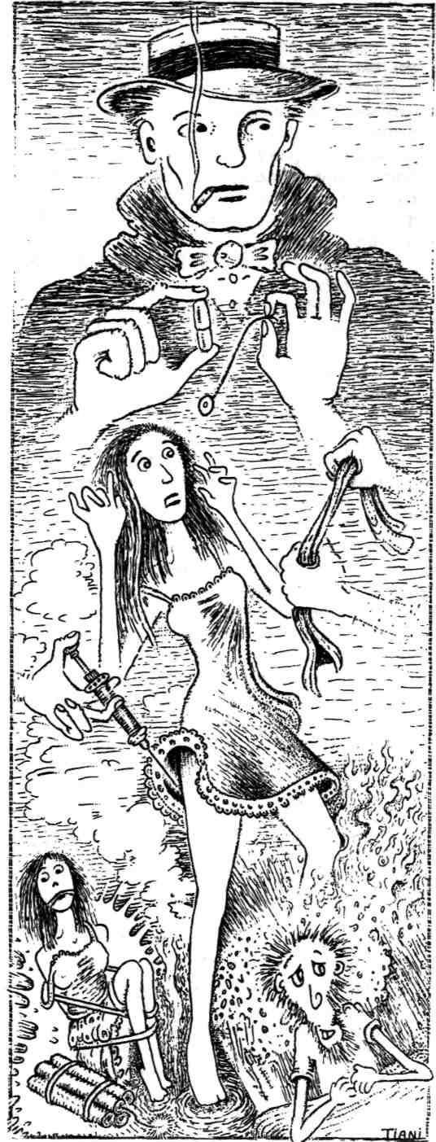
I took my note pad from my car and sat under the two big elms that towered in front of the home, oblivious to my surroundings. Words came furiously, my pencil moving across the pages so brutally that I wore the point blunt and had to pause to sharpen it three times. In less than an hour I stopped and held the pages in hands that trembled both from exertion and excitement. Then, my heart rising in my throat, I went back into my father's room.

He lay just as I had left him — shrunken, distant behind those sightless gray eyes — but impulse made me hide the notebook behind me until I was seated by the window and certain he couldn't see what I was holding.
"What time ith it?"
I forced the excitement out of my voice. "It's story time, Dad," I said.
Then I began to read.
It was a simple story, formulaic even. A beautiful girl locked in a room, escaping her captor by means of her feminine wiles. My voice rose and fell in the cadences of melodrama naturally built into such tales, and when I finished, I felt a little ashamed that I had actually been proud of such rot. I started to rip the pages out of the notebook when my father stirred in his bed.
"Oh, Toddy," he whispered. "How does it all end?
I looked up to see a man transformed. He had raised himself up on his elbows and leaned as far in my direction as he could without falling out of bed. His breath had quickened from excitement, and his lips had parted and quivered like a boy's on the verge of his first kiss. But his eyes ... they had begun to gleam like chips of gray ice and the distance in them was no longer inside the man, but far away — in a locked room where a fiery redhead sat awaiting her captor. I wondered how my father would have felt had he seen himself at that moment.
Because he was wearing my "poetry look."
"End?" I asked him. "What do you mean?"
"There's more to it," he said, more a plea than a statement of fact. "What happens next?"
I couldn't answer him. In my mind, the story was finished, a self-contained little adventure yarn of about two thousand words. A beginning, a middle, an end. The end. But how could I explain this to a man straining on his deathbed, desperate to find out "how does it all end?"
"Lie back and rest, Dad," I said, tucking him back into bed. "I'll read you the next chapter tomorrow."
And tomorrow. And tomorrow.
I added a second chapter to my little story and read it to my father the next day. Then I added a third and a fourth, all written in longhand — so disposable, unlike my poetry. Every day I would arrive at Briarwood at six and read my father the latest chapter of Chastity LeMay. Every day he would sit up beguiled until I was finished and then collapse back into bed, exhausted from the effort. It became our ritual, and I had written nothing else since the ritual began.
And not once did I tell him it was my story. He never asked and I never volunteered the information. My satisfaction came in the hypnotic power my story held over him, the way he sat entranced until I finished reading, even though the effort took its obvious toll on him. After each reading, he would shrink back into the pillow, ashen-colored and panting, noticeably weaker with each passing day.
But I didn't stop. It was my writing, and my father had finally begun to pay attention.
Summer gave way to an early fall, and harsh winds stripped the elms guarding Briarwood by Halloween. By mid-November, my daily visits became shrouded in darkness, and the spotless fluorescent-lit halls of Briarwood became an oasis of heatless light in the gloom of chill autumn evenings.
One night, braced against the cruel winds and armed with Chapter 283 of my magnum opus, I arrived at Briarwood earlier than usual. It was a long chapter — in which Chastity finally confronted one of her nemeses, Ben Al-Hasaad, in a battle to the death — and I wanted to be sure I would finish reading it to my father before visiting hours ended at eight o'clock. Most of the residents sat crowded into the tiny dining hall, slurping down the variety of puddings and strained fruits that served as dessert, but I knew that my father, unable to sit in either the dining hall chairs or a wheelchair, took his meals in his room, so I headed for the stairs.
Leaving the stairwell, I nearly collided with the stark, red-mouthed nurse I had become used to seeing behind the front desk. I apologized for my haste, but she continued to wear a look of stunned surprise.
"Really, I'm sorry," I said again. I held up the manuscript pages and smiled apologetically. "I guess I'm a little too eager for my dad to hear this."
The red smear disappeared as she pressed her lips into a tight little slit. Her eyes held a look I couldn't recognize. Anger? Pity? Sadness?
"We tried to call, Mr. Geisinger. Last night. Your father passed away shortly after you left yesterday. We tried to call, but we couldn't get through on your line."
Of course you couldn't get through, I started to say. I disconnect the phone at night so I can write undisturbed. Then I realized what she had said.
"My father? Dead? What have you done with him?"
"Your brother claimed the remains. He came right away. He tried to contact you too."
The red came back, an angry blotch of it curling beneath her nose. It seemed contagious: I could feel my cheeks filling with hot blood. She excused herself curtly and quickly walked away, leaving me alone in the false light of a place where I no longer belonged.
I don't remember turning around or walking down the steps or opening the door to leave Briarwood for the last time. My only memory is how cold the wind felt outside and how easily it caught the pages of Chapter 283 of Chastity LeMay as they fell from my hands, scattering like dead elm leaves in the night.
The numbness followed me home. I entered my apartment with all the energy of one of Briarwood's shambling residents. I noticed the dangling phone cord still disconnected from the night before. I imagined voices — the red nurse's, my brother's — straining mutely at the unplugged connector, unable to reach me. I saw by the clock that it was still several minutes till six. I saw the door of the cabinet where I keep a bottle of bourbon.
Even the bourbon couldn't cut through the numbness. Alone in the dark I drank, waiting for the burn, feeling nothing. Remotely I heard the clock begin to chime the hour as dull images floated up behind my eyes.
One: Chastity LeMay struggling valiantly against Ben-Al-Hasaad.
Two: my father's quivering lips and far-away dreamy eyes.
Three: the cold, shadowless hallways at Briarwood.
Four: the nurse's angry disappearing red lips.
Five; my brother signing release papers as attendants carried away my father's body.
Six: Chapter 283 fluttering away into the night —
Something moved in my apartment. I didn't hear is so much as feel it: a movement in the air — not wind, but something electric, firing past me, through me. Then a sound came from the bedroom. A rustle of fabric. The creak of a bedspring.
Someone was lying in my bed.
The numbness fled and a hot coil of panic tightened inside my chest.
"Who's there?" I called. My voice sounded thunderous in the darkness, and immediately I wished I could call the words back, just quickly
— quietly — turn and run away.
Whoever it was didn't seem startled. I heard the bed groan as weight shifted on the mattress —
And then I heard the sound. It was deep and breathy at first, and I didn't recognize it as a voice right away. It grew louder, a sibilant whisper snaking through the dark.
Calling my name.
"toddy... taaaaaaaaaaahhhhhdy... come... read... to ... me...."
The bourbon became a sudden hot geyser spewing up from my stomach, and I clamped my hand over my mouth to keep from retching. The bottle fell from my hand, but over the glugging of its spilled contents, I could still hear the voice.
"please, toddy... what... happens... next?"
My feet began to move. I didn't want them to, I screamed silently for them to stop, but they paid no attention. Step by step, they carried me toward one of two unwanted destinations.
The insane asylum.
Or a room where my dead father lay in my bed calling my name.
"... taaaaaaaahhhdyyyy..."
I managed to stop outside the bedroom door. Sweat had erupted on my forehead and blood pounded in my ears. If I stepped inside and found nothing, did that mean I had lost my mind? And if I stepped inside and found my father lying in the bed, could that mean anything less?
I fumbled around the corner for the light switch, then thought better of the idea. Whatever lay waiting inside, I knew I didn't want to see it in the light.
I stepped inside.
Light streamed in from the streetlight outside my window, and the shadows cast by the windblown cedars outside make skittering spider-shapes on the wall, on the bed — And on my father's face.
He looked as he had the last time I'd seen him: sallow, sunken-cheeked, hollow-eyed. The sheets rose and fell unevenly, and the sound of his labored breathing filled the room. I had to grab the door frame as my knees turned watery, and I felt the hot whiskey rising again in my gorge.
"toddy... what... happens... next?"
I looked into his eyes then and saw it. Distant hunger. Wherever he was, whatever he may have seen, it wasn't what he wanted. His eyes were focused on the sordid streets of Algiers where a fiery redhead named Chastity was making a stand against the villainous Ben Al-Hasaad.
"J-just a minute," I muttered.
My feet led me again. I shuffled into the other bedroom, the one I use as a study. Unconsciously, my hand reached out for the stack of note pads on the desk and peeled away a pad of blank pages.
Back in the other room, my dead father's breathing continued irregularly, painfully. I entered holding the blank note pad elevated in front of my chest, as an acolyte holds the Bible for a priest.
"toddy...?"
"Just a minute, Dad." I cringed at the hollow sound of my own voice. I remembered the pages of Chapter 283 carried away by the wind and wondered exactly what I might do next.
I looked at the empty pages. Whether by a trick of memory brought on by stress or by the same mystery that had brought my father back, I could see the number "283" at the top of the first page. Beneath it, the words I had written the night before, the same words I had watched blow away earlier, seemed to shimmer and glow with their own light.
Then I heard my voice begin to read, and I heard my father struggle up onto his elbows, his rasping breath quieting immediately.
He stayed that way until I had finished reading Chapter 283.
When Chastity had succeeded in vanquishing Al-Hasaad, I heard my father settle back onto the bed. His breathing again became a painful hiss, and in the dancing spider-light from the window, I looked down into the distant pain of hunger in his eyes.
"oh, toddy . . . how . . . does . . . it. . . all. . . end?"
He seemed to sink deeper into the pillow, and deeper still. The bedsprings creaked and I saw the sheets settle down flush against the mattress.
And then he was gone.
Yes, Toddy, how does it all end?
There have been so many six o'clock rendezvous between Chapter 283 and tonight's scheduled installment, Chapter 427. Chastity and I have come a long way together. Her battles have taken her from Africa to the Mediterranean and all across Eastern Europe, and she has dealt with spies, thieves, lovers, murderers, and a rogue's gallery of other ne'er-do-wells, all in 144 chapters.
And I have written and read my father all 144 of those chapters. I don't seem to do much else, but I am so very tired.
And tonight it's going badly.
Lately, the words just don't seem to want to come. I don't want them to come. I don't want him to come.
But he will be here soon. Very soon I will feel a bristling in the air about me and a tingling electric warmth coursing through the very depths of my heart. From the next room, I'll hear a very fragile weight settling in the center of my bed, and a tremulous, airy voice will begin to call my name.
For the time being though, I look into the darkened window, my face reflecting sallow yellow light from the blank note pad, and I wonder just what will happen when the words stop coming.
Because it just may be tonight.
And then we'll both learn how it all ends. Q
DRAGON'S EGG

Miraculously found In the dark womb Of a mountain cave, Encrusted with limestone From ceiling drippings,
A perfect, melon-sized Egg of long ago, Heavy to the holding, Still warm to the touch From inner whisper of fire
And if you softly press
An ear to its shell
You can faintly hear
A waiting heartbeat.
— K.S. Hardy DEADLINE

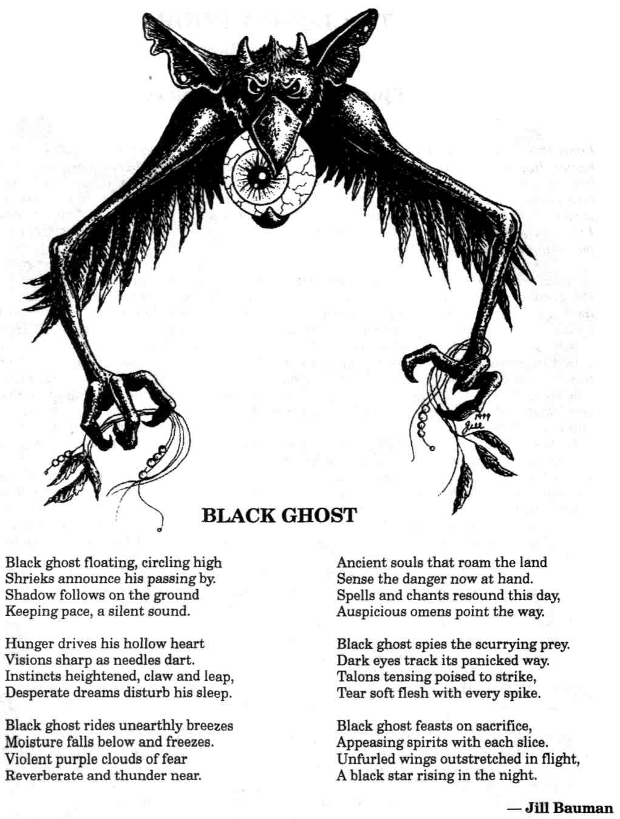
TO CLOSE A DOOR

by George Barr
illustrated by George Barr
I pray for long life... I who have already lived a score of years more than anyone else I have ever known. It is not that I, in the long twilight of my life, have suddenly found the dawn of each new day imbued with a fresh sweetness to make me wish for its continuance. In all truth, I would long since have gladly breathed my last. Existence holds for me not the slightest promise of happiness. It is not joy for which I hope, but the dark pleasure of satisfaction. I would live to see proof that the measures I took against an unknown foe had the effect I planned. Then I will most willingly go to whatever punishment or reward my life has earned.
When first I saw Dorinhild's mirror turn dark, the candles were aglow and a cheerful blaze danced in the grate. Moonlight poured in a silver flood through wide-flung shutters and the room was a haven of brightness and warmth. Yet the glass which ought, by all the laws of the natural world, to have shown with that selfsame light and warmth, was a smoke-filled reflection of something and somewhere untouched by the cheer of that room.
None saw it but I: Dorinhild's aged nurse. The rest ate and drank, danced and laughed, rejoiced in Red Gerain's safe return from battle, joining my mistress — his wife — in welcoming the hero home from the war.
Many were the rich gifts he'd brought to his faithful and beautiful spouse: cloth woven with gold threads, strings of amber and pearl, spices from faraway lands, ointments rare and fragrant, and the crystal looking glass in its bronze knotwork frame.
These were among the spoils of that war, the bounty and the booty wrested by Gerain from the stronghold of that sinister lord who — so years of rumors told — had held the lands northward by his practices in the foul arts. Red Gerain had long laughed at such tales, and offered now his own victory as proof of their foolishness.
All the afternoon had his dear wife posed and strutted before the sorcerer's glass, displaying the new gowns and jewels to all our delight. Truly Dorinhild was beautiful. Always had she been beautiful — even when just a new born babe: the babe I cared for from the moment of her birth. There was a sweetness and joy that made her preening a means of sharing rather than a flaunting of newfound wealth. No one resented her good fortune. Rather, those of us who loved her were glad to see her happy, considering her rich presents small compensation for the loneliness she'd suffered while Gerain had been at war.
In puzzlement I approached the mirror where it hung upon the wall. I could see my withered face in it, but darkly, as in a window which looked out upon the night. And — as though it were that window — I felt the creeping sense that something looked back at me from the other side . . . something which might burst through into the warmth and light . . . something dark, envious, and evil.
Fearfully I raised a hand to touch the glass and saw the darkness fade swiftly away. The mirror was cold to my touch ... cold, with the feeling of ice upon a pond ... the kind of ice which conceals beneath its sparkling surface the depths of ooze, and decay, and wriggling, cold-blooded, alien life.
When the guests had departed, long past the mid of the night, and Gerain and his lady prepared for the bed they had not shared for far too long a time, the thought came to me to cover the glass with a cloak. I did not, lest it be seen as a sign of mourning — an ill omen on our master's return.
The last to leave the room after all the muss of the celebration had been straightened, I was glad the master's great deerhound slept before the fire. I know not why I was so certain that evil had entered the house, for the mirror seemed naught but a glass, and the dog obviously sensed nothing amiss.
Alas for that faithful dog.
The morning found the walls encrimsoned by the poor beast's blood. Hard it was to believe that so much gore could have been contained within one mortal body — even a body as large as that dog's had been. That body itself was nowhere to be found, though the casements and doors had been bolted against the night and those bolts were yet fast and true. Whatever had slain the creature had devoured it entire.
Our lord, Red Gerain, had loved that dog.
He was not a man to believe that which he could not see, and I well knew that he'd not listen kindly to my thoughts of what had slain his hound nor whence it had come. I kept my peace as he questioned each servant and bondsman who'd been within the house. Sure he was that someone had admitted a foe, then locked up tight again after that villain had done his bloody deed.
None could tell him ought to satisfy him, and dire punishments might have befallen many had not a serving wench brought to our master's attention the puzzling fact that — despite the rivers of blood which covered the room — there was not a single drop outside the house . . . neither on lintels nor doorsteps, nor anywhere in the dust. It gave him pause that a deed done so messily within the house could have been continued with such cleanliness outside.
The fact that caused all in the house to shudder was that, in all that spilt blood, there was not the print of a single foot. It did not seem that even a mouse could have picked its way across that floor without leaving a track.
More strange still — and it was something I alone noted and told to no one at that time — though the frame of Dorinhild's mirror was, like the wall upon which it hung, covered with clotting gore, there was not a droplet, a stain, nor a smudge upon the glass itself. It was as though the mirror had been set within its frame of bronze after the horror was over. How else could there be blood splashed over, around, and about it so thickly without a single drop touching the glass?
Most of the day was required to clean that room. Blood could be scrubbed from the stones and the tiles, but there was little hope that it could be washed entirely from draperies and cushions.
All that day I kept my eye upon the mirror but saw naught to give evidence of the truth of what I knew to be true.
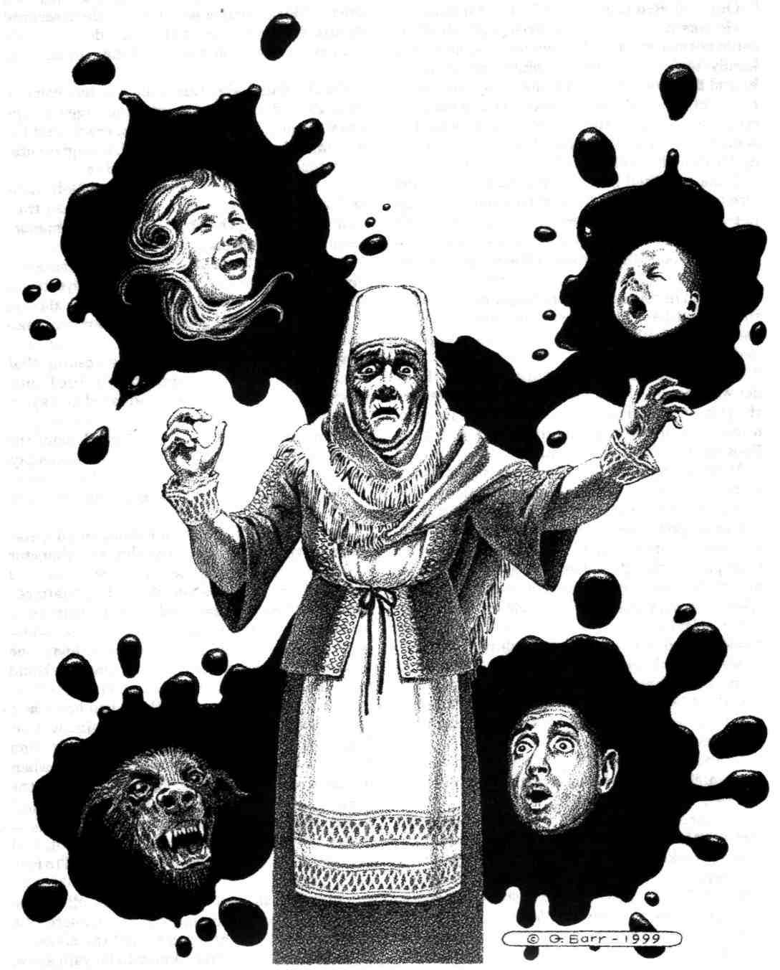
A guard was ordered to stand attention through the night, and men patrolled about the house to make certain no intruder came again. To my great relief, the guard still lived come daylight, and he had seen or heard nothing untoward throughout the hours of the dark.

Three days passed with no clue to what had slain the dog, and no further strange happenings.
Our master and his lady, having naught else to blame, accepted that a madman had somehow gained entry to the house during the day before the doors were closed, had committed his foul deed, hidden somewhere inside, then escaped during the furor over what he had done. I held my peace and watched the mirror.
On the fourth day Dorinhild's sisters came to visit: the ladies Faye, Artrude, and Rigga. Rigga, the youngest, brought with her a cradle and her nursing babe but four months old. It slept quietly, undisturbed by the talk and laughter.
Never for a moment was that babe left alone and unguarded. I myself never stepped foot from that room during the visit, and was seldom more than two or three paces from the cradle.
But in the midst of the ladies' conversation, I saw a movement from the corner of my eye. It was but a glimpse of something large that flashed past me, and I turned about to see the mirror once more dark and clouded.
Again I had that inexplicable feeling that something stared back at me. Then, before I could utter a sound, the darkness had faded and again the mirror was but a mirror.
It was several moments, as I looked about the room, before I noticed that the cradle was empty.
Rigga's sleeping babe was gone.
The land was searched for miles in all directions, as the supposition was that the abductor had come in through an open window and snatched the infant while the ladies chattered unaware. The unlikelihood of that was overlooked simply because there was no other explanation imaginable, and I — who was known to be nothing but a superstitious old woman — could not make anyone believe what I had seen.
On the coverlet where the babe had lain was a single spot of blood. From that, I knew that Rigga's infant would never be seen again. Had there not been so many others in the room when it was taken, I'd no doubt there'd have been the same splashing of gore as when the dog had died. But this time the creature — whatever it was — instead of devouring its prey on the spot, had dragged it back into its own stygian world to feed at its leisure.
I ignored, as well as I was able, all of the mourning, the recriminations, the threats, the preparations for vengeance should the abductor be taken ... all of what I knew to be vain show. The enemy was within the house and I had no proof to offer.
I had it in my mind to feign an accident while sweeping the room, to knock the mirror from the wall with my broom handle in hope it would shatter upon the tiles. I did not . . . because of thoughts I had whilst sweeping slowly toward it.
The mirror was of a size that — were it a hole in the wall — a man might have squeezed through it . . . but with difficulty . . . certainly not without attracting the attention of anyone nearby. Yet the movement I had glimpsed had seemed of something huge. It had been something large enough to have dismembered the great deerhound. It had, however, disappeared into that mirror in the blink of an eye. How, I wondered, was that possible?
Then I remembered a time when I was but a child and my brother, with his dip net, had drawn a small octopus up from the sea. I had never seen one and was fascinated by this soft, squirmy, living thing. It was almost large enough to fill a soup bowl yet it had managed without difficulty to escape, from the bag into which my brother put it, by squeezing its boneless body through a hole no larger than the nail on my thumb.
I knew not what form the creature from the mirror took, but I knew that the size of the doorway through which it came did not necessarily limit the size of the creature itself. Some forms of life could flow like water through almost any opening.
Therefore, I reasoned, breaking the cursed mirror might prove no hindrance to the demon which dwelt behind it. A chunk of amber is no less amber for being shattered by a mallet. The size of the piece has no bearing on its substance; the smallest particle of it is still amber. Thus, this doorway might still be a doorway in each of its broken parts, and the being which used it might merely flow through a smaller door than it had used previously. It would be too easy to lose or mislay one of the countless shards of a broken mirror, and I feared that each small piece might be as dangerous as the whole of it.
I thought that if, perhaps, the mirror might be cut precisely in half, and the two identically shaped pieces bound face-to-face, the doorway might then be effectively closed by becoming only a reentry to the place from which the creature had come.
But I knew of no way to cut a piece of glass that surely . . . that exactly. And I doubted there was anyone I could convince of the necessity who would do it for me.
That night, as I was again the last to leave the room, I risked the master's displeasure and did hang a cloak over the glass. I wished there'd been a door I could bolt, but the big room opened upon a hall which led to the chambers of Gerain and Dorinhild, as well as to the stairway which wound up to the servants' quarters above.
In the morning I found the cloak upon the floor across the room from the mirror, but nothing else disturbed. Naught was said to me about it, but I supposed the master had flung the cloak away from where I'd hung it, and that he did not scold me because of my age and that I had expressed my fears to him. Though he thought me foolish for them, he at least doubted not my sincerity.
It was nearing midday when the kitchen maid said that she'd been unable to rouse the butler and feared that he was in a drunken stupor. His door was bolted and — after an hour of futile pounding — it took two strong men to break it down.
The sight which met our eyes was such as would give sleepless nights to even the strong of heart. The man's bed was a pool of congealing blood. Gore splashed the floor, the walls, and even the ceiling.
There was no sign of a struggle. Nothing was amiss within the room save for the blood which must have sprayed from that bed like spume from a breaking wave. That, and the fact that there was no other trace of the butler.
My fears—my certainty—were again ignored, this time because the man's window had not been locked. Though there was no sign of blood outside the casement nor on the ground beneath, the unlocked window was proof enough for Red Gerain that the assassin had entered and left through that portal.
It is a mystery to me why men will think that they themselves will retain their knowledge and wisdom to the end of their lives, when they are so certain that all others about them, whose hair has whitened and faces wizened with age, have utterly lost their senses so that all they may say is dismissed as the babbling of the aged. I have learned much in the years I have lived, and it was painful to me that my master saw me only as a muttering crone devoid of intellect. Had he hearkened to my warnings, I am full certain much would have been different in the remainder of his life . . . his, and my own.
The thing that had killed the butler had, I was sure, gained entry through the finger's-breadth space beneath the man's door. Within the room it had devoured its prey, then escaped by the same means to disappear through the glass into its own mad universe.
That I found red smudges on the inner rim of the bronze frame served only to convince my master that I had not cleaned the mirror as well as I ought after his dog had been slain. His view of the world did not allow him to see anything which might disturb that view.
As I stood before the glass, later that day, staring in impotent frustration into my own ancient eyes, again the mirror grew dark. I saw my face dim as the eyes of that reflection grew bright. They glowed back at me balefully, without intelligence, without understanding, but filled with an avidity that was shocking. My knees turned to water as I realized those were not my own eyes into which I gazed.
What reflection I could yet see in the smoky glass dissolved and I looked into the face of nightmare incarnate. I have tried many times to tell what I saw; I will not do so again. Things can only be described in terms of what they most resemble; there is no other way to put into someone else's mind a picture of what he has not seen. But details are not the whole of a thing, and to say that something had a bit of this, a suggestion of that, a feeling of something else ... cannot convey the reality, nor even suggest the horror. I will not again attempt it. Suffice it to say, I would most willingly face the dread lord of Hell, himself, if I could be certain he did in no way resemble what I saw looking back at me from that bronze frame.
In fear of my very life, I fell to one side. And for the rest of my days I'll curse myself that I moved at all. I should have died. My death then and there would at least have convinced Red Gerain that I had spoken truth, and he might yet have acted in time to avert further disaster.
Alas, I lived.
Something vast, and alien, and awful poured through that opened portal, leaping past me to the next available prey. There was a flash of lightning movement, a swirl of golden hair, and ... a sigh. No more than that; just a sigh. And my beloved Dorinhild, who could not have been more dear to me had I borne her myself, was being pulled through that frame by . . . what? Hands? Paws? Tentacles? Of what? Sinew? Water? Smoke?
I pray that she died beneath that first slashing leap. I pray that she was not alive to feel herself torn asunder by being dragged sidewise through an opening so much too small to admit her. I pray she did not see the fountain of her blood which drenched us all.
Her lord and husband leapt toward her too late even to grasp the hem of her sleeve. His right arm plunged through that unholy doorway ... and it closed upon him.
That arm was severed as by a headsman's ax, and only quick action by one of his men, binding the arm with a leather belt, saved his life at all.
For those who have wondered, that is how he lost his arm after the war he'd fought had left no scar upon him. I myself have wondered if the very fact that — throughout that war — he was not harmed, is not reason to suspect that his victory wasn't so hard-won as he believed. I cannot but wonder if he was not left deliberately alive in order that he might carry home his foe's means of ultimate revenge: that wretched, accursed glass.
I reached up one hand to touch a lock of Dorinhild's golden hair which hung from the surface of that mirror as though each strand had been dipped in hot beeswax. When my fingers brushed it, it fell away to scatter in the pool of her blood upon the floor.
Convinced at last, my master pointed at the glass which had been his proud gift to his wife, and with a croaking voice ordered it destroyed.
His man grasped an iron candlestick and swung it back above his head.
"No, My Lord," I begged, placing myself before it. "Let me! Let me dispose of it... and perhaps the demon, too. Please, My Lord!"
He looked hard into my eyes and saw, perhaps at last, that there was sane thought behind my words. "Do with it what you will," he said, "but take it from my house."
I snatched it off the wall and wrapped it in my blood-soaked apron. With no word of explanation, I ran with it from the house and up the path which led to the cliffs. It had come to me, when I saw the creature flow like water from that frame, what might be done to prevent its ever coming again into our world.
That nothing else had come out of that doorway after the demon, told me that it lived in a world with air like our own. Had it swum in a sea like the octopus my brother had captured so long ago, that sea would have poured forth from that open portal.
Thus, the sea became the answer.
I stood upon the cliffs overlooking the dark, wind-tossed waters. Those cliffs arose straight up out of the ocean with no shoreline, no beach, no slope at all. For my purpose it could not possibly have been too deep.
I tore the apron from the frame and with all my strength cast the mirror out as though it were a plate, to sail upon the wind . . . away from the cliffs and the chance that it might break before it reached the sea. I saw it strike the water on edge and it disappeared beneath the surface to sink — I hoped — a thousand fathoms into the black ocean.
When next the creature opened its portal into our world, the water would pour through, pushed by the weight of all the sea above it, in a torrent it could not stop nor swim through to wreak its vengeance upon us.
Perhaps — as I hoped — it would drown in that first fierce rush. In any event, I prayed it would be unable to close the door that it had opened.
I wondered... I wonder now ... how long it will be before the waves break lower on the cliffs... be fore the sand of our shore stretches long miles out to sea as that sea drains away into the evil world from which that creature sprang. I pray I live long enough to see it happen ... and to know that my Dorinhild is revenged. Q
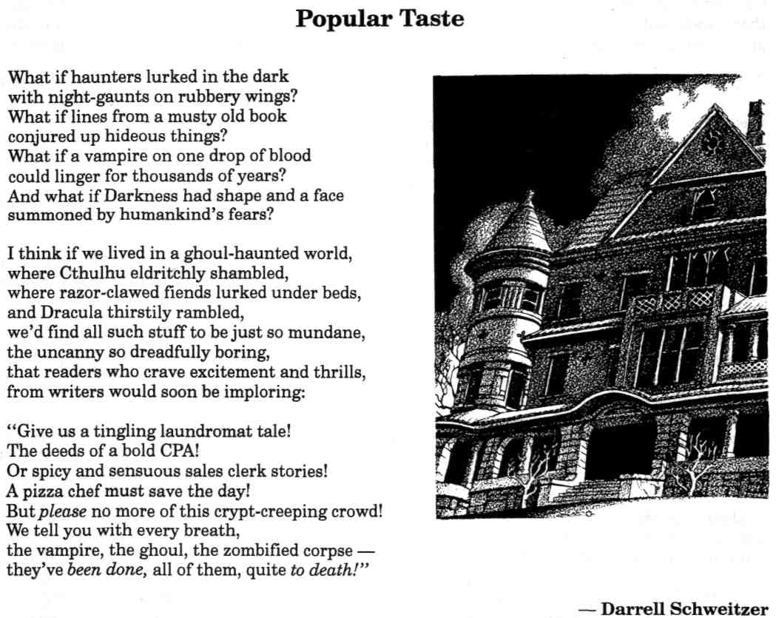
THE OLD MAN'S FINAL VISIT

by James Robert Smith
The Old Man sighed and watched his breath go puffing out, a long trail in the cold, black air. His antlered steeds heeded his strangely muffled commands as he took them speeding silently over weird lands. Below, hills covered in bare trees marked their passage on this night. Moonlight beamed and guided them along the way, the hills coming up beneath them as he took his sled down and down.
There were almost no roads in the gnarled and trackless country. There was no happy community feeding woodsmoke to the chilly sky to guide them in for another of their many visits. Here, there were only the cold hills and the trees grasping empty air like wizened old folk grasping for a last shred of life.
A lone house appeared from out of those arthritic trees and hooves skittered in nothingness as if to halt their descent to this awful place; but obediently they eased down to light upon the frozen, slate roof. The deer stood uncharacteristically still on their perch. Nostrils flared and huffed steam, and within their eyes there was a spark of fear.
The Old Man stood down from his great, solid sled, and he went along the tether, patting each one upon its furred muzzle and whispering words of encouragement. "Shhhhh," he said. "Sshhh." They calmed, but stared at those dark woods with fearful eyes.
He looked down, seeing through that unyielding roof, through those dark slates and into the house. Rooms stood cold and empty, floors un-trod. But there was someone who waited. A pair of pale figures lay in the great bed of the master's room: male and female. The nursery bed was vacant, but something stirred the air: waiting.
Moonlight shined down and illuminated the pale trim of his coat. The cold light shone, glinting from his polished boots. And even his coat was a faint crimson in that frigid illumination. He went to the chimney and into it, descending its black throat. No warm fire welcomed him. Only the silence of a freezing, unlit place.
Magically, he unbent himself from the hearth, standing in an empty room that did not house a gay tree, that did not bear jolly stockings hanging in wait from the mantle, that did not hold cheer for those awaiting the wonder of this date.
His weight came down upon the ancient floor, and the wooden creaking fairly screamed his arrival in this silent night. Overhead, even the steeds skittered at the sound. He peered round, left and right. He blinked.
And there he was. The child was just there, in the doorway of the hall that led down from the attic. Little child torn away and left pale and cold in this dead place. He sighed and blinked again, and behind the child the two who had made it. The parents looked on with flinty gazes that reflected the moonlight and showed the dark, soul-free depths of their own damnation. A damnation with which their insatiable curse had marked their own little one.
"Come to me," the Old Man said, kneeling for this child who had been robbed of his childhood. He went down, prayerfully, his knees resting with a muffled thud, to rest. The un-child stared with the same diamond gaze of its parental companions.
There was a rasp of gloves on coat, and the Old Man revealed his warm, plump throat. "For you, little one," he whispered. Those small eyes glazed over with a crimson brighter than the coat that was drawn aside for it, and it glided silently across the floor where icy hands gripped ample flesh and white teeth flashed like little knives and a great, warm stream flowed: a gift.
The thing that was not a child felt the warmth flow in. It felt the glow of a home that had a fire burning cheerfully in the hearth. It felt the compassion that waxed between husband and wife and parent and child; and it knew the love that had once been its own before curse had chilled them all. Visions were imparted from countless homes, each happy place the Old Man had graced on his endless, night-long journey. There were trees and lights and healthy sustenance, and a sweetness that was not tinged with that coppery stain. There were colors: bright greens and yellows and blue and happy orange; there was painted paper and glowing lights and ribbons and bows. And toys.
Cold, tiny fingers gripped the Old Man. The small body with the great hunger drew on and on, sucking down those wonderful visions. "These should have been yours," the Man thought, feeling the teeth holding tight to his great neck, letting his limitless strength hold him to this path.
Then, the sky began to pale, barely, in the east. Those cold fingers loosened their inhuman grip, and the small thing stepped away, a glimmer of something lost receding far and away and deep in its glassy eyes. Slowly, it backed away from the great, round figure, and it turned to the two who waited. It went to them and they knelt and licked at its face with white, dead tongues, something like pleasure shivering through them.
They were gone. Vanished back to their places there in that secluded, rotting place.
At the hearth, the Old Man drew his coat tight about his neck, and up that cold, black throat he went.
On his sled, drawn up and northward by his great steeds, he glanced back only once, and wished he could give something more... Q
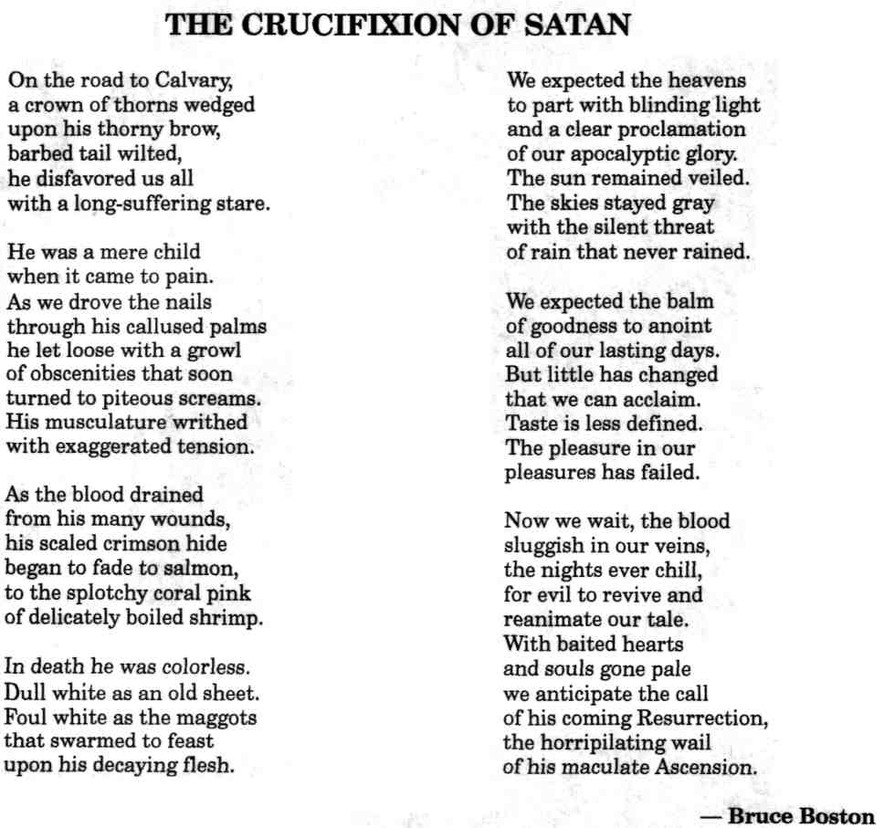

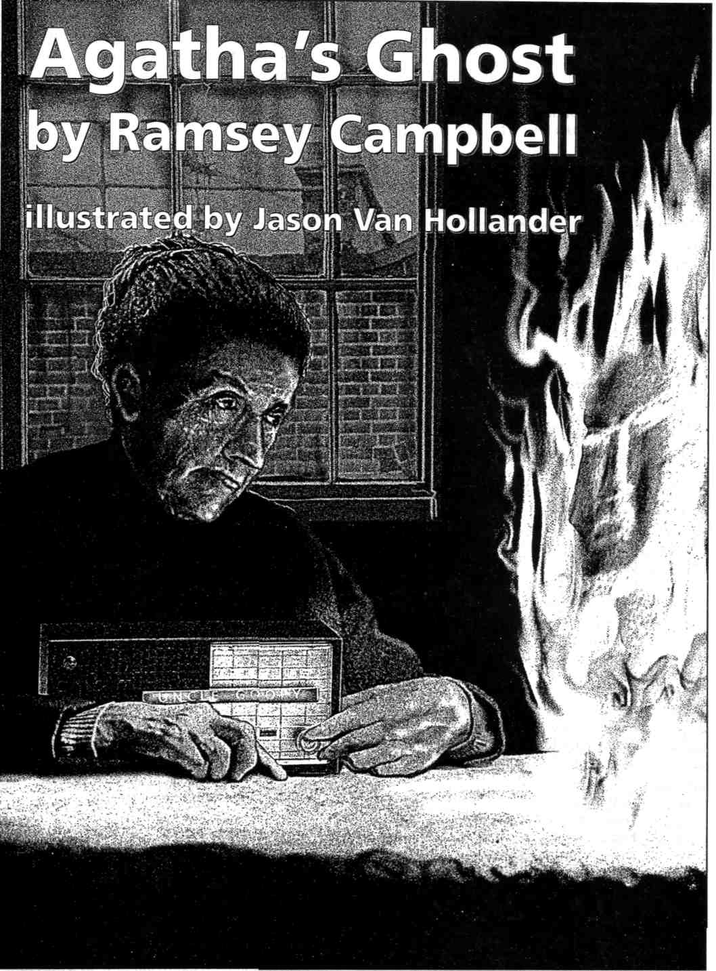
He'd done his best to hide her radio, but he'd forgotten to switch it off. That was the voice like someone speaking with a hand over their mouth she heard as she awoke. She was seated at the dining-table, on which he'd turned all four plates over and crossed the knives and forks on top of them to show that crosses were no use against him. She didn't know if it was daytime or the middle of the night, what with the glare of the overhead bulb and the grime on the windows, until she recognised the voice somewhere upstairs. It was Barbara Day, presenter of the lunchtime phone-in show.

Agatha eased her aching joints off the chair and lifted her handbag from between her ankles so that she could stalk into the hall. Was he lurking under the stairs? That had been his favourite hiding-place when he was little, and now, with most of the doors shut, it was darker than ever. She stamped hard on every tread as she made her slow way up to find the radio.
It was in the bathroom, next to a bath full almost to the brim. When she poked the water, a chill cramped her arm. Now she remembered: she'd been about to have her bath when the phone had rung, and she'd laboured downstairs just in time to miss the call, after which she'd had to sit down for a rest and dozed off. He'd got her into that state with his pranks — what might he try next? Then she heard Barbara Day repeat the phone number, and at once Agatha knew why he was so anxious to distract her. He was trying not to let her realise where she could find help.
She clutched her bag and the radio to her with both hands all the way downstairs. She sat on the next to bottom stair and trapped the bag between her thighs and the radio between her ankles before she leaned forward, dragging agony up her spine, to topple the phone off its rickety bowlegged table onto her lap. She pronounced each digit as she lugged the holes around the dial, but she was beginning to wonder if he'd distracted her so much she had dialled the wrong number when the bell in her ear became a woman's voice. "Daytime with Day," it announced.
"Barbara Day?"
"No, madam — just her researcher. Barbara is—"
"I'm quite aware you aren't she. I can hear her at this moment on the radio. May I speak to her, please?"
"Have you a story for us?"
"Not a story, no. The truth."
"I get you, and it's about..."
"I prefer to explain that to Miss Day herself."
"It's Ms, or you can call her Barbara if you like, but I need to have an idea what you want to talk about so I know if I can put you through."
Agatha had dealt with many secretaries when she was selling advertising for the newspaper, but never one like this. "I'm being haunted. Haunted by a wicked spirit. Is that sufficient? Is that worthy of your superior's time?"
"We'll always go for the unusual. Anything that makes people special. Can I take your name and number?"
"Agatha Derwent," Agatha began, then shook her fist. The paper disc had been removed from the centre of the dial. "My number," she cried, not having given it to anyone since she could remember, "my number," and grinned so violently the teeth almost came loose from her gums. "It's may I please go to the party."
"I'm sorry, I'm lost. Did you just say —"
"My number is may I please —" Since even talking at half speed seemed unlikely to communicate the message, Agatha made the effort to translate it. "It's three one six —"
"Double two three five. Got you. If you put your phone down now, Agatha, and switch your radio off we'll call you back."
Agatha planted the receiver on its stand and held them together. She wasn't about to switch off the radio when it might refer to her. She was listening to Barbara Day's conversation with a retired policeman who built dinosaur skeletons out of used toothbrushes, and staring at the darkest corner of the hall in case the twitch of spindly legs she'd glimpsed there meant that her persecutor was about to show himself, when the phone rang, almost flinging itself out of her startled grasp. "Agatha Derwent," she called at the top of her voice as she grappled with the receiver and found her cheek with it. "Agatha —"
"Agatha. We're putting you on air now, so can you switch us off and not say anything till Barbara speaks to you."
The minion's voice gave way to the policeman's, requesting listeners to send him all their old toothbrushes, and Agatha's sense of his being in two places simultaneously was so disconcerting that she nearly kicked the radio over in her haste to toe its switch. Then Barbara Day said in her ear "Next we have Agatha, and I believe you want to tell us about a ghost, don't you, Agatha?"
"I want everyone who's listening to know about him."
"I'm holding my breath. I'm sure we all are. Where did you have this experience, Agatha?"
"Here in my house. He's always here. I'm sure he'll be somewhere close to me at this very moment," Agatha said, raising her voice and watching the corner next to the hinges of the front door grow secretively darker, "to make certain he hears everything I say about him."
"You sound a brave lady, Agatha. You aren't afraid of him, are you? Can you tell us what he looks like?"
"I could, but there'd be no point. He never lets me see him."
"He doesn't. Then excuse me for asking, only I know the listeners would expect me to, but how do you know it's a he?"
"Because I know who it is. It's my nephew Kenneth that died last year."
"Did you see a lot of him? That's to say, were you fond of each other?"
"I'd have liked him a great deal more if he'd acted even half his age."
"Will he now, do you think? I've often thought if there's life after death it ought to be our last stage of growing up."
"There's life after death all right, don't you wonder about that, but it's done him no good. It's more like a second childhood. He always liked to joke and play the fool with me, but then he started stealing from me, and now I can't see him he does it all the time."
"That must be awful for you. What sort of—"
"Clothes and jewellery and photographs and old letters that wouldn't mean a sausage to anyone but me. He had my keys more than once till I made certain my bag never left me, and now he's started putting things in it that aren't mine to show me it isn't safe."
"How old is he, Agatha? I mean, how old was —"
"Far too old to behave as he's behaving," Agatha said loud enough to be heard throughout the house. "Forty-seven next month."
"And forgive me for asking, but as one lady to another, how old would that make —"
"I'm retired from a very responsible job, maybe even more responsible than yours if you'll forgive my saying so. What are you trying to imply, that I'm growing forgetful? I'd know if I owned a brass candlestick, wouldn't I? Do you think anybody would be in the habit of keeping one of those in their bag? Or a mousetrap, or a tin of dog food when I've never owned an animal in my life because my father told me how you caught diseases from them, or a plastic harmonica, or a tin of lighter fuel when all I ever use are matches?"
"I was only wondering if you might have picked up any of these items somewhere and —"
"That would be a clever trick for me to play, cleverer than any of his, since I haven't stirred out of this house for weeks. I bought enough tins to last me the rest of the year, and I've been waiting to catch him at his wickedness, but he thinks it's a fine game keeping me on edge every moment of the day and night. Do you know he whispers in my ear when I'm trying to get to sleep? I thought I could deal with him all by myself, but I won't have him wearing me down. One thing I'll tell you he's wishing I wouldn't: he doesn't want me to get help. He hid the phone directory, and he even tried to take away my radio so I wouldn't have your number. He doesn't want anyone to know about him."
"Well, all of us certainly do now, so I hope you feel less alone, Agatha. What kind of help —"
"Whatever has to be done to send him away." "Do you think you ought to have a priest in?" "I went to the one up the road, and shall I tell you what he said?"
"Do share it with us, please." "He told me they don't —" Agatha made her voice high-pitched and supercilious. "— believe in such things as ghosts any more."
"Good heavens, Agatha, I'd have thought that was what they were supposed to be all about, wouldn't you? I'm sure some of our listeners must believe, and I hope they'll phone in with ideas. That was Agatha from the city centre, and let me just remind you if you need reminding of our number ..."
At the start of this sentence Barbara Day's voice had recoiled from Agatha, who felt abandoned until the researcher came between them. "Thanks for calling. You can turn your radio on now," she said.
Agatha found the switch on the radio with one of the toes poking out of her winter tights before she fumbled the receiver into place. She returned the phone to its table as she levered herself to her feet with the arm that wasn't hugging her bag, in which she rummaged for her keys to unlock the front room. None of them fitted the lock, he'd stolen her keys and substituted someone else's — and then she saw that she was trying to use them upside down. He'd nearly succeeded in confusing her, but she threw the door triumphantly wide and grabbed the radio to carry it to her armchair.
When she lowered herself into the depression shaped like herself the chair emitted a piteous creak. It was the only one he hadn't damaged so that her friends would have nowhere to sit. He'd made the television cease to work, and she suspected he'd rendered the windows the same colour as the dead screen, to put into her head the notion that the world outside had been switched off. She knew that wasn't the case, because people who were on her side had started talking about her on the radio, Ben, who sounded like a black man, wanted Agatha to keep stirring a tablespoonful of salt in a glass of water while she walked through the entire house — that ought to get rid of any ghosts, he said. Then there was a lady of about her age who sounded the type she would have liked to have had for a friend and who advised her to keep candles burning for a night and a day in every room and corridor. That sounded just the ticket to Agatha, not least because she'd bought dozens of candles the last time she'd felt safe to leave the house. She'd stored them in — She'd bought them in case he started making lights go out again and pulling at the kitchen chair she had to stand on to replace the bulbs. She'd put them — The candlestick he'd planted in her bag would come in useful after all. The candles, they were in, they were in the kitchen cupboard where she'd hidden them, unless he'd moved them, unless he'd heard the lady tell her how to use them and was moving them at that very moment. Agatha grasped the arm of her chair, avoiding holes her nails had gouged in the upholstery, and was about to heave herself to her feet when Barbara Day said in a tone she hadn't previously employed "I hope Agatha is still listening. Go ahead. You're —"
"Kenneth Derwent. The nephew of Agatha Derwent who you had on."
The kick Agatha gave the radio sent it sprawling on its back as she did in the chair. Was there nowhere he couldn't go, no trick he was incapable of playing? He'd clearly fooled Barbara Day, who responded "We can take it you aren't dead."
"Not according to my wife. Just my aunt, and that's the kind of thing she's been making out lately. I must say I think —"
"Just to interrupt for a moment, does that mean everything your aunt said was happening to her —"
"She's doing it to herself."
Only Agatha's determination to be aware of whatever lies he told kept her from stamping on the radio. "I did wonder," Barbara Day said, "only she seemed so clear about it, so sure of herself."
"She always has been. That's part of her problem, that she can't bear not to be. And I'm sorry, but you didn't help by talking to her as though it was all real, never mind letting your callers encourage her."
"We don't censor people unless they say something that's against the law. I expect you'll be going to see your aunt, will you, to try and put things right?"
"She hasn't let me in since she started accusing me of stealing all the stuff she hides herself. She won't let anybody in, and now you've had someone telling her to put lighted candles all round the place, for God's sake."
"I can see that mightn't be such a good idea, so Agatha, if you're listening—"
Agatha wasn't about to, not for another second. She threw herself out of the chair, kicking the radio across the room. It smashed against the wall, under the mirror he'd draped at some point with an antimacassar, and fell silent. She stalked at it and trampled on the fragments before snatching the cloth off the mirror in case he was spying on her from beneath it. She was glaring at the wild spectacle he'd driven her to make of herself when the phone rang.
She marched into the hall and seized the receiver, not letting go of her bag. "Who is it now? What do you want?"
"Agatha Derwent? This is the producer of Daytime with Day. I don't know if you heard some of our listeners who phoned in with suggestions for you."
"I heard them all right, and they aren't all I heard."
"Yes, well, I just wanted to say we don't think it would be such a good idea to put candles in your house. It could be very dangerous, and I'd hate to think we were in any way responsible, so if I could ask you —"
"I'm perfectly responsible for myself, thank you, whatever impression somebody has been trying to give. I hope you'll agree as one professional lady to another that's how I sound," Agatha said in a voice that tasted like syrup thick with sugar, and cut her off. She pinched the receiver between finger and thumb and replaced it delicately as a way of controlling her rage at the way she'd been made to appear. No sooner had she let go of it than the phone rang again.
She knew before she lifted the receiver who it had to be. The only trick he hadn't played so far was this. She ground the receiver against her cheekbone and held her breath to discover how long he could stand to pretend not to be there. In almost no time he said, "Aunt Agatha?"
"Are you afraid it mightn't be? Afraid I might have got someone in to listen to you?"
"I wish you would have people in. I wish you wouldn't stay all by yourself. Look, I'm going to come round as soon as the bank shuts, so will you let me in?"
"There's nobody but me to hear your lies now, so stop pretending. Haven't you done enough for one day, making everybody think —" Suddenly, as if she had already lit the candles, the house seemed to brighten with the realisation she'd had. "You are clever, aren't you. You've excelled yourself. All the things you've been doing are meant to make me look mad if I tell anyone about them."
"Listen to what you've just said, Aunt Agatha. Can't you see —"
"Don't waste your energy. You've confused me for the last time, Kenneth," she said, and immediately knew what he was attempting to distract her from. "You got out by going on the radio, and now you can't come back in unless I let you, is that it? You won't get in through my phone, I promise you," she cried, pounding the receiver against the wall. She heard him start to panic, and then his voice was in black fragments that she pulverised under her heel.
She knew he hadn't finished trying to return. She drew all the downstairs curtains in case he might peer in, she hauled herself upstairs along the banister to fetch a blanket that she managed to stuff into the tops of the sashes of the kitchen windows. Once the glass was covered she crouched to the cupboard under the sink.
He hadn't got back in yet — the candles were still there. She had to put her bag down and grip it between her wobbly legs each time she lit a candle with a match from the box that wasn't going to rattle her no matter how much it did so to itself. She stuck a candle on a saucer on the kitchen table, and found another saucer on which to bear a lit candle into the dining-room. The candle for the front room had to make do with a cup, because he'd hidden the rest of her dozens of saucers. Her resourcefulness must be angering him, she thought, for as she carried another cup with a flickering candle in it along the hall he began to ring the bell and pound the front door with the rusty knocker.
"Aunt Agatha," he called, "Aunt Agatha," in a voice that didn't stay coaxing for long. He tried sounding apologetic, plaintive, commanding, worse of all concerned, but she gritted her teeth until he started prowling around the outside of the house and thumping on the windows. "Go away," she cried at the blotch that dragged itself over the curtains, searching for a crack between them. "You won't get in."
He did his best to distress her by shaking the handle of the back door while he made his knuckles sound so hard against the wood that she was afraid he might punch his way through. The illusion must have been his latest trick, because all at once she heard his footsteps growing childishly small on the front path, and the clang of the garden gate.
She held onto the banisters for a few moments, enjoying the peace, though not once she became aware of his having made her smash the phone. If she hadn't, might he have been trapped in it for ever? Suppose he'd angered her so as to trick her into releasing him? She hugged the bag while she stooped painfully to retrieve the cup with the candle in it from the floor.
She was less than halfway up the stairs when the flame began to flutter. She took another laborious step and knew he was in the house. All his play-acting outside had been nothing but an attempt to befuddle her. "Stop your puffing," she cried as the flame dipped and jittered, "don't you puff me." It shook, it bent double and set the wax flaring, and now she was in no doubt that he wasn't just in the house; he'd crept up behind her — he was waiting for her to be unable to bear not to look. She swung around without warning and thrust the candle into his face. "See how you like —"
But he'd snatched his face away as though it had never been there. Nothing was in front of her except the air into which the cup and its candle thrust, too far. The shock loosened her grip on her bag. She tried to catch it and keep hold of the cup as the latter pulled her off her feet. The bag fell, then the candle, and she could only follow them.
She didn't know if the candle went out as she did. She didn't know anything for she didn't know how long. When she grew aware of darkness, she found she was afraid to discover how much pain she might be in. Then she understood that she was fully conscious, and there was no pain, nor anything to feel it. He'd got the best of her in every way he could. He'd stolen her bag, and her house, and her body as well.
She was in the midst of the remains of the house, a few charred fragments of wall protruding from the sodden earth. All around her were houses, but she couldn't go to her neighbours; she wouldn't have them see her like this, if they could see her at all. None of them had believed her when she'd tried to tell them about Kenneth. For a moment she thought he'd left her with nowhere to go, and then she realised who would believe in her: those who already had.
She heard their voices as they'd sounded on the radio. They weren't just memories, they were more like beacons of sound, and her sense of them reached across the night, urging her to venture out and find them. She felt as she had when she was very young and on the edge of sleep — that she could go anywhere and do anything. She was free of Kenneth at last, that was why; and yet now that he was gone she was tempted to play a
few of his tricks, in memory of him and to prove she still existed. Maybe this was her second childhood, she thought as she scurried like the shadow of a spider across the city to seek out her new friends. Q

OUR LADY OF THE UNICORN

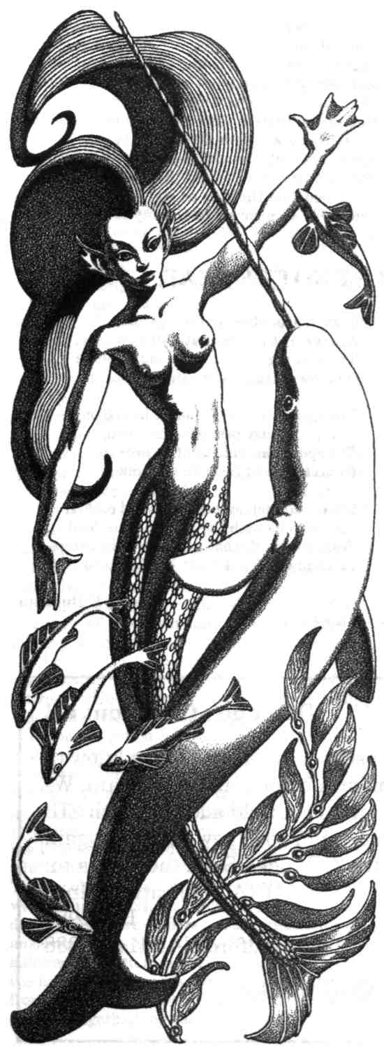
Litanie en l'honneur d'Elle
"A mon seul desir." (To my one desire)
Motto from late mediaeval tapestry.
I
She holds forevermore in fee
All tides, all treasures, of the sea,
But never would she flout or scorn
The empire of the rose and thorn,
Or yet the kingdoms of the dew,
Nor those of cypress and the yew.
She of the pure and only horn, Our Lady of the Unicorn.
II
Where coldest ocean currents run
In seas below the midnight sun,
Cloud-borne, she hovers in the air
To watch the sport and frolic there
Of one-horned narwhals through the waves
Like jousting knights with ivory staves.
She of the pure and only horn, Our Lady of the Unicorn.
III
Where gardens gleam with rose and leaf,
With promise of delight and grief,
She stands amid the shadowed brake
By fountains gushing near a lake,
To wait of that One sure to come,
Driven there by his heart's own drum.
She of the pure and only horn, Our Lady of the Unicorn.
IV
Where morning dew and evening dew
With gems and filigree bestrew
Their traceries, their treasure-troves,
Upon the fields, upon the groves,
She skims above the level grass
Like phantom gliding over glass.
She of the pure and only horn, Our Lady of the Unicorn.
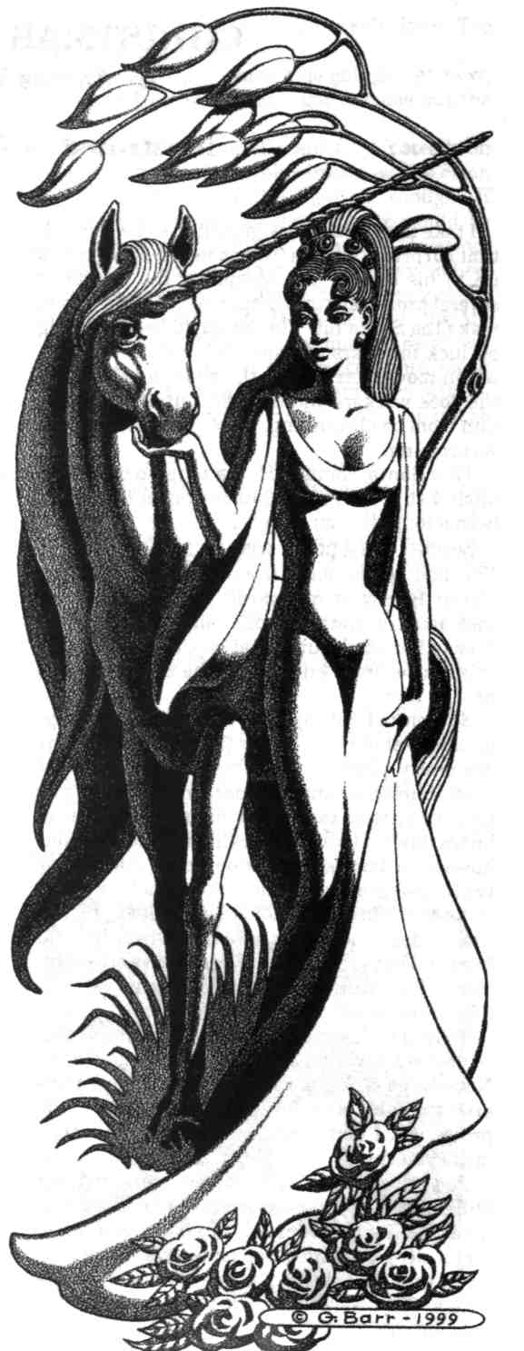

V
Where graveyard cypress, graveyard yew,
And grimmest ilex-oak endue
The silent space between the tombs
With but the purest gloom of glooms,
She watches through the midnight hours
To heed the bloom of ebon flowers
She of the pure and only horn, Our Lady of the Unicorn.
VI
Attended in her tented bourn
By maiden, lion, unicorn,
She looms inside the tapestry
Amid its Figured imagery —
Where, summing all of love and fear, The motto reads: A mon seul desir.
She of the pure and only horn Our Lady of the Unicorn
VII
So thus and yea — yes, in this way —
To trumpets or to lutes at play,
Whether by night or yet by day,
She holds forever more in fee
All tides, all treasures, of the sea,
But never would she flout or scorn
The empire of the rose and thorn,
Or yet the kingdoms of the dew,
Nor those of cypress and the yew.
She of the pure and only horn Our Lady of the Unicorn
Elle de I'unique et pure corone, Voila Notre-Dame a la Licorne.
— Donald Sidney-Fryer
CHRISTMAS STALKING
by James Van Pelt illustrated by George Barr
I take the unusual assignments, so I wasn't all that surprised when a Tampa mob boss who was up to his elbows into skimming the profits of several prominent toy companies contacted me to make the Santa hit. The fat guy'd been cruising on luck for years anyway. He'd cold cocked the union movement among the elves, and he'd cut the dock workers and truckers out of his operation from the beginning, so he probably knew it was coming.
That Santa, though. He's a tough old son of a bitch. I suppose I should have known that. He's been a long time on the job
Seemed like a pretty easy score to me. I mean I've had to do some doozies. Picking off the Easter Bunny at 500 yards, for example. That took artistry. And the Tooth Fairy had eyes in the back of her head, but the fat guy, Hell, he's as big as a house, and I knew where he'd be and when he'd be there.
So I picked out my gear. Now a lot of guys go for single-shot rifles. Those finely bored Mausers are pretty popular. They break down easy, are dead accurate at any distance, and depending on your load, they can go for high penetration or knock down. I like the .45 caliber El-hal-Alamine however, a Turkish magazine loader that can zip twelve 540-grain titanium jacketed hollow points in four seconds on autoload. Of course, no one would clear the magazine all at once: it kicks hard and to the left, but I can put all twelve shots into a four inch circle at a thousand yards in fifteen seconds if the wind is calm.
To Hell with style points, I say. You've got a job to do, and you want to make sure it gets done. Nobody pays for a wounded mark, and there aren't any bonuses for saving on ammo in this profession. I don't care what the movies might make you think.
So I set up in a back-yard tree-house in Arden Hills, a pricey, Chicago subdivision filled with fake-colonial two-stories. From my vantage I had a clear bead on three chimneys, although I knew that I'd only get the one chance. My scope was a 60-power Verstaadt-Bern with a good anti-fog polish on the lenses. Cold weather set-up, I couldn't risk condensation at a key point. Street lights would give me plenty of light, I figured. What I didn't figure on was the snow.
About 11:30, the front pushed through. I had a sleeping bag wrapped around my shoulders, and a thermos of Brazilian Black laced with a touch of rum beside me. Big, sloppy wet flakes fell at first. Christmas lights on the houses up and down the streets wrapped themselves in a layer of fuzzy color and visibility dropped right off. I didn't really mind at first until the snow swallowed my view of a suburban sweet tart whose unshaded bedroom window a block away I'd been scoping pretty regular. Guess it hadn't occurred to her when she went to shower that a guy with time on his hands would camp out in the neighbor's tree house. Then pretty soon all I've got for sure is the back of the closest house and its chimney. I'm getting nervous because I don't have time to set up somewhere new, and it'd be twelve months before the old boy would come out again. No hope for an off-season score. He's got that North Pole hidey-hole locked down tight as Fort Knox.
But the temperature kept dropping, and the flakes turned into those dry, little pellet things that sound like sand bouncing off your hat. I could see better, but it was darn cold, and the wind kicked up. I checked my load again. It's a habit. Don't want to be lined up for the chance and click on an empty chamber.
Somewhere I hear some caroling. Group of church kids, I suppose, since first it's "Hark the Herald Angels," and then "Silent Night," and then "Little Town of Bethlehem." I've got the piece resting on my knees, pointing in the right general direction, but my hands are jammed up under my arm pits. Can't wear gloves. Not even those thin-leathered Italian ones. Just never have been able to do that. You see a lot of wrong stuff in movies about aiming a rifle, and they all make it look easier than it is. It's in the squeeze, you know, and if I'm wearing gloves, my squeeze is off. Even at a hundred yards, I could miss. So now I've got all kinds of things to worry about. It's getting way cold, and I'm thinking about temperature changes in my scope and barrel. Hell, the firing mechanism is filled with high-tech, mono-filament carbon alloys, and I don't know if they're tested at ten-below.
Then, there's the wind. It's steady, and not all that bad (if it weren't the dead of a Chicago winter!), but it's a cross breeze. On top of that, the visibility might go again.
These mob guys, they don't like disappointments. Hell, I can just see me now saying, "It was cold and windy." And he'd say, "Do you know how much you cost me this year?"
I hear those Tampa guys don't kill you before they dump you in the bay. They slice you up a bit, drop you a couple of miles off shore, then make bets on how far you can swim before the sharks get you.
So I'm sitting there with all of these bad thoughts running through my head, and it feels like my butt is turning into an ice sculpture, when the fat guy makes his appearance on the roof across the yard. It's spooky. Not a sound. No sleigh bells. Nothing. One minute it's a bare roof with snow curling around the chimney, and the next there's a regular stock-yard snorting steam into the frosty air, a honking big sleigh, and the fat guy slinging a bag over his shoulder.
I scope him. Cross hairs over his heart. He's got tiny glasses perched on his nose, and he's checking this list he's holding. The snow is bad — it's screwing up the light — and he's mostly a silhouette. I'm afraid I won't get the shot before he scoots down the chimney, but he checks the list twice, and I adjust for windage and squeeze real gentle.
He moved. The shot went anyway. I couldn't hold it back. The reindeer start, but they don't run. Their heads are up, ears up. Disciplined though: they don't go anywhere, and the fat guy is behind the chimney, peeking over the top in my direction.
I drop the cross hairs on him and take four more chances real quick. Three in the wind and one powders a hunk of mortar off the corner. He's gone. I'm hoping that maybe I got him and he's tumbled off the backside of the house, but I know I didn't. You can hear a bullet hit. None of these did.
So where is he? I scan the roof. Nothing. Just shadowy reindeer and the sleigh. Windows in the house are dark, but lights are popping on all over the neighborhood. Don't hear any caroling now. Then a curtain moves. Streetlight catches it. It's him. How'd he get in? I swing the rifle down. Too late. He's long gone.
So I'm thinking, where's he going to go next, and all I figure is that he's got to come out the chimney.
I settle in, brace the rifle, and hold it steady on the target. Even in the blowing snow, it's clear. It's spooky how bad the light is, though. If it weren't snowing, the street lights would be enough, but everything is dark and indistinct now. The sleigh's a hump in the snowy eddies. The reindeer are black on black. My eyes water a little, so I blink them dry. Don't feel cold now. My cheeks are burning, while my hand is calm and cool. Finger resting on the trigger. Gun stock firmly placed. Head a bit to the side. Everything focused in on that bit of roof and the top of the chimney.
He's got to come. He has no choice.
Then, there's movement. A rounded silhouette pushes out the chimney. It's like candy. I empty the magazine, seven flat reports, starting from the top and working my way half way down the brick and mortar. I've got the penetration. Titanium jackets don't even flatten on the way through.
I watch for a second. He's slumped over the top.
Things are getting serious in the neighborhood though. Lights on all over the place. Some distant shouting. Doors opening. A couple of sirens in the distance. Wind picks up again and the snow is fierce.
My gun breaks down in three sections and goes into the case.
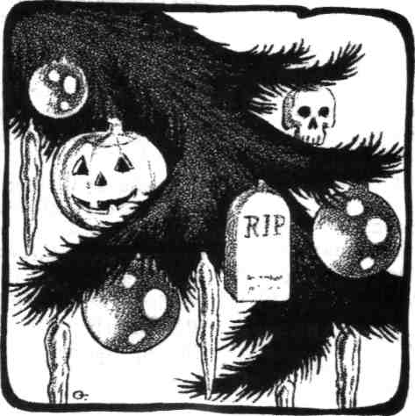

A job goes in parts: the setup, the chance, and the getaway. I'm getting ready to go down the tree when I glance up at the house. Something's moving at one of the windows. It opens. I grab just the scope out of my case and check it out.
I should have known. After all, he's been in the business a long time. It's the fat guy. He looks my way and waves. How'd he know I'd have the gun put away by now? Then he climbs up the side of the house. Pretty creepy to see a guy that big move like that. Then he pulls his bag out of the chimney. He piles it onto the sleigh, and he's gone.
You'll pardon me if I thought his "Ho, ho, ho," was a little mocking.
Five hours later, I unlock my condo, thinking about how much money I have deposited in accounts out of the states, and wondering if there's any chance of booking a flight during the heavy, holiday travel season. I turn on the lights, and there, nailed to my mantle, is a Christmas stocking. I live by myself, and I don't do Christmas decorations. I approach cautiously. In it is a brand new, Baush & Laumb night-vision rifle-scope. I turn its polished mechanisms over in my hand. If I'd predicted the snow, it's the tool I would have needed to make tonight's hit. I'd have known that wasn't the fat guy coming out of the chimney. Despite myself, I laugh. You've got to appreciate a guy with a sense of humor.
And the next day, while I'm talking to travel agents from my cell phone, and keeping on the move, I learn my Tampa employer got a Christmas stocking too. Santa paid him a visit. He knows who's been naughty and who's been nice, you know. Only his present wasn't so funny. Stocking blew up in his face.
Took it right off I hear. Q
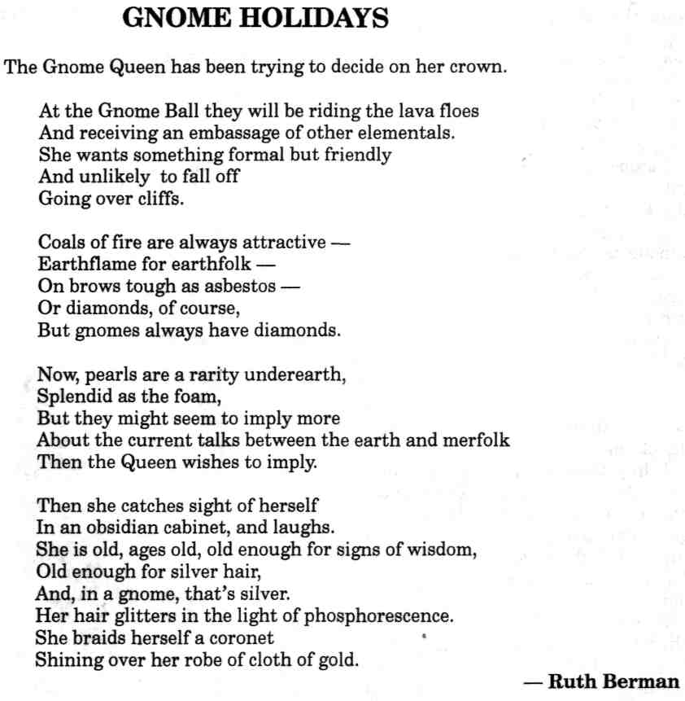
DEATH COMES IN THE WINDOW

by Chris Presta-Valachovic
Death is a wonderful bed-partner, all bony and white, and she doesn't snore. Her bones do poke from time to time, and her fingertips can be scratchy, but I'm used to that now — uppity women like me can get used to anything, once we realize the benefits. I just wish she'd quit whispering all those names at me and let me get some sleep.
It happened one night a while ago. I was lying in my queen-size waterbed, alone as usual and curled up in the scratchy cotton sheets, and staring up at my ceiling, which I'd painted black and covered with those cheap glow-in-the-dark plastic stars. It was a hot night, and I was sweating to soak the sheets. The window was wide open, but it didn't do any good — no fan in that window, not in my basement apartment. Living in this neighborhood means that one has to forego such comforts, if you want to wake up in the morning and find your fan still there and your screen unslashed.
'Course, it's stupid leave a window open to begin with, but I'm not one to be consistent, and I was too hot. Besides, after living in this neighborhood this long, there's nothing that could come in that window that I can't handle, and my neighbors sidestep me wide every morning because of it.
So I lay there, window wide open for the non-existent breeze and I could hear the regular police sirens, gunshots and yelling outside, down the street and next block over from the sound of it. But then I heard a different noise, scratching against the mesh of my window screen, and I turned my head towards my window, thinking someone's being really stupid to bust in here when I'm right there watching.
But then I stared at the window, for once surprised. The gleaming bony figure of Death crouched outside my window, its skeletal hands scratching at my window screen, to slash it open and get in. It peered in with shadows filling the eye-holes in its skull, as if it couldn't see in clearly — no surprise there. Despite the glow-in-the-dark cheapies on the ceiling, despite the full moon outside, my bedroom's in the shadow of the biggest stack of condemned bricks in the city, just across the alley.
I decided to let Bony know I was here, anyway. Perhaps then it'd run away and let me get back
Death is a wonderful bed-partner, all bony and white, and she doesn't snore. Her bones do poke from time to time, and her fingertips can be scratchy, but I'm used to that now — uppity women like me can get used to anything, once we realize the benefits. I just wish she'd quit whispering all those names at me and let me get some sleep.
It happened one night a while ago. I was lying in my queen-size waterbed, alone as usual and curled up in the scratchy cotton sheets, and staring up at my ceiling, which I'd painted black and covered with those cheap glow-in-the-dark plastic stars. It was a hot night, and I was sweating to soak the sheets. The window was wide open, but it didn't do any good — no fan in that window, not in my basement apartment. Living in this neighborhood means that one has to forego such comforts, if you want to wake up in the morning and find your fan still there and your screen unslashed.
'Course, it's stupid leave a window open to begin with, but I'm not one to be consistent, and I was too hot. Besides, after living in this neighborhood this long, there's nothing that could come in that window that I can't handle, and my neighbors sidestep me wide every morning because of it.
So I lay there, window wide open for the non-existent breeze and I could hear the regular police sirens, gunshots and yelling outside, down the street and next block over from the sound of it. But then I heard a different noise, scratching against the mesh of my window screen, and I turned my head towards my window, thinking someone's being really stupid to bust in here when I'm right there watching.
But then I stared at the window, for once surprised. The gleaming bony figure of Death crouched outside my window, its skeletal hands scratching at my window screen, to slash it open and get in. It peered in with shadows filling the eye-holes in its skull, as if it couldn't see in clearly — no surprise there. Despite the glow-in-the-dark cheapies on the ceiling, despite the full moon outside, my bedroom's in the shadow of the biggest stack of condemned bricks in the city, just across the alley.
I decided to let Bony know I was here, anyway. Perhaps then it'd run away and let me get back to trying to sleep. "What do you want, Bony?"
It actually jumped, all of its bones flying apart, then rattling back together. I could've sworn that skull-face looked sheepish, but I guess it had to save what was left of its face, for it gathered itself up and boomed out, in a hollow, echoing voice, "I've come for David!"
"Pipe down," I said. "No need to shout. I'm right here."
Naturally, it ignored me. "David!"
David's the drug-dealer next door, and I was thinking that if Bony offed David, then I'd be up all night from the noise of gunfire, sirens and agitated neighbors right outside my window. "There's no David here."
It peered in at me again. I could've sworn the shadowy eye-pits squinted. "Uh ... Timothy?"
Oh, lord. Was it after me, then? But then again, Timothy was the block's meanest pimp, so maybe Death was just confused. But if Timothy bought it, I'd be walking to work through gang-fighting every morning, as all the young hoods scrambled to take over Timothy's sorry stable. "Nope. No one like that here, either."
"Joshua?"
No doubt about it. That bony face was peering at me and its eye sockets were squinted in puzzlement. So Bony wanted me, eh? Tough — I didn't want to go. But Josh was the local sneak thief. If he went instead of me, I'd have to bribe someone new to leave my apartment alone. I was getting tired of this. At this rate, I'd never get any sleep.
So I stalked over to the window and popped the screen out of the frame. Bony jumped, rattling in shock, but before it could do anything else, I'd snatched out to grab its neck vertebrae and squeezed those dry old bones, hard, and they froze my hands and turned my arms to icy lumps. I couldn't hold on too long; I had to end this quick.
Those shadowy eye-pits got just a touch bigger as Bony saw my body, my skin gleaming in the faint light of the moon shining over top of the condemned bricks. Its mouth gaped open in a bony, triumphant grin. "Marsha!"
Why the names? I thought fast and hard. Maybe if Death didn't know your name, it couldn't take you. It was worth a shot. "Nope," I said cheerfully. "Not even close."
Ever see bones deflate? "Jan? Marilyn? Sojourner?" When I went on grinning back, it looked desperate. "Don't suppose you'd give me a hint?"
"Nope," I said, sure of myself now. "You gotta get it right. That's the rules."
"You could come with me anyway," it said seductively. "I'll take you for a wild ride on a midnight stallion across the stars and we can skim the mountains and dance in the sky with the stars lighting our feet...."
I knew a come-on line when I heard one. "Sorry," I said. "I like it here."
"Here?" Despite my grip on its neck, Bony gestured, taking in the slums, gunfire, endless sirens and sweating heat.
"It's not much," I agreed, "but it beats the alternative."
"I'm the alternative!" Bony sounded offended. Now that I looked, those bones did look handsome, gleaming white and hard in the moonlight, and Bony was only doing its job. No need to offend it, after all. "It's just an old saying. You are kinda pretty."
"You must come with me," Bony said.
Whatever was left of a brain in that dead skull was surely one-track and stubborn. "Sorry. But you know the rules. You don't know, I don't
go."
"But I must take someone tonight!" There was a touch of whine in that hollow voice.
"So why mess around here?" This time it was my gesture that took in the slums and sirens. "Lots of other folks around that are long past their time. Why not take the Pope? Or Dick Clark? Or Dennis Hopper?" At least then we might have a shot at getting a decent movie villain in Hollywood, but I didn't say that out loud.
"I'm just a minor-league Death," Bony said. "I'm not allowed to handle the big cases yet."
"There's more than one Death?" "Of course." The way Bony said that, I felt ashamed for not thinking of it sooner. Of course, not thinking right now was the definite wrong way to go.
"City hospital's two streets over," I said. "Lots of folks there would love to go with you and bless you for your mercy."
"I'm not allowed mercy yet, either," Death said, in a small, whispery voice. "I've got eons before I work up to that level."
Feeling sorry for Death has got to be the weirdest shivery feeling in the world. But I did anyhow; it would give my neighbors a new reason to sidestep me. "Brother, you are between a rock and a hard place," I said sympathetically.
Those shadowy eye-pits narrowed just a touch. "Brother?"
Perhaps the moon gleamed brighter, perhaps the street light around the corner had decided to work for a change, but the light was now enough for me to get a real good look at the Death I gripped by the neckbones. Now I saw the curving cup of the pelvic bones and the wide-set hip bones and the long silvery hair clinging to its skull. "Sister," I said then, and made it sound apologetic.
"Then you'll let me take you?" She sounded as if she mistook my sympathy and apology for giving in.
"Not a chance," I said. "You ain't said my name yet."
Those bones deflated again. "Then let me go. I will report my failure to the One In Charge. She won't be happy with me this night." She sighed in a whispery shiver. "Again."
But I was looking around at my sweaty apartment, at my fan hidden in the corner instead of up in the useful window, and, more importantly, at my huge empty bed. Then I was looking at Death and her nicely curved bones and silky silver hair, and I started laughing as the idea came together in my head. I leaned over and whispered it to Sister Death, right into the holes in her skull where her ears should've been, and soon, she was laughing, too, her whispery chuckle shivering over my hearty giggling. Then I let my grip on her neckbones go, and she took my fleshy hand in her bony one.
Now I don't sleep alone, and there's a nice cool breeze blowing in my window from my fan each night. Almost every night, some fool tries to steal our breeze, but my sister Death takes care of that.
So each night, her quota is met, and the One In Charge has spoken of a promotion soon. My sister is now a happy Death, and we've gone for a couple of those wild rides on a midnight stallion, and I've shown her the pleasures of dancing to thumping disco in an crowded club. It's been a wonderful affair.
But each night, as the moon shines down on our bed and I'm settling down to sleep, she whispers a long string of names into my ear. Every night, I spend at least a couple hours saying "no, nope, not even close."
I don't think I'll be ready to say "yes" for a good long while. Q
GRAND GUIGNOL
by Andy Duncan

illustrated by Allen Koszowski
1. Max
Charles is my friend, my brother, my right arm, my most valued assistant, my comrade in glory and trial since before the Armistice, and to say anything against him is almost more than I can bear—but today he brought me a sack of eyeballs of which, before God, not one was usable. Stress? Love? Syphilis? Who can say? I am saddened beyond speculation.
The instant I hefted the sack, I knew. A director senses these things. Yet to appease Charles, I dutifully held each eyeball, rolled it in my fingers, inspected it, flung it to the floor. Not one bounced — not one! Smack, smack, smack, like so many eggs. They surrounded my desk, gazing up at my shame.
The climax of A Crime in the Madhouse is so sublime, and to cut corners would be ruinous! The crones cackle . . . the victim shrieks and writhes, her arms pinned... the knitting needles flash . . . first one eyeball, then the other, is ripped free ... they fall to the stage and bounce, roll, toward the edge, toward the front row. Ah! what a spectacle with which to launch our 1925 season! But if the eyeballs just plop, plop, like clots of pate from a drunkard's cracker — Is this what our patrons demand, deserve? Is this theatre? All this I pointed out to Charles, to no avail.
"Max, be reasonable. You send me for eyeballs, I bring you eyeballs. I bring you three score eyeballs at a good price, from the taxidermist in the rue Duperer. If we keep them on ice, we have enough to last for weeks, we have one less thing to worry about. Do you know, Max, how badly we need one less thing to worry about?"
"I have only one thing to worry about, Charles, and that is my art. I pay you a salary greater than the premier pays Marshal Petain to worry about everything except my art, and how do you repay me?"
"Max —"
"You kick me, you spit upon me!"
"Max —"
"You smear me with offal!"
"Max, you are a melodrama with no audience and a cast of one!"
Finally, of course, we embraced, we wept, we kissed like brothers, the stagehands outside the door applauded, and Charles did as he should have done before: He set out for the slaughterers in the Bois de Bologne. I have high hopes. For The Garden of Torture and The Castle of Slow Death, they provided commendable eyeballs, outstanding in every respect. Also, once, a truly remarkable liver.
But I still feel all is not well with Charles. Perhaps I will consult Dr. Binet when he calls this afternoon with the latest progress report on the sanity of our resident genius. How I wish he could persuade Andre to return to the theatre, to come in out of the damp! I am weary of transacting business with my star playwright in a cemetery. Pages blow away before we have revised them, surly mourners rout us from tomb to tomb, and Andre is so easily distracted by the play of light on marble, by the wink of a cherub. In my hour of need, all my comrades go mad! Did Aeschylus suffer so?
2. Andre
I am at home in this city of the dead. I stand on the hilltop and see all around me the spires, the turrets, the battlements of these silent narrow houses, grouped by gravel paths into thickets of gray. I press my palms against their cool gates and peer through the frosted glass at the flowers huddled into slender vases, at the precarious shrines stacked within. No balconied block on the Isle de St. Louis is more noble than these apartments of bronze and stone.
One tomb reminds me of Max's theatre. It is surrounded by a stone deck like a stage, and its angels are large and ridiculous. I sit here and eat my lunch, a cheese quiche and a lemon pastry bought from a cart propelled by a woman in crepe. I alternate bites of citrus and onion and wonder how rehearsals are going, and then I berate myself for wondering. Max will squat upon the stage and deposit his usual pile of miracles, and the patrons will stumble away fulfilled. Dr. Binet is right to tell me to stay away from that fetid little theatre in the rue Chaptal. He is acting as my amanuensis, delivering to Max the pages of my next play as they are completed. It is an adaptation of de Maupassant's "The Maker of Monsters," which will tax the company's skill with stage deformities. But they may make of it what they will; I no longer care. The true production is the one I envision alone, here in the center of Pere Lachaise. I have no actors to stable, no turnstiles to crank, no boulevardiers to appease. When I am done writing, the play is over.
3. Charles
While she is onstage, being strangled to death, I am in her dressing room, laying down a bouquet.
Or attempting to. Where to leave it? Like all the dressing rooms, this is little more than a closet, a vertical stall. The vanity is a jumble of overturned bottles, opened jars, and wadded handkerchiefs, every surface tacky with lipstick, rouge, and greasepaint. The two chairs are swaddled with layers of evil-smelling costumes, sleeves and bloomers all entwined. The lamp is wearing, at a flirtatious angle, a wig clotted with gore.
Finally I open the shallow drawer of the vanity, insert the clump of stems, and close the drawer so that the blooms jut out horizontally, sagging like broken fingers. It will have to do. I dare not be seen. Max would flay me alive, as in the climax of The Horrible Experiment. "Fraternizing with the enemy!" he would trumpet. Max suspects all actors of ongoing subversion, of plotting to overthrow their divinely appointed producer-director and launch another Commune. He suspects even the company's brightest light, its Bernhardt — Sonia Morel, glorious Sonia, beautiful Sonia, whose closet this is, who has been killed on our stage more than 10,000 times. I keep the books, and I know.
4. Binet
I did not know at first that Andre de Lorde was a playwright. At the time, I knew little of theatre, though I found it prudent several times a season to go on display in my box at the Opera. Andre was a patient of my embarrassingly earnest colleague Dr. Metenier, who would have had a prominent career had he not squandered so much of his time on patients. Metenier called the case the most absolute death fixation in his experience and, in despair, sent Andre to me. In our first consultation, I saw that Andre would never be cured. He enjoyed the process of analysis too much. He perched on the edge of his chair like an excited child, eyes wide behind his spectacles, and gazed raptly at me as if I were the only visible object in the room. Later I saw this expression on the faces of actors standing in the dark awaiting their cue. He showed a rude lack of interest in the framed certificates and testimonials all around, however prominent and well-lighted. I waited, with steepled fingers, until the silence became unprofitable. Then I sighed and took up my pen.
"Let us suppose, Monsieur de Lorde, that you have a free afternoon in Paris. It is a lovely spring day. What would you do to pass the time? Where would you go?"
"Oh, any of several places, Doctor. Let's see. Well, recently I have been spending much of my spare time in the Place de la Nation."
"Could you be more specific? Do you shop, stroll, do you feed the birds?"
"I walk about, and I think about the guillotines."
"Pardon?"
"The guillotines. That plaza was the site of most of the executions during the Terror."
"Yes, but the Terror was a long time ago."
"I know, Doctor, but—well, while I'm walking, I try to imagine what it must have been like. Oh, I have seen executions in our modern day. I have accompanied my friend Max, who once worked for the police commissioner. But today only vile criminals are executed, and the atmosphere is so ... sterile. Like the removal of a gangrenous limb in an operating room. Do you follow?"
"I'm not sure, Monsieur de Lorde."
"You may call me Andre."
I simulated gratitude. "Andre. Thank you. Please continue. The atmosphere, you say, is sterile?"
"Not so much sterile, I suppose, as . . . drab. The bureaucrats in their dusty grey suits, the mumbling priest, the journalists smoking and doodling rude pictures in their notebooks. Everyone, even the condemned man, looks bored, going through the motions, ready for everything to be over. There's not even as much blood as one would expect. The very arteries seem . . . inhibited."
"And this differs from the Terror?"
"Oh, yes! As the name implies. The prisoners went screaming to the stocks, and a thousand throats cheered each spurt of crimson. The Old Regime was a Hydra, and its coils spasmed for months after the first head had been severed. Each execution was a separate pageant, unlike any before or since."
"What an imagination! You envision all this, walking there with your hat and cane, with the newsboys yelling and the traffic roaring past?"
Andre smiled and shrugged. "Yes, it is silly, but I confess it. Call me a sentimentalist."
"Do you call yourself a sentimentalist?"
"No. Do you know what I read just this week, doctor? I read that puppeteers waited beside the guillotines to drag the corpses across the plaza to small stages made of pushed-together cheese crates. There they performed impromptu satiric plays, working the bodies like life-sized puppets." He sprang to his feet and stuck out both elbows, letting his forearms dangle, and did a loping dance about my office. His head flopped about as if his neck had, indeed, been severed. " 'Here is the merry Marquis, dancing at the ball!' Oh, how the crowd laughed."
I clapped slowly, forcefully, holding my arms aloft as if I were at the Opera. "You are most vivid and convincing, Andre. You should go on the stage."
His face fell, and he sat down heavily. "Acting? Pfagh! I am no actor." His tone reeked of contempt.
"Forgive me. I meant no offense. What is your profession, Andre?"
"I am a playwright." He leaned forward, fixing me with a Jacobean stare. "And I am looking, Dr. Binet, for a collaborator."
Thus it began. I provided Andre with case studies of the wretches I have treated in the lunatic asylums of France, and he turned their madness into melodrama. And so the brilliant Dr. Michael Binet, director of the Psychological-Physiological Laboratory of the Sorbonne, became a technical adviser to a back-alley theatre in Montmartre, the Grand Guignol.
Andre de Lorde, a fevered scribbler, saw his name in lights, while I saw my name on the back of the program, listed in small type with the milliners who designed the hats and the slaughterers who filled the buckets with grue.
I allowed my resentment to grow, swell, fester.
And now, thanks to Andre's unfortunate turn for the worse, I may at last claim a share of the credit I have so long deserved.
5. Sonia
I could be at the Theatre Antoine, the Odeon, the Gymnase, the Vaudeville, the Ambigu, even the Comedie Francaise. Why not? I could be playing Portia, Roxanne, Antigone. But no, I am throttled nightly by a bellowing, beery lout on a stage smaller than Max's bed.
"You witch! You strumpet! You will never leave me again!"
"Paul! What are you doing with that wire? Keep away from me! Keep away!"
"You left our baby to die, you slut!"
"Paul, no! No! —Aieeeeeeyeeeeeee!"
"Die! Die!"
"Auggggghhhhgugghhhhhh!"
"That blood is coming out very nicely, very nicely indeed." Max's voice in the dark is as bodiless and satisfied as God's. Near the back row, his cigarette glows.
"Eugenie used a bit more glycerin in the mix tonight, Max. Wait till you see how well it clots."
"Thank you, Camille, I look forward to it. Sonia, my dear, could you thrash your downstage leg a bit more? The front row will demand refunds en masse if they don't feel endangered. That's better. Your grimace, Octave, is much improved. You have studied the gargoyles as I suggested, yes? Yes. Can we hear that scrap of dialogue again? Let's return to — where should we resume, Camille?"
"Um, 'You left our baby to die, you slut.'?"
"Yes! From there, please, Octave."
"You left our baby to die, you — Auggggghhhhgugghhhhhh!"
"Octave. That's Sonia's line."
Octave crumpled, hands jammed into his groin.
"And you'll get another one just like it," I shouted, "if you ever again try to grope me onstage, you bastard!" I slung the prop wire into the wings, beribboning the curtains with blood. Octave whimpered.
"Sonia, my dear, our company is small and our resources limited. I must urge you not to kill any of your fellow performers until the season is over."
"Max, my dear, you are a miserable piece of shit!" I strode into the wings, shouldering aside poor little Eugenie, who cowered behind her cauldron of blood. I entered my dressing room, slammed the door, and righted the vanity mirror. I made fists and bounced on the balls of my feet. I bared my teeth like an ape, screwed shut my eyes, strained all my muscles, and hummed my rage.
Why do I stay? Max believes for love of art; the company believes for love of Max. Love! I love neither as much as I would love a role that did not require me to be strangled or boiled or gutted like a fish twice each evening plus matinees.
Most of all I would love a dressing room in which I could actually pace, large enough for me to admit more than one admirer at a time. One night King Carol of Rumania and his mistress, Mademoiselle Lupesco, came backstage to offer their compliments on my performance in The Merchant of Corpses.
Deposed monarchs require even larger retinues than active ones — their fiefdoms are rented suites and the lackeys who fill them — and so three rows of the theatre emptied to follow His Majesty and the mademoiselle into the dim and grimy corridors. I was forced to receive them in the passageway! Mademoiselle Lupesco could not precede the king into any room, and the king could not enter a woman's dressing chamber without a chaperone — as if I had space and air enough for a tryst! If His Majesty could maneuver that expertly, he would not be in exile. Even intimacy is too ambitious in this snuffbox.
I have given up on Max. At the theatre, his response is always the same. "What more will you demand of me?" he moans. He flings his hands outward, palms up, as if to receive the nails. "Are you not already renowned? Do you know what the newspapers call you? The High Priestess of the Temple of Horror!" As if this is a compliment. Away from the theatre, at his flat or at mine, Max has a different stock response, one more enjoyably physical, but it leaves my situation equally unresolved.
Here are more flowers. From Charles, no doubt. Poor Charles. He thinks his infatuation is so well hidden. He is as flamboyant, in his quiet way, as Max: He wants the drama of being a secret admirer. I am tempted to encourage him a little, but at this point in my life I need something more tangible than mute longing. Perhaps, indeed, something more than Max. I have told no one my vow: If I don't get a good notice from a serious reviewer this season, I will quit the company — and Max as well, ululate though he will.
In the meantime, I am at least learning new aspects of my craft. Eugenie is teaching me some of her more elaborate makeup tricks. The child really is talented. If I ever get to play Cordelia, I can also act as technical adviser to whoever gouges out Gloucester's eyeballs. "More bounce! More bounce!"
I will not become hysterical.
6. Eugenie
Some nights Charles and I are the only ones left in the building, and he is kind enough to walk me home. I always finish my work first; Max leaves him quite a list. I push open the thick oak doors to the theatre proper — I have to lean with my whole body to budge them — and I sit in the middle, toward the back, where Max sits during rehearsals. I sit in the dark and wait for the outlines of the stage, the seats, the beams in the ceiling to appear, to resolve themselves into outlines of black and grey.
It is a curious thing. When I am not in my apartment, I have difficulty remembering what it looks like, even where it is. I keep the address pinned to the inside of my sleeve, on a folded scrap of butcher's paper, just in case. But I can always summon every pulley, every lamp, every alcove in this theatre. I don't need light to study their details. I asked Max once whether I simply could move my few belongings into the theatre, into the garret above the balcony, but he made popping noises and fluttered his hands and said it would not be proper. Surely he knows that I virtually live here already. I certainly live nowhere else. If I were able to sit here in the dark long enough, if there were enough hours in the night, I'm sure I eventually would be able to see not only the broad strokes of my surroundings, but the most minute flourishes carved into the farthest corner of the ceiling. It is all a matter of concentration, and at the same time of relaxing so that the images come to you, rather than straining yourself to meet them halfway. One night, as the theatre formed around me, one swatch of darkness became the shape of a man, and I recognized the spectacles of Monsieur de Lorde. He was sitting in the next row, facing the stage.
"They say no place on Earth is quite as dark as a darkened theatre," he said. "This frightens many people, Eugenie. Not you?"
"No, monsieur." I could not recall his addressing me before.
"That's good. Because at this time of night, in a darkened theatre, one can hear the most remarkable things, if one is open to hearing them. Did you know, Eugenie, that this building was once a convent?"
"Yes, monsieur. Charles — I mean, Monsieur Goudron—told me it had been gutted during the Terror. This hall used to be the chapel, and that's why angels are carved into the ceiling."
"Monsieur Goudron — I mean, Charles — is quite correct. I would share with you another part of that history, Eugenie, but I fear it would mean your following me upstairs, into the balcony. Upon my honor," he added, raising his hand, "I mean you no harm, and I will maintain my distance."
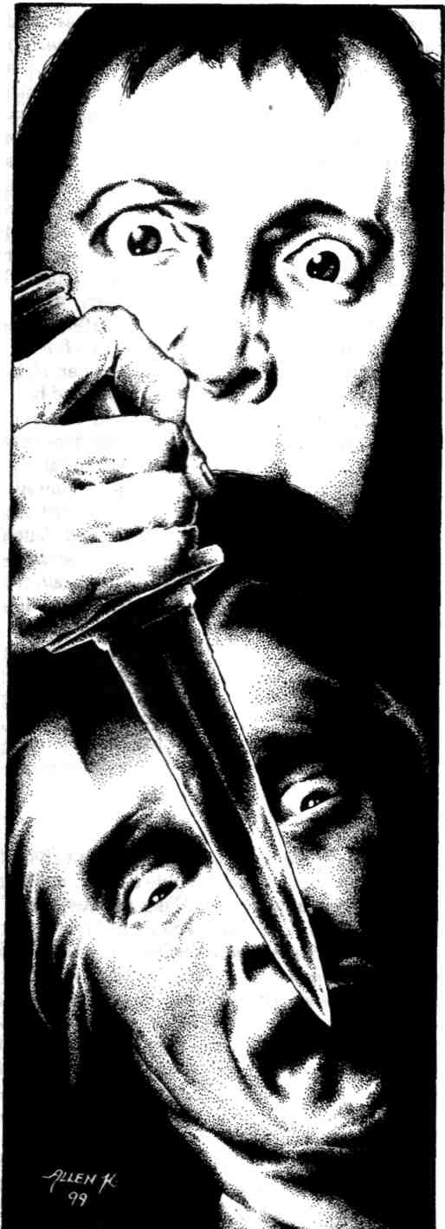
I was sure he could feel the warmth of my embarrassment even if he could not see its color. "Oh, I do not doubt you, Monsieur! I will follow you." We climbed the narrow stairs, which spiral up a chimneylike brick shaft. The darkness of the balcony was, if anything, more absolute than that below. Monsieur de Lorde sat, and so did I, at a proper distance of several feet. For many minutes we said nothing, only sat and looked at the oblong space above the stage. I believe that before I actually heard the murmuring, I felt it in my neck and arms, which prickled as if charged with electricity. The burbling was as faint as a trickle of water within the walls during a rainstorm, but there was no rain this night. The sounds had the tone and timbre of human speech, but the words, if words they were, were inaudible. I thought of Charles's mumblings as he tallied figures in Max's ledger.

"What is that sound, Monsieur?"
"This was their convent, and they are still here, still praying for us all." Monsieur de Lorde's voice was hushed. "Even during the uproar of performances, while this balcony is jammed with patrons, I can sit in this spot and hear the sisters. The terror continues, and so do the prayers."
Far from being frightened, I felt oddly consoled, as one feels when hearing a distant train. I was smiling when the lights came on. Charles was standing at the switch-box just inside the doorway below.
"There you are, Eugenie! Hello, Andre. My, you are a fine pair. Claiming your seats early for this weekend's show?" He laughed and swept a shock of hair out of his face. "Keep sitting up there in the dark like that," he said, "and you'll both be seeing things."
The murmuring had become so muted that my breathing drowned it out, but it continued, soft and frolicsome inside my ears.

7. Max
I marvel that I can go on. Dr. Binet tells me that poor Andre no longer is well enough to see any of his friends, that he wanders the cemetery like a spectre, hardly eating, and — worst of all! — unable to write. Binet has been kind enough to pass me drafts of a play he himself is writing, The Maker of Monsters. Everyone is a playwright. Soon the concierges and streetcar drivers will be handing me scripts as well. Why does no one aspire to be a director? Because they watch me, study the terrible example that is my life, and they learn. Oh, the struggle!
Octave has left the company. He said terrible things — bloodcurdling things! — about Sonia. I could not bear it. Only three days before we open, we have no one to play Paul le Hirec, the insane sculptor who strangles his cruel and faithless wife in The Dead Child. Would that I were a dramaturge of ancient Greece, able to recast a play with a shuffling of masks! Would that I were in any other theatre, in any other age, than in this Sisyphean ordeal that occupies me now. Will the very slopes of Montmartre yawn wide to swallow us on opening night? I would not be surprised. The gods are against my endeavor. In the perfection of my art, I have angered the gods.
On the other hand, Charles could play the role. Excellent. It is decided. I will hand him the script today, and Sonia will rehearse with him tonight — all night, if necessary! Perhaps at her flat, where they will have some privacy. Charles will make the usual excuses, but I will not be swayed.
8. Charles
I woke sweating, naked and disoriented in a close and sultry bedchamber, sheets tangled about my legs. I sat up, startled, felt my stomach lurch, and lay down again, breathing deeply with my eyes closed. The sheets I lay upon were soothing, damp and cool, and I focused on the thin intersection of flesh and fabric, enjoying the contours of my body. I returned to the borderland between waking and sleeping, and wraiths of the evening before coiled around me. My body remembered before my mind how my night had been spent: a soreness in my upper arms and shoulder blades, an unusual coarseness in the play of my tongue along my palate, a detached numbness in my twitching penis. Eventually the room reshaped itself around the absent figure of Sonia, and then I remembered all, and smiled. I sat up, slowly this time, waited a few seconds for my dizziness to pass, and padded unclothed to the doorway, where I looked across the sunny common room of a top-floor flat. At the far wall stood Sonia, with her back to me, bent over a countertop, intent on some project that she blocked with her body. She wore an abundant purple gown as generous as the matted sheets I had left behind; its drape revealed one bare shoulder. Her russet hair, streaked with grey, roamed long and loose; if I walked up behind and clasped her, her hair would enfold me down to my thighs. I moved softly across the room, my memory of the bedroom hours narrowing and intensifying this daytime moment, and just as I reached for her, she turned and smiled and held up her right forearm, to show that where her hand had been was a jagged, bleeding stump, flesh tattered, bone splintered and shining in the morning light. I screamed and lunged backward, falling, bruising my lower back as I hit the windowsill. I twisted and leaned out over the boulevard, my arms numb as I shuddered and heaved. Then her arms were around me, and her hands — both hands! — were caressing my forehead, my cheeks, my chin, and Sonia was saying: "It's makeup, that's all it is, one of Eugenie's tricks, she's been teaching me, I'm sorry, I'm so sorry, what was I thinking, I'm fine, Sonia's fine ..." I slowly hauled myself into the room, leaving damp handprints in the grime of the windowsill, and sank to the floor, sobbing into her shoulder, my erection wedged between us like a lever.
9. Andre
Eugenie came to see me today. She found me leaning against Oscar Wilde's tomb, making notes toward an article on "Fear in Literature." The sunlight becomes her. I could not recall ever seeing her before outside the walls of the Grand Guignol. I was amazed but delighted to see her small, pale head cresting the hill, a breeze lifting what hair she has left. Why do young women crop their tresses so? I pocketed my notes on Poe and Baudelaire, stood, removed my hat and bowed from the waist not once, but twice. "Good afternoon, Mademoiselle," I said. "I trust you are well?"
The enthusiasm of my greeting flustered her and disconcerted me. Before I could make amends, she thrust at me a package wrapped in brown paper.
"I hope you will not think me forward, Monsieur de Lorde, but please accept this gift from your friends in the rue Chaptal."
I could think of nothing to say, so I bowed again, took the package and gestured her onto a bench. I gently shook the package as I sat beside her.
"I am surprised that Max has time for such gestures, in the final week of dress rehearsals." I slit the adhesive with a fingernail and began unfolding the paper.
"Monsieur, I must confess, Max knows nothing of this. I was building some props, and this one — well, this one turned out so fine that I felt I should present it to someone." I smoothed out the paper, revealing an ornate dagger of Chinese design.
"It is lovely," I said. "Fake, I hope?"
"Oh, yes, Monsieur, and with the usual spring blade." She slid the dagger gently from my lap, raised it above her head and, with surprising force, drove it to the hilt into her forearm. Then she lifted it slowly, allowing the dull and retractable blade to slip back out of the hilt that had concealed it. The illusion was flawless, as always.
"Wonderful," I said as she gravely handed back the weapon.
"The dagger is not loaded, Monsieur; I did not want to risk fouling your clothes. But here in the hilt is the reservoir that holds the blood — as much as a pint."
"Such craftsmanship. Dr. Binet will be impressed, as well. I will show it to him when he next visits."
"Oh, Monsieur, I beg you, don't tell Dr. Binet I was here! He will be at our opening Friday night, and he will be so angry."
"Hm? Angry? Whatever are you talking about, child?"
"Dr. Binet said that none of us were to contact you under any circumstances. He said your — your treatment required complete isolation. 'A break with his theatrical past,' he called it."
"How extraordinary!" I stood and walked a few deliberate paces on the gravel, like a lone duellist. "What, then, has Binet been doing with the manuscript of our latest collaboration? The adaptation of the de Maupassant story, about the awful woman who turns her babies into monsters? Is it locked away in a lab at the Sorbonne? Has he not been passing the pages to Max as they are completed?"
Eugenie frowned. "Collaboration, Monsieur? Dr. Binet has brought Max such a manuscript, yes, but he says it is his own work. He says your illness prevents you from writing. Oh, I have said too much!" she said, standing. "I have upset you, Monsieur. You are all a-quiver, like the doctor at the climax of The Kiss of Blood. Please forgive me. I have spoken out of turn."
"Not at all, Eugenie, not at all!" I mopped my face with my handkerchief and took deep breaths, calming myself so as not to frighten the girl. "I thank you so much for the gift, Eugenie, and for visiting me today. I wonder, could I ask you to bring me one thing more?"
"Of course, Monsieur."
I held the dagger before me. "Might I have some blood with which to load this?"
10. Sonia
Opening night. My God, what next? Max and I were preparing ourselves in our usual superstitious way, perhaps indiscreetly, behind some balsa-wood trees backstage. I looked up, and there was Charles, pale and staring. I was going to have a conversation with him anyway — after what happened at my flat the other night — Oh! the folly! What was I thinking? — but I didn't want him to find out like this. And now, five minutes before the curtain, Charles is pacing and mumbling and rolling his eyes, ignoring all my entreaties and explanations. A frightening display. The stagehands think he is merely preparing for his role, but I wonder whether he will make it through the performance. I wonder whether I will.
11. Georges Choisy, On Theatre
A DARING NEW REALISM AT THE GRAND GUIGNOL
(The World, final edition, 9/21/25) In recent months, much of the dramatic press in this most dramatic of cities has been devoted to new trends toward realism on our stages. We have seen a decided shift in dialogue this season, for example, from witty bourgeois repartee to rough, often crude, street argot, sometimes with electrifying results. No recent evening of realistic theatre, however, has so impressed this reviewer as tonight's season premiere at a most unlikely location: that venerable Temple of Horror, the Theatre of the Grand Guignol.
All the more remarkably, this overwhelming impression was made in the final minutes of the night's entertainment. Producer-director Max Mitchinn, with the daring of a master showman, began the evening in routine and traditional fashion: a series of short playlets of horror and broad comedy, including A Crime in the Madhouse, a new ghastliness from the clotted pen of Andre de Lorde. This included a particularly repellent eye-gouging in which the liberated orbs actually bounced into the front row, causing much commotion. So far, nothing to disconcert or surprise the dedicated "Guignolers," who roared and retched with their customary verve.
The climax of the evening, however, was something else entirely. Messieurs Mitchinn and de Lorde have newly shod a war-horse of their repertoire, The Dead Child, the story of a grief-maddened sculptor and his faithless wife. The new production eliminates all the violence but intensifies by many orders of magnitude the emotional power.
After a cataclysmic speech denouncing the perfidy of Woman, the sculptor collapses, howling in wordless grief and rage. Dazed, the wife slowly reaches out to him, holds him, and then her own tears come.
The sight of the devastated couple, the raving sculptor and his penitent wife, sobbing together in the center of the stage, holding each other with taut desperation as if encircling arms could possibly join the shards of their sundered lives, is a sight this reviewer will never forget. Nor, I suspect, will the majority of tonight's audience. The silence was as profound as that of a tomb. Never had the patrons seen such naked emotion laid bare in the theatre. The tatty backdrops, the prompter's box, the elbows rubbing my own to right and left, all dropped away like canvas scenery, and for a few anguished seconds I forgot my situation, and believed I was beholding a heartbreak as real and as wrenching as any I have experienced myself. At the curtain the applause was thunderous. The actors themselves seemed dazed as they emerged for a bow with the rest of the company.
As the sculptor, Charles Goudron made a stunning Paris debut. As the wife, Guignol veteran Sonia Morel, who so often sparkles in otherwise dull vehicles, proved herself worthy of comparison even to the great Bernhardt. One glows at the thought of the life force that Mademoiselle Morel would bring to the role of Antigone!
But the evening's revels were not ended. The lights came up, the patrons stood and rummaged for their belongings, and then the final, ultimate act of realistic drama took place, in the very aisles of the theatre itself, without the reassuring distance of a stage! Two shouting men began grappling with one another in the middle of the seats.
When one of the men drew a dagger, I was at first frightened and tempted to summon the police. Then I was thrilled beyond words to recognize the assailant as none other than Monsieur de Lorde himself, and to realize that this must be a wonderfully satiric climax staged in the midst of the patrons.
This brief playlet ended comically. In true Guignol fashion, de Lorde shouted, "Die, Binet! Die!" and shoved his dagger into the chest of his gibbering partner, spraying a geyser of stage blood. After staring at the protruding hilt that quivered in the bubbling wound, the victim—wonderful reversal of expectations! — seemed to recover instantaneously. He fairly galloped up the aisle, yelling as he went, "Madman! Insane! Help! Help!" I am told the performance continued through the foyer, out the front door, and onto the pavement outside, until the gifted actor — whose name, I regret, was unavailable at press time — had vanished into the promenading crowds of the rue Chaptal...
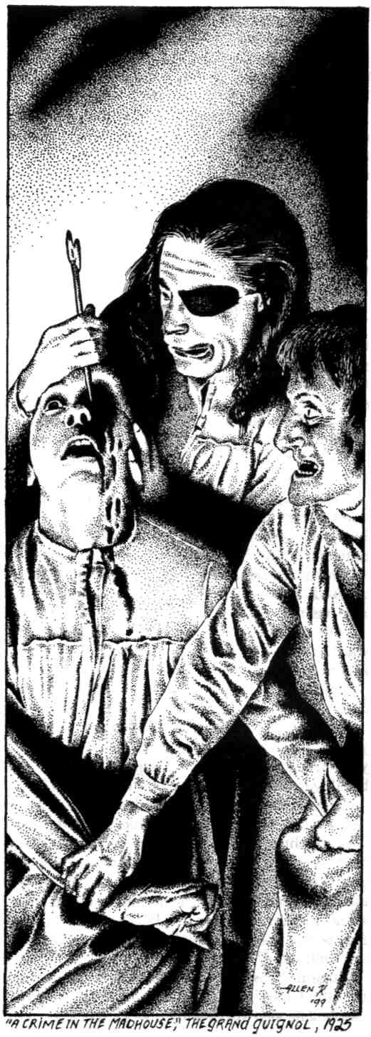
12. Max

Our new season is a triumph. Sonia is radiant, and she and I test repeatedly the capacities of her dressing room. Charles is a matinee idol, standing in the stage door and signing autographs for crowds of adoring young women; a new gaiety fills the blind alley where patrons once stumbled only to vomit. Happily, this tradition continues as well — eleven last night, by Camille's count, a record. When the weather is bad, Andre and Eugenie spend an afternoon in the cemetery, stalking hand in hand among the tombs, visiting all their favorite dead. He and I, meanwhile, are at each other's throats on the staging of The Maker of Monsters, though Eugenie assures us that the plural of the title is not a problem, for she can produce hunchbacked urchins at will. It is like old times.
Late at night, Andre and Eugenie and Sonia and I sit in the balcony, rest from our labours, and bask in the murmur of the nuns. We toast the stage with cocktails of bicarbonate, and we see in the darkness a capering future, awash with
drama and blood. Q
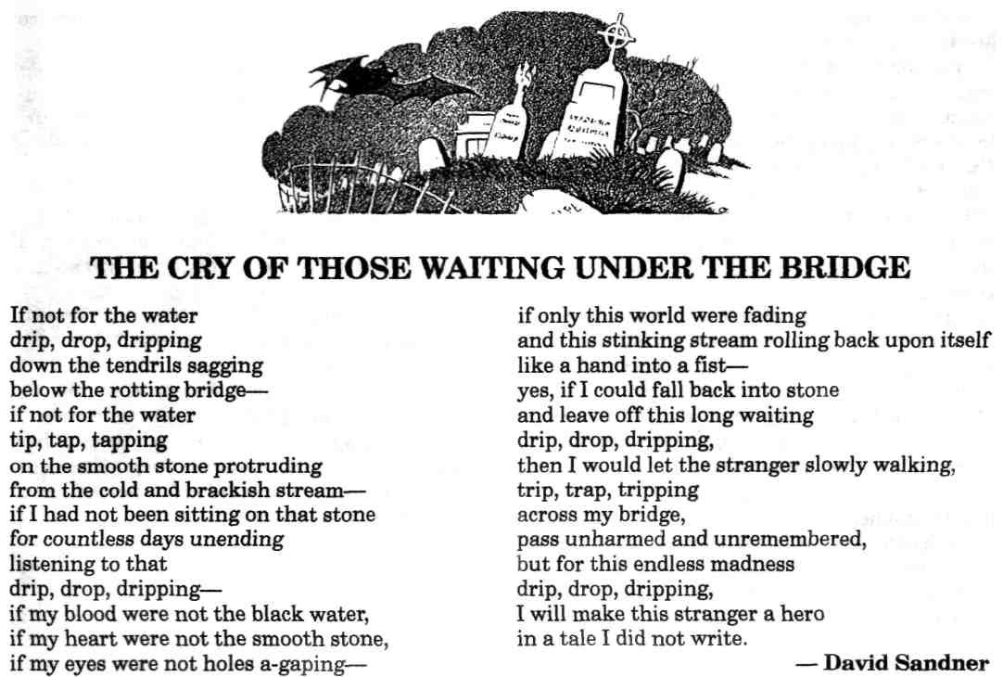
AN IRON BRIDE by Tanith Lee

Illustrated by Tom Simonton
Mirabeau said: "War is the national industry of Prussia." In the eighteenth and
nineteenth centuries, Prussia asked her rich citizens to give up their gold and
jewels to support a war, and rendered in their place, replicas of the ornaments in
iron. These replicas were apparently so exquisite that other countries tried to copy
the method — inadequately. None was as good, it seems, as war-mongering Prussia.
This stern city in the snow, who would think that it could ever be summer here? But once it was.
The lime trees had opened their parasols of aching green, birds flew about the red roofs, and in the gardens there were colored lamps at dusk, and soft music, and laughter. Along the boulevards carriages rattled. The sky was flowered with stars.
It was at the end of this lovely summer that they were to be married, Marten and Klovia. They had to wait a year, as was customary. But they had not minded so very much. Though young, both were possessed of a curious maturity. Meeting each other, they knew, each of them, that they would be together for the rest of their days, and, perhaps, beyond life. It was a love match, strange for their social position and era. They had been very lucky. Good luck always says, Now I am with you, to the ending of the world. And is believed.
Both were remarkable, he handsome and fair, she beautiful and very dark of hair and eyes. In this way, then, descending to some ballroom, he golden in his black clothes, and she crowned by night in her white dress and skin. They were the talk of the city, these two. No one wished them any ill. Sometimes perfection awakens in human beings an innate nobility and spiritual height. Marten and Klovia were like a talisman, like clear weather or a winter festival. Like a promise to everyone, of what might be.
And then there blew through the lavish corridor of summer the coarse trumpet note of war. Some had looked for it, and others, caught up in their own lives, not. The lovers raised their heads and saw, on the horizon, the march of men, banners, and cannon, and the black smoke that follows like a raven.
He held her in his arms. He said, "I'll soon come home. It will have to be an autumn wedding after all." She said, "Kiss me."
In the dark he went away, late in the night, but when the sun rose the next day, it did not rise for her. The light was gone.
Klovia's aunt came to the house of her mother. In the salon they drank tea, and beyond the doors, the charming garden stretched. Klovia did not eat the little cakes, and no one pressed her.
"It's been asked," said the aunt, who had once been beautiful, and now was only cruel.
"But surely —" said the mother.
"No. How can it be wrong to make a sacrifice for one's country?"
Klovia looked at her aunt stilly. In the green shade of the tree through which the sun, meaningless, was shining, the aunt glowed with purpose.
Klovia said, "I'll do it."
"Of course," said the aunt. "There you are. The young are sometimes able to teach us."
Klovia's mother put her hand dubiously to the golden pendant that hung about her own neck.
"Why do they need such things?"
"To pay for this war," said the aunt. "Do you think we should bow to our enemies?"
"But — a necklace —"
"It will be melted down. And look, do you see what's given in return? The badge of patriotism."
The aunt displayed the cruel black claws of her brooch. It was of iron. In return for an ornament of gold and pearls, they had given her an exact iron replica. It was very delicate, like a briar of thorns.
Klovia undid her golden bracelet and took the two filigree golden drops from her ears.
"What else do you have?" asked the aunt.
Klovia's mother said, "Wait —"
"Many things," said Klovia.
"Fetch them," said the aunt imperiously.
As they walked along the boulevard in their slim, pale dresses, the aunt told Klovia of the virtue of what she did. It was the pride of women now to wear iron jewelry, showing they had given their riches for their country.
At a tall white building, they went in, and were treated most respectfully. Klovia placed her casket in the hands of a man who gasped in turn at this and her beauty. She was awarded a receipt written very carefully and stamped with the seal of the city.
Her aunt left her after this, and at home her mother wept over the loss of the jewels as if she had lost her son or husband.
Klovia looked at the bare column of her slender neck, her empty wrists, the white lobes of her ears. She did not know why she had done what she did. That she would be praised for it, faintly, distantly, annoyed her. This was irrelevant.
After a week, the iron jewelry came. It was brought ceremoniously, and the banner of her land nodded in the street as the things were presented. Every item had been faithfully copied.
Klovia set them out, the rings and earrings, bracelets and necklaces and combs. Like the sun, they had grown dark and hard.
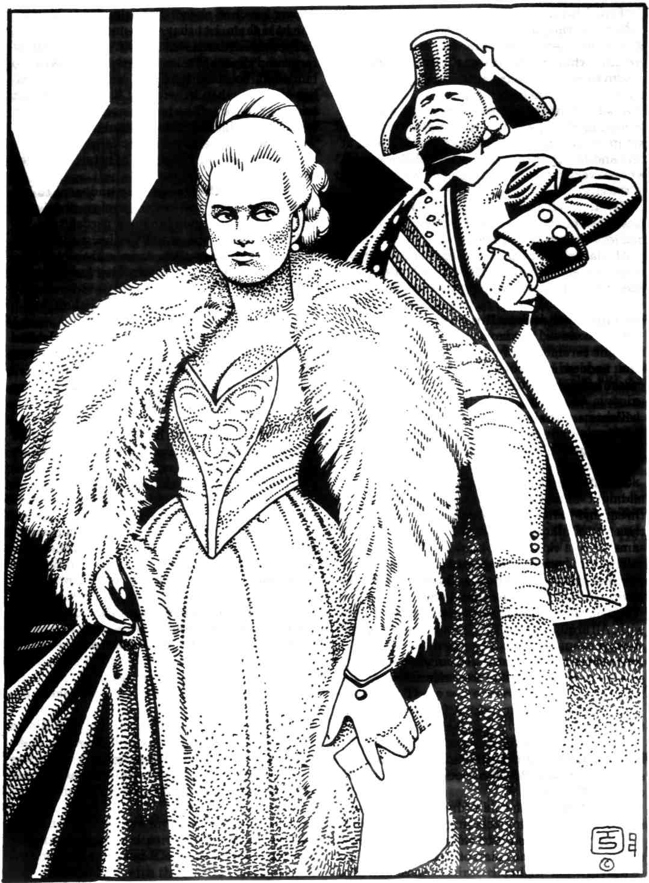
A ball was held. Klovia entered. She wore midnight blue that was nearly black. At her throat and in her ears, delicate black metal, like traceries of ink. And the other women — all the same.

The men were like ghosts, only those the war had spared. Elderly men, invalids, the very young, the blind and halt and lame.
Klovia danced, and did not see who she danced with. All around the bright dresses and black iron jewelry.
On the terrace of the ballroom she looked up, and there was the black iron sky set with diamonds.
An old man said to her, "I fear you find me thirty years too late."
Klovia smiled at him. She realized that one day she too must be old and all things left behind, like shells on a beach. But she thought she would be old with Marten.
She left early. She said to her mother, "Don't ask me to go to such places anymore."
"But, my dear, you'll be talked about. It's our duty to maintain the spirit of the country."
Klovia went to her room and took out of a drawer a pair of gloves that belonged to Marten. She held them, but they were only gloves.
There had been one letter. It was full of repressed misery. She knew he would not write to her often, because there was only horror to tell her of. Even when he wrote of his love for her, it had become part of the horror, as if, by loving her, he had made himself the reasonable prey of war.
It seemed to her she did not exactly miss him or grieve. It was only as if half of herself had been cut away.
She took off the iron jewelry and went to bed and slept, for she was healthy and youthful still. Outside, a nightingale sang in a garden tree.
She dreamed she stood in the garden with Marten, as she had often done, and the nightingale sang on. When she touched her lover's hand, it was cold.
"What does the nightingale say?" she asked.
"That I love you."
But she knew it was no longer so. He had surely ceased to love her, for love had become a piece with the desperate darkness of war.
And when the sun rose in the dream, it was black, with rays like thorns.
After three months, Klovia knew she would never see Marten again. When acquaintances spoke of him, boldly, gladly, to cheer or please her, she smiled politely as she had to the old man at the ball. Marten in turn had became unreal. Perhaps he had never existed, and she and her mother, and all these other people, had simply imagined him. Before her stretched her life, which now had no meaning or interest. She had been trained from childhood, as rich women of her country had always been, to show nothing publicly of her deeper emotions, possibly not really to think of them.
Her gracious fortitude and bravery became a byword of the city. They understood, if she must not, what she had been deprived of.
The summer passed into a russet golden autumn.
There was a tall white church, and here Klovia and her mother and hundreds of others regularly went, to praise God for His grossly imperfect world and His faulty, erratic genius, and to thank Him for any occasional fortune or happiness they might have scavenged.
From this temple Klovia was coming out, when the news was brought to her, in front of five hundred people, on the steps, that Marten had been killed.
Klovia stood quite still in her dark red gown, holding the letter in her gloved hands that had a bracelet of black iron. The captain saluted her and spoke in ringing tones of Marten's courage, and how he had sacrificed his life for the honour of his land.
The crowd stood hushed. The crisp blue air was electric. Klovia nodded, and bowed her head.
"He is a hero," cried the captain. "His name will be remembered for ever."
A strange thing happened to Klovia. For a moment, only that, she could not remember Marten's name at all.
Klovia sat waiting through the autumn. She did not know for what she waited. Perhaps for them to bring her, again, the bad news.
Her mother wept copiously and even the maids in the fine house shed tears over the loss of Marten.
Klovia did not cry. It was as if she did not have the proper mechanism. She wondered if she had ever cried — in childhood certainly. She recalled as a child how her doll was broken — she had cried then. And when a favorite cat died, then too. But now her eyes were as empty as her life.
No one expected her to do anything in the way of social things. It was accepted that she would be reclusive. Only to the church was she still supposed to go, as she was supposed to pray to God, who had presumably permitted the death of Marten in horrible circumstances of blood and maiming, for the care of Marten's soul. She did go to church, but did not pray at all. She closed her eyes and thought of trivial things, that a new button must be sewn on her cuff, that she was thirsty.
However, every day, although no other social obligations were entailed, Klovia must rise and dress, breakfast and lunch and dine, attend her weeping mother, and listen to her mother's curious entreaties that she too, Klovia, should burst into loud sobbing.
"What is wrong with you?" cried Klovia's mother. "Are you unfeeling?"
But Klovia's aunt said, "Don't be foolish. Klovia's grief is assuaged by her pride in him. He died for his country."
Sometimes the war was mentioned. It was going very well.
One morning an important official arrived at the house. He showed Klovia and her mother a complex document with the seal of the city.
Klovia waited politely, looking at his face, and sometimes modestly lowering her eyes. But she did not hear much of what he said. She was thinking that the leaves would be gone from all the garden trees, turning them from gold to black.
"And today, this very evening, it will be brought here."
"It is a great honour," said Klovia's mother. "We are touched. My daughter is very sensible of this kindness."
Klovia raised her eyes, "It is more than I deserve," she said.
The official was gratified. He assured her that her stamina in loss had been an inspiration to the city. He went out.
Klovia's mother was flushed and excited. She exclaimed that she must send a message at once to the aunt.
Klovia said, "It... will come this evening."
"Yes. And a perfect likeness. No one else has been recognized in this way."
Klovia was puzzled. She lowered her eyes now to the complicated paper, and slowly read it. So she learned at last that she was to be given a life-size statue of her lover, Marten, modelled precisely to resemble him, and the face also, for a mould had been taken of this after death. Her city regretted that no valuable material was available because of the war. The statue was made of black iron.
As evening fell, the statue arrived with great circumstance, and was carried into the house and so out into the garden to a suitable site. After a lot had been said, and Klovia had made her thanks, she was left alone to stand beside the iron Marten, staring up into the face that had been constructed from a death-mask, and then its eyelids opened.
Indeed, it did look just like him, handsome and graceful, the high intelligent forehead and strong jaw, the classical mouth and nose, wide eyes, and fall of hair. There was a secretive, smiling look to the face, however, that he had never worn in life. He knew things now that living persons did not.
Night sank down to the grass, and Klovia was summoned into the lamplit house to dress and dine with her mother and aunt, and two or three officials.
After this, in her black necklace and bracelets, Klovia slipped out again, and stood under the trees, looking into the black eyes of Marten. No one tried to dissuade her.
Nevertheless, far into the night, she was called again, to go through the decorum of undressing and lying down in bed.
About two in the morning, she descended through the house and let herself out once more. Once more she stood beside the statue.
The night was cold and crystalline with frost, and no nightingale sang, but Klovia did not think of this. Although when she touched the statue, the cold of it burned her.
It was the same height Marten had been. In the darkness it truly might have been he, except it had no light or warmth. It did not speak or move. It did not think.
Klovia had remained puzzled. She gazed on and on into the black face and eyes, trying to undo the riddle.
In place of her golden lover they had given her an iron bridegroom. What did this mean?
At last she gave it up, stopped considering it at all. She stepped between the statue's arms and stood against it, her hands loose at her sides, looking up even now, as if to receive the pressure of his kiss.
At the hour of arising, no one could find Klovia. They searched through the house and finally went out into the garden. Initially they did not discover her. However, at length, her mother noticed that the iron statue under the trees, the statue of Marten, had altered.
Presently Klovia's mother fell on the lawn in a faint. No one went to her aid for some
while. They were arrested in contemplation of the statue — which overnight had become that of two persons, a handsome young man, and a lovely young girl, gazing up into his face as if awaiting some caress. Both figures were of black iron, and the frost webbed them over with a delicate filigree which, catching the sunlight, appeared to be made of gold. Q




