Lady Cottington’s Pressed Fairy Book; Barnes & Noble Edition
By Terry Jones & Brian Froud

Eversion 1.0 by therealcaterpillar

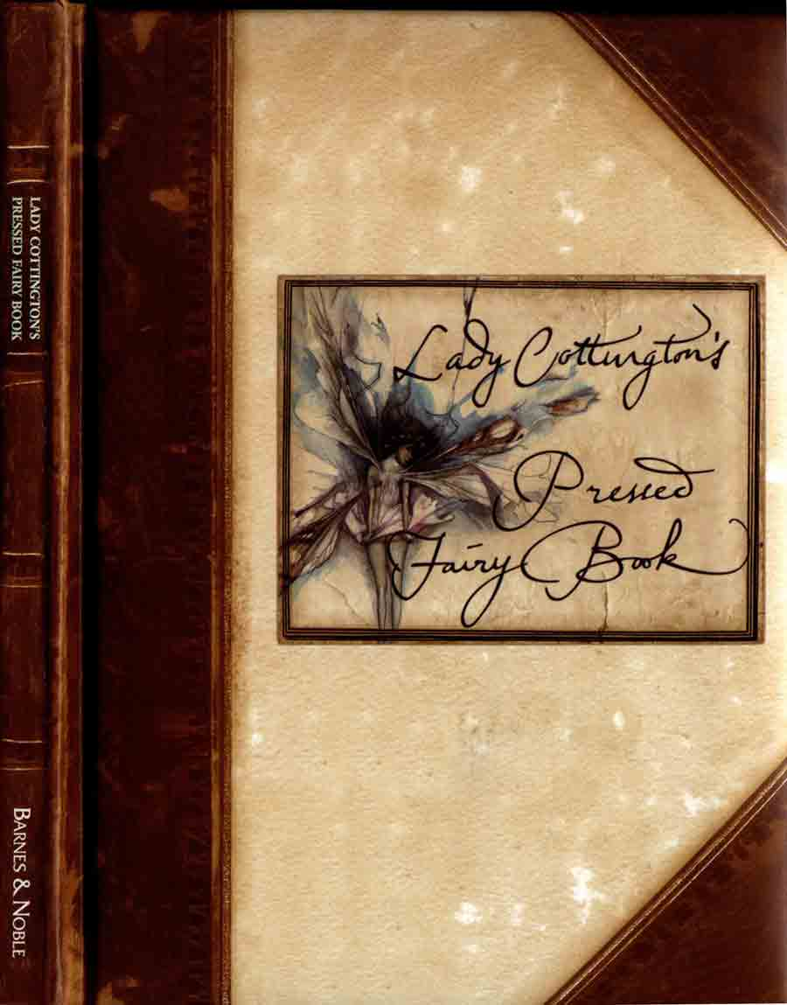
Notes from Scanner: Ran into trouble with sizing and was forced to separate pages into separate pages instead of having them face each other as the first few pages of the diary are (several pages below). I thought it was important to leave a few in that format to give a better feel of the book. Also, text was unreadable at less than 900px width, so that is what I went with – they are smaller by default, but if you zoom in, they should get larger up to 900px width. I kept the text primarily image-based for obvious reasons. If you make any changes to this file, please increase version number by 0.1 and redistribute. Yes, the Terry Jones that wrote this IS the Terry Jones from Monty Python, so buy this book. It’s definitely worth having.

Text by Terry Jones copyright © Fegg Features Ltd 1991 Illustrations copyright © Brian Froud 1991

All rights reserved. No part of this publication may be reproduced,
stored in a retrieval system, or transmitted, in any form or by any means, electronic, mechanical, photocopying, recording or otherwise, without the prior permission of the copyright holder.

This edition published by Barnes & Noble Inc.,
by arrangement with Pavilion Books Limited

2001 Barnes & Noble Books

M 10 9 8 7 6 5 4 3 2 1

ISBN 0-7607-2688-4

First published in Great Britain by
Pavilion Books Limited

Designed by Wherefore Art?
Calligraphy by Ruth Rowland

Printed in Italy

publisher's note

The RSPCF (The Royal Society for the Prevention
of Cruelty to Fairies) has asked the publisher to
make it clear that no fairies were injured or killed
during the manufacturing of this book. The
pictures in this book are psychic impressions of
fairies. The RSPCF would also like to point out
that, after one or two unfortunate casualties in
the early stages, all the fairies presented in these
pages had discovered a way of leaving their
psychic imprint without suffering any physical
harm themselves. In fact, the whole process
became recognized as a Fairy Sporting Activity and
qualified for a Gooseberry Medal at the Millennial
Fairy Olympics in 1921.

LADY COTTINGTON’S PRESSED FAIRY BOOK

Of course everyone is familiar with the famous photograph of the small girl surrounded by fairies, which caused such a sensation when it was first published in The Regular magazine in 1907. It inspired many imitations and was circulated around the world. While some sceptics dismissed it as a hoax, it was hailed in many quarters as the final, irrefutable proof of the existence of fairies. No less an authority on the subject than Sir Arthur Conan Doyle was fully persuaded of its authenticity, and spoke to packed audiences about its significance, particularly in the Manchester area. J. M. Barrie himself was convinced that he recognized at least one of the fairies in the photograph, and the Rev. Charles Dodgson (better known as Lewis Carroll) appeared from beyond the grave to clairvoyants up and down the country to vouch for the veracity of the photograph.
But, until recently, surprisingly little was known about the young girl in the photograph. It was known that her name was Angelica Cottington, and that she was the only daughter of Lord Cottington of Bovey, but otherwise the page of history upon which her name appears was blank. On the death of her father, Angelica became Lady Cottington, and lived as a recluse on the family estate until she died in 1991. She never married and had no friends or even acquaintances other than her housekeeper, Ethel, and she did not even know her very well.
It was thought that perhaps it was the ridicule heaped upon the photos by the popular press that drove Angelica Cottington into her life of seclusion. But nobody really knew the full story, until last year, when the Cottington estate was bought by Potterton Properties plc, and the old house was finally demolished to make way for a Prestige Office Block in an unspoilt country setting, which so many firms have already chosen as their preferred lifestyle.
Before the bulldozers moved in, a group of local trouble-makers, led by the vicar, the Rev. Charles Dodgson (no relation), Dr Broadbent (Bovey's last GP working within the now outmoded NHS system) and the entire population of the village of Bovey itself, established a squat in the building with the intention of preventing Potterton Properties plc from going about their lawful business of obliterating the Elizabethan manor house and medieval outbuildings. During the course of this occupation (which was eventually brought to a conclusion by the police and the armed forces, with surprisingly little loss of life) one of the squatters, the Right Hon. Phillip Menzies, MP, QC, OBE, discovered a small volume stuck behind a trunk in the attic.
As he was about to tear out the pages in order to light a fire, he became aware that he might be holding in his hands something rather special. When he put his glasses on, he immediately recognized the importance of his find. He abandoned

LADY COTTINGTON’S PRESSED FAIRY BOOK

the squat in order to obtain the services of a first-class London lawyer, who specialized in Copyright, Treasure Trove and Making Money out of Other People's Property (a little-known by-water of English law, which has proved surprisingly fruitful for those who have taken the trouble to avail themselves of it).
Thanks to this chance discovery, and the untiring efforts of the publicity department of the publisher, you are now holding in your hands a faithful reproduction of one of the most intriguing, sensational and epoch-making books of all times — Lady Cottington's Pressed Fairy Book.
Here at last is explained — in all its graphic detail — the way in which that first photograph came to be taken. What is more, here is a faithful record of many, many more fairies who appeared to Angelica Cottington throughout her earliest years. And not only written accounts - for this book is nothing less than a physical record of actual living fairies.
The way in which all of these remarkable impressions came to be left upon these pages is explained within the book itself, and in a further batch of photographs which
was later found under her bed. Suffice it to say that Angelica Cottington discovered that if she sat still with the book upon her lap, fairies (being inquisitive creatures) would come fluttering around her, and with a sure eye, a quick lunge and a firm snapping together of the book she could catch the fairies between her pages and thus preserve their appearance for posterity.
At the same time, Lady Cottington kept a detailed diary of her fairy sightings and this is faithfully reproduced here in its original position, alongside the pressings of the fairies themselves.
This is a unique and remarkable book - perhaps the most extraordinary volume that it has been my privilege to supervise for publication. I hope it will bring lasting pleasure and happy memories to those who are already familiar with the fairy world, and, for those who have not as yet been granted that privilege, I hope this book will bring some illumination.
terry jones London, February 1994

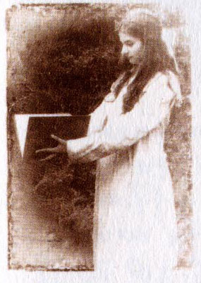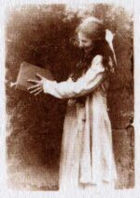
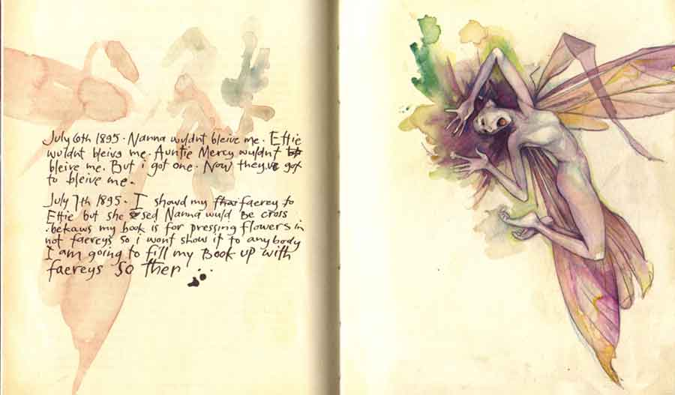

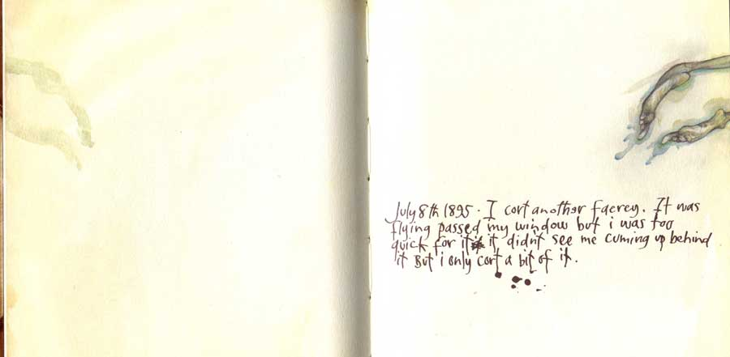
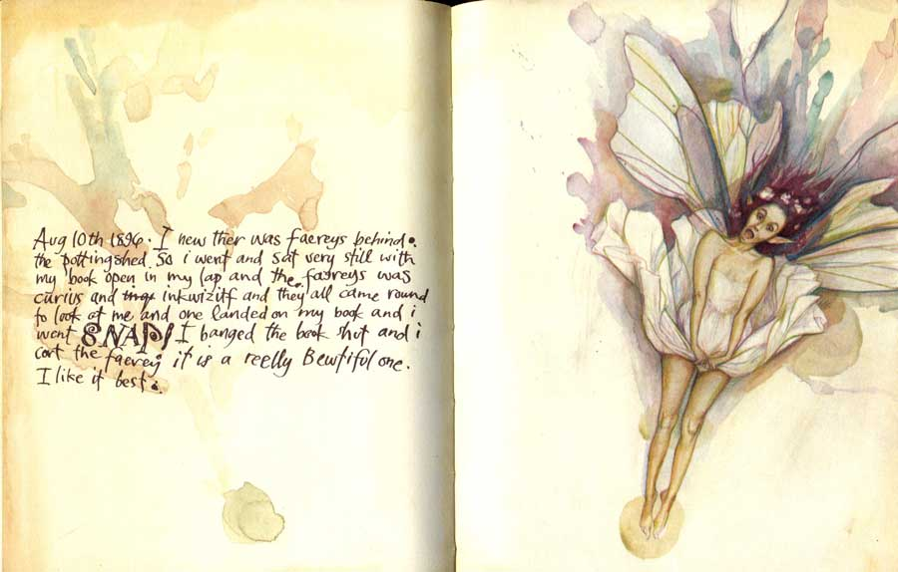

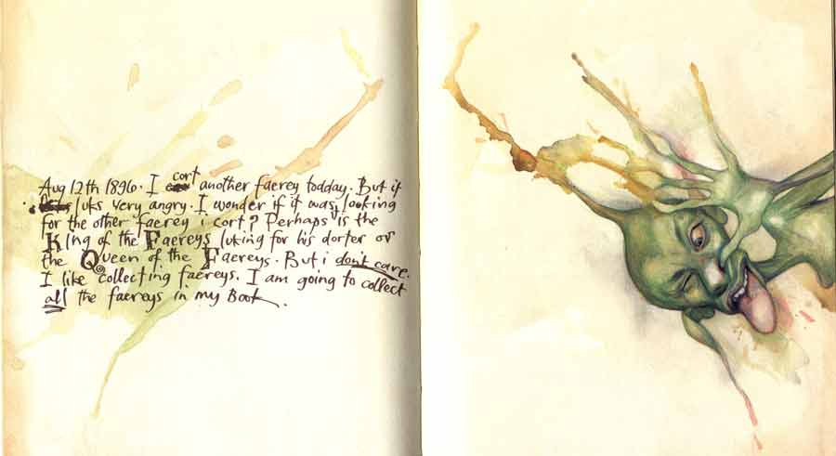

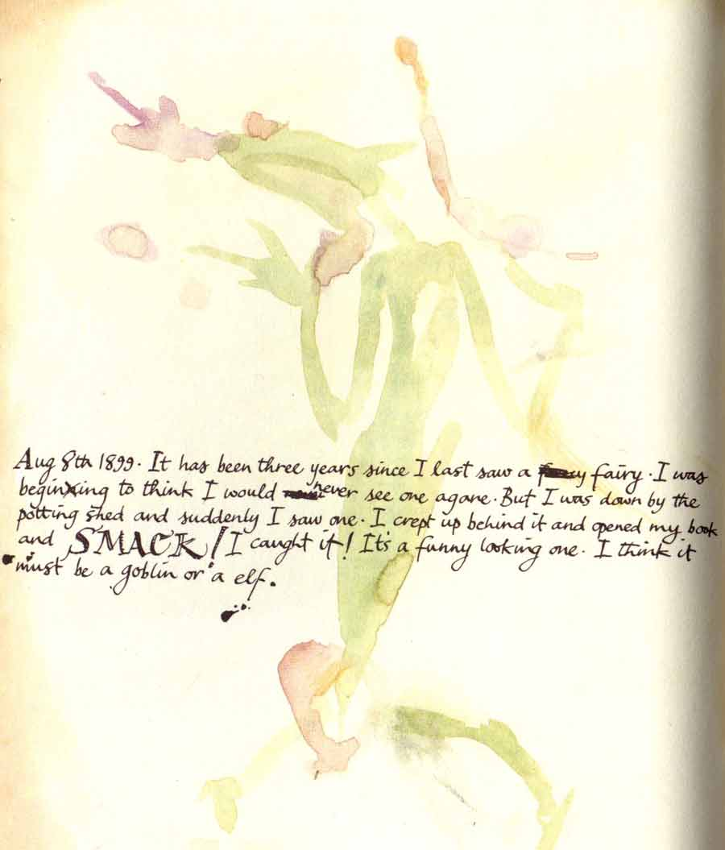

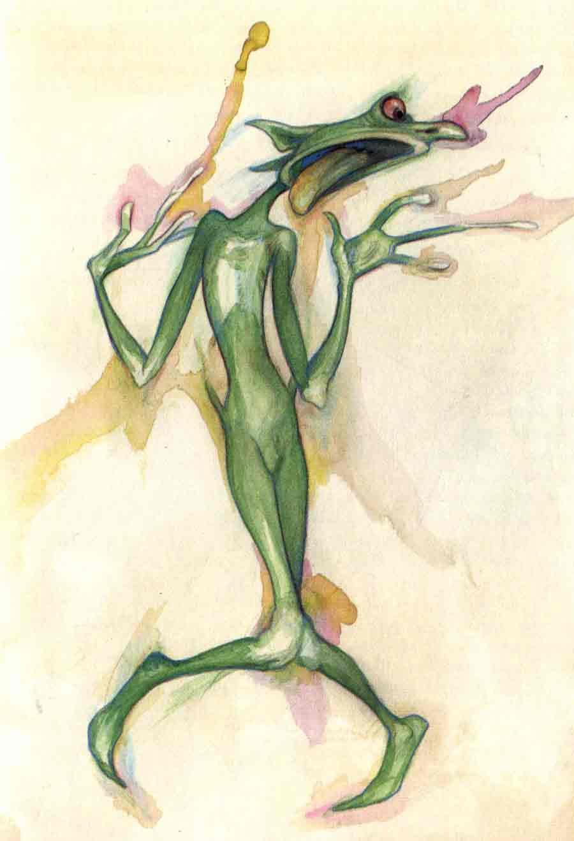

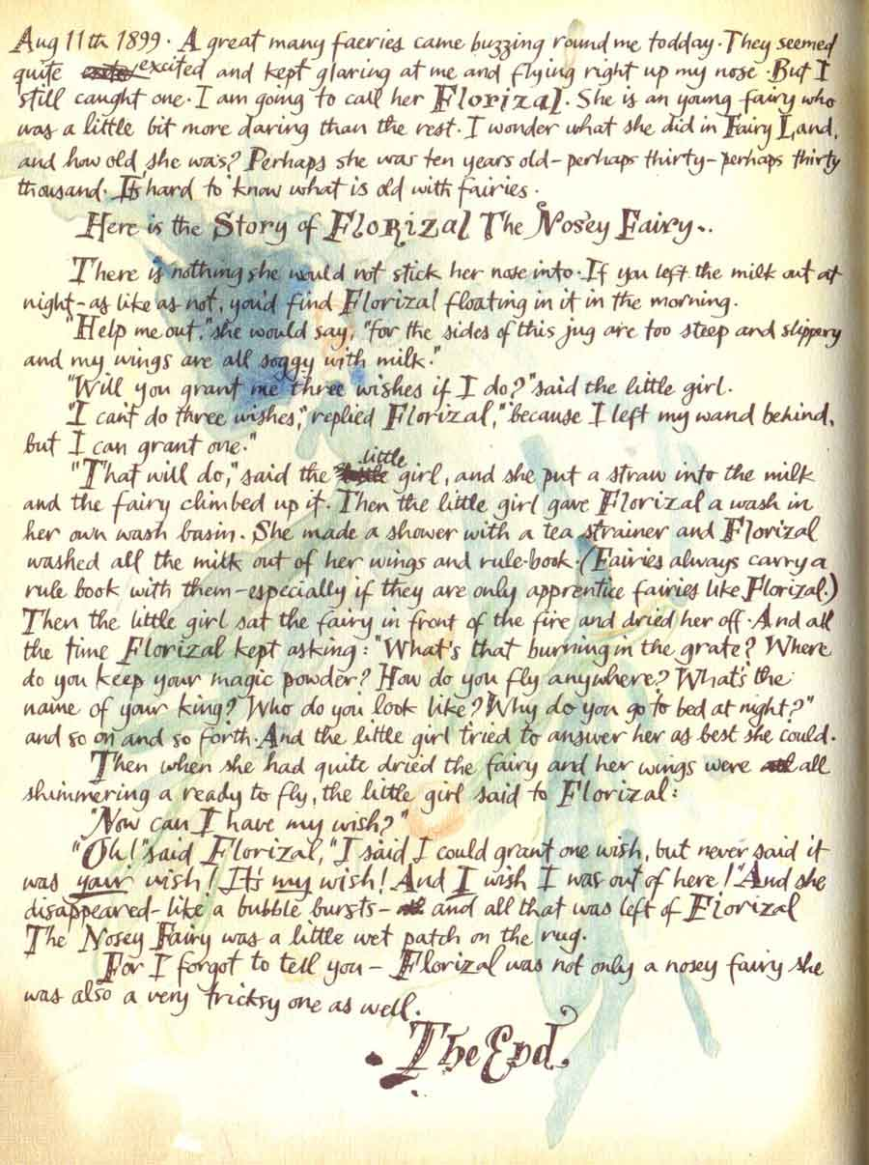

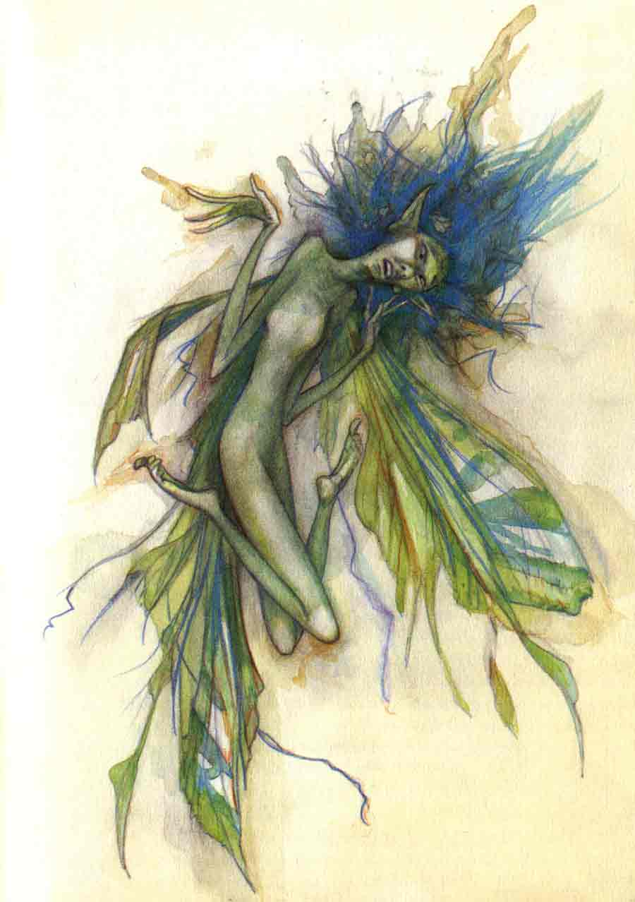
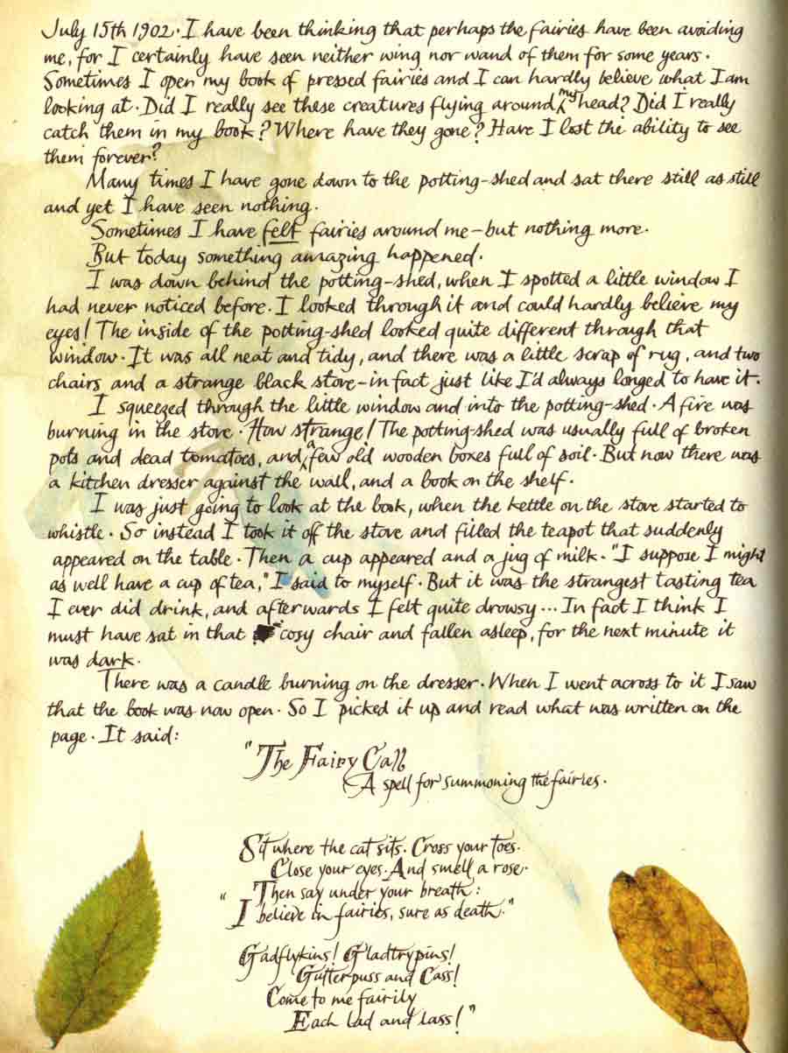

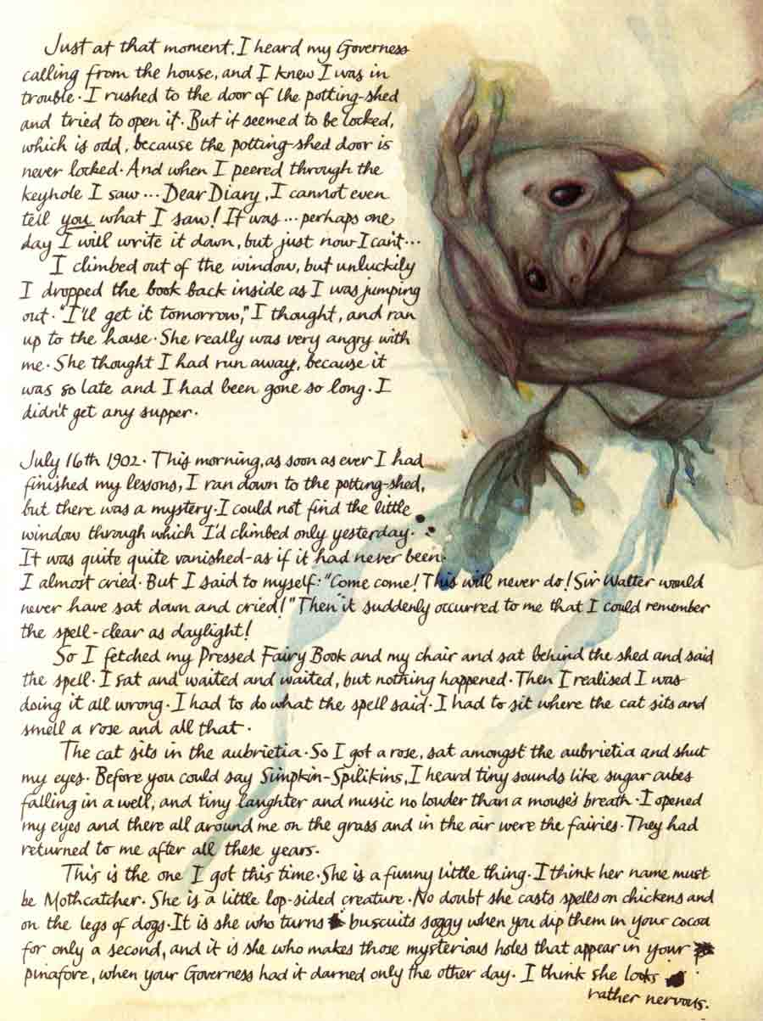

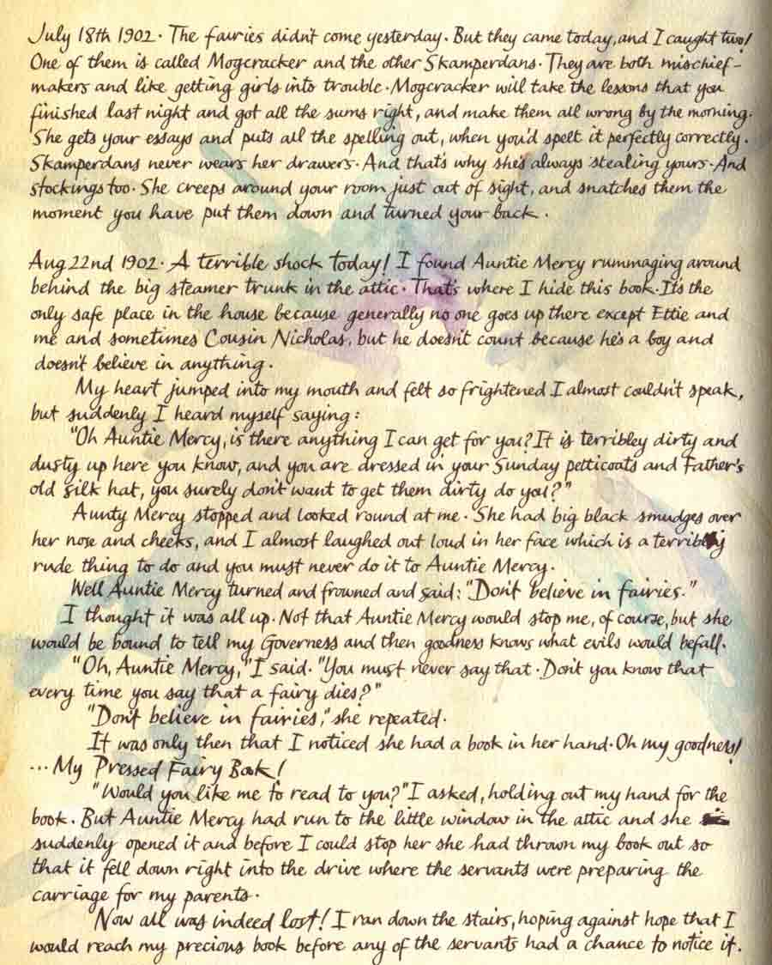

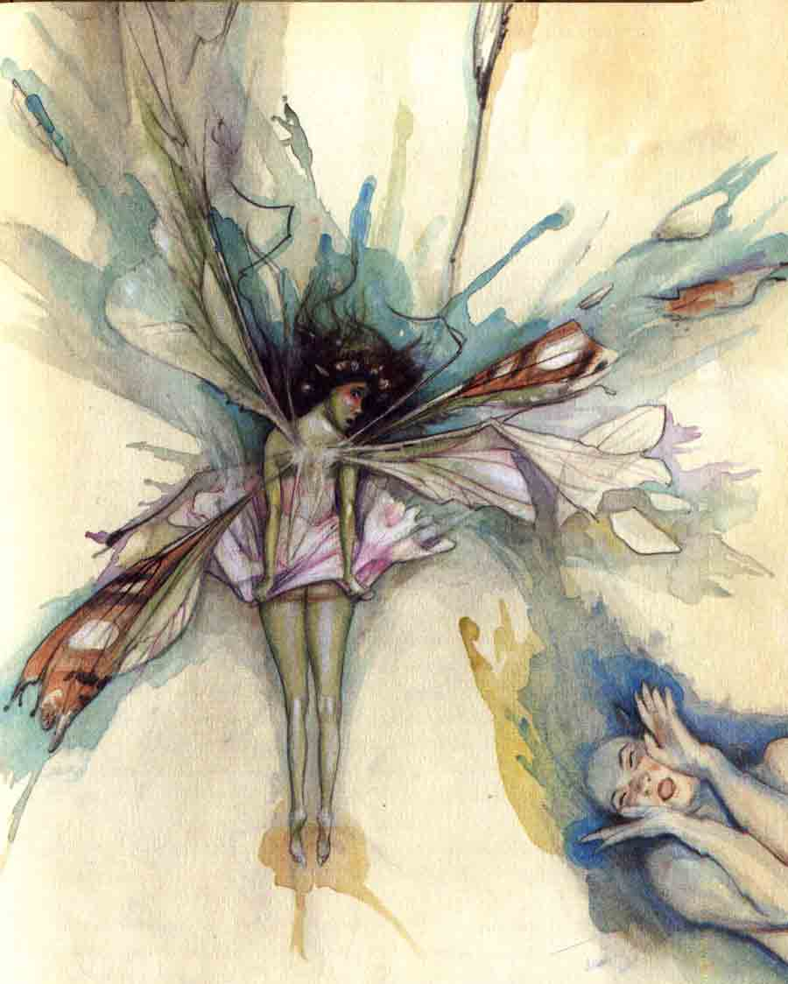

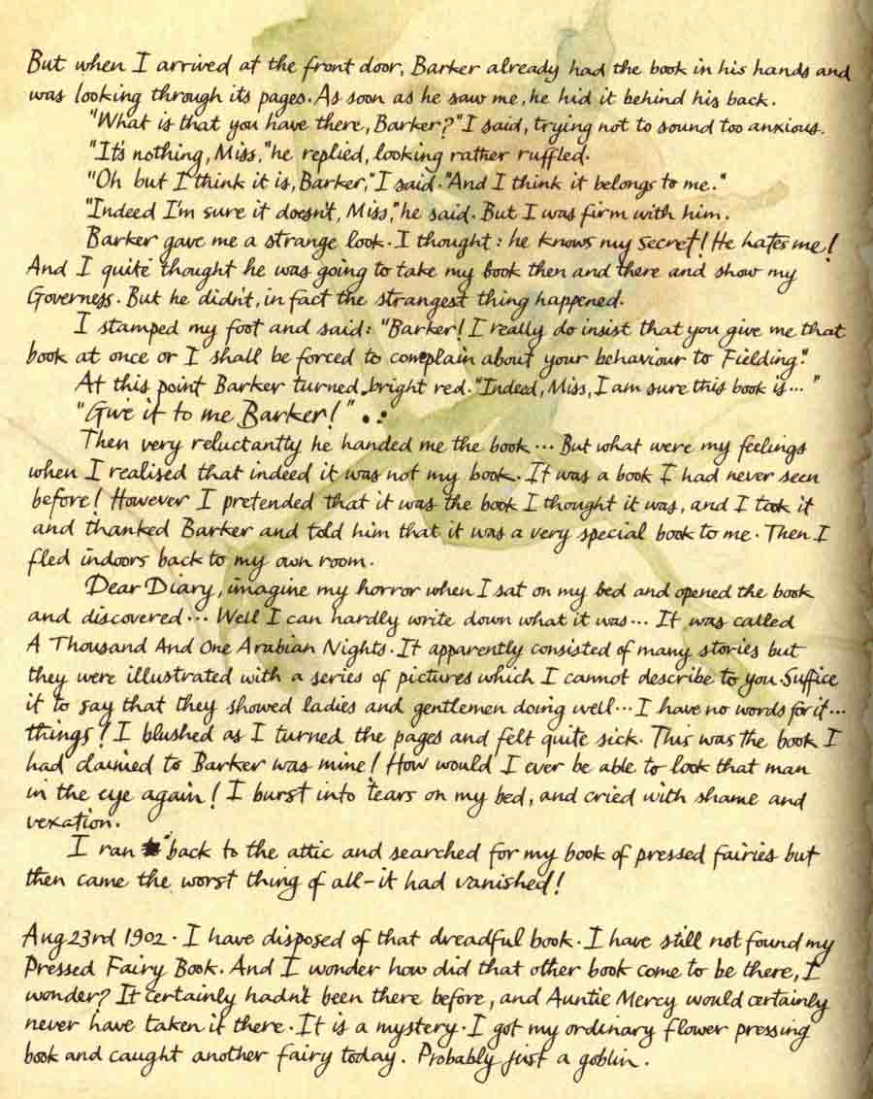

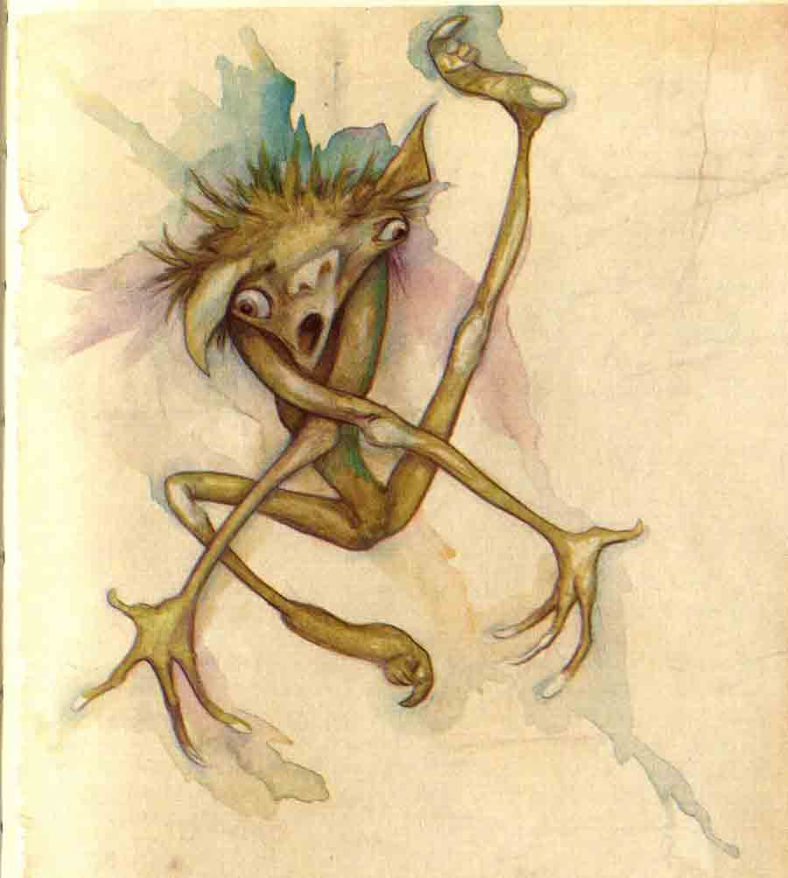

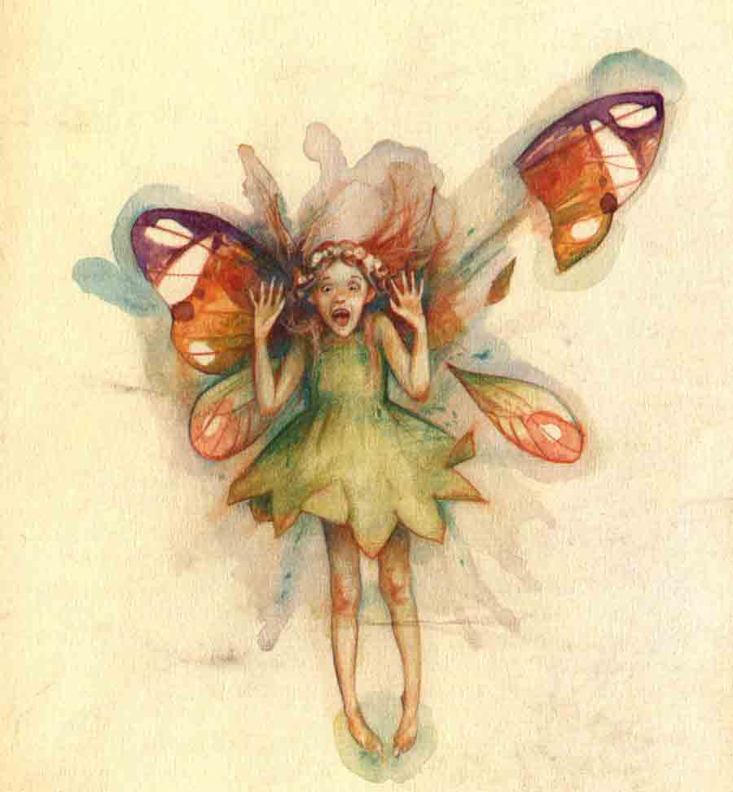

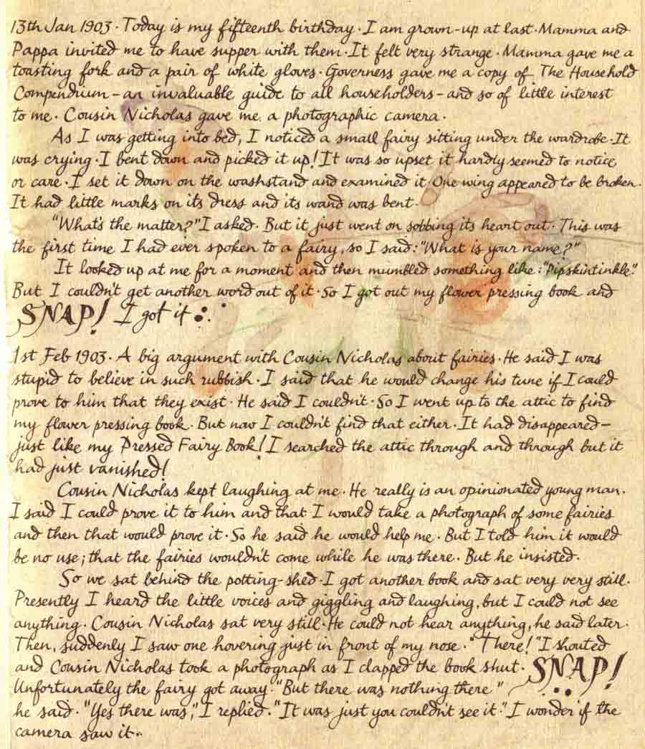
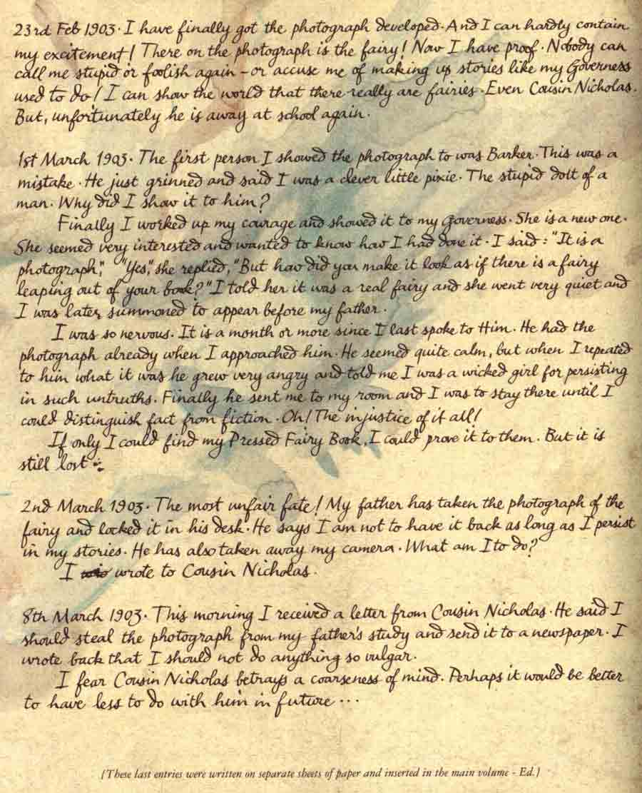

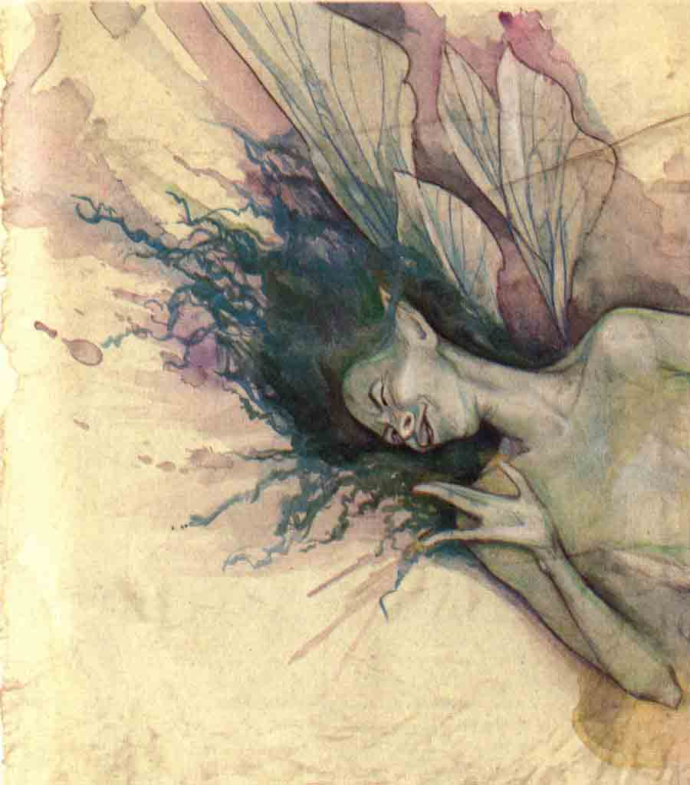

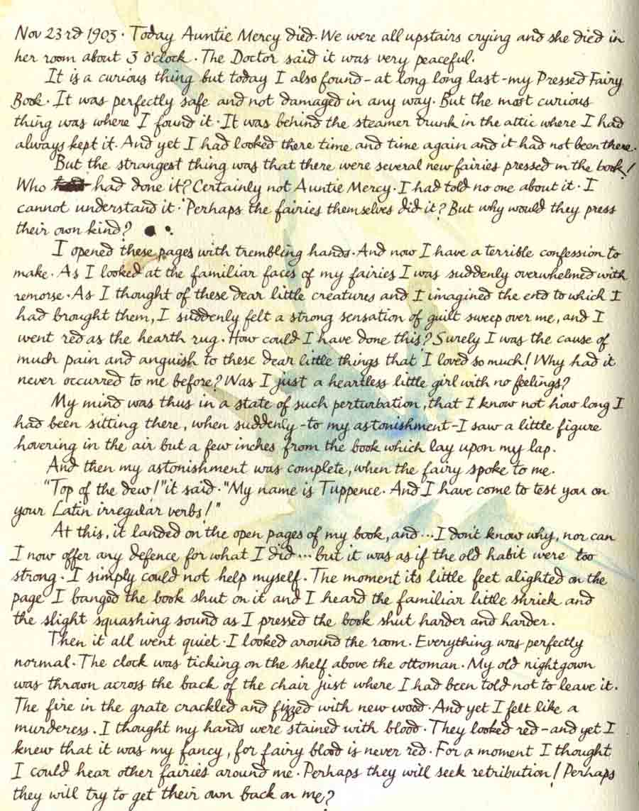

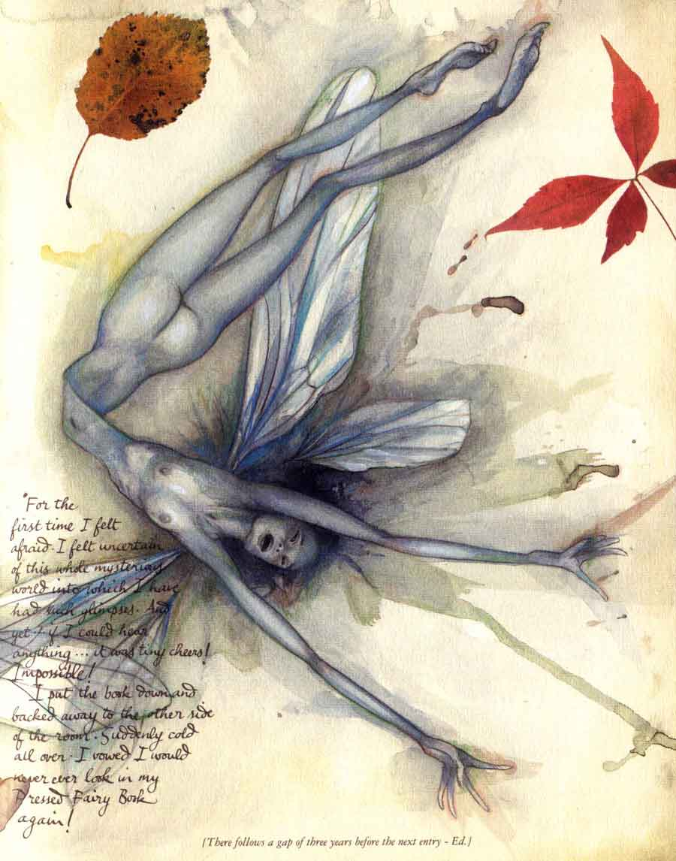

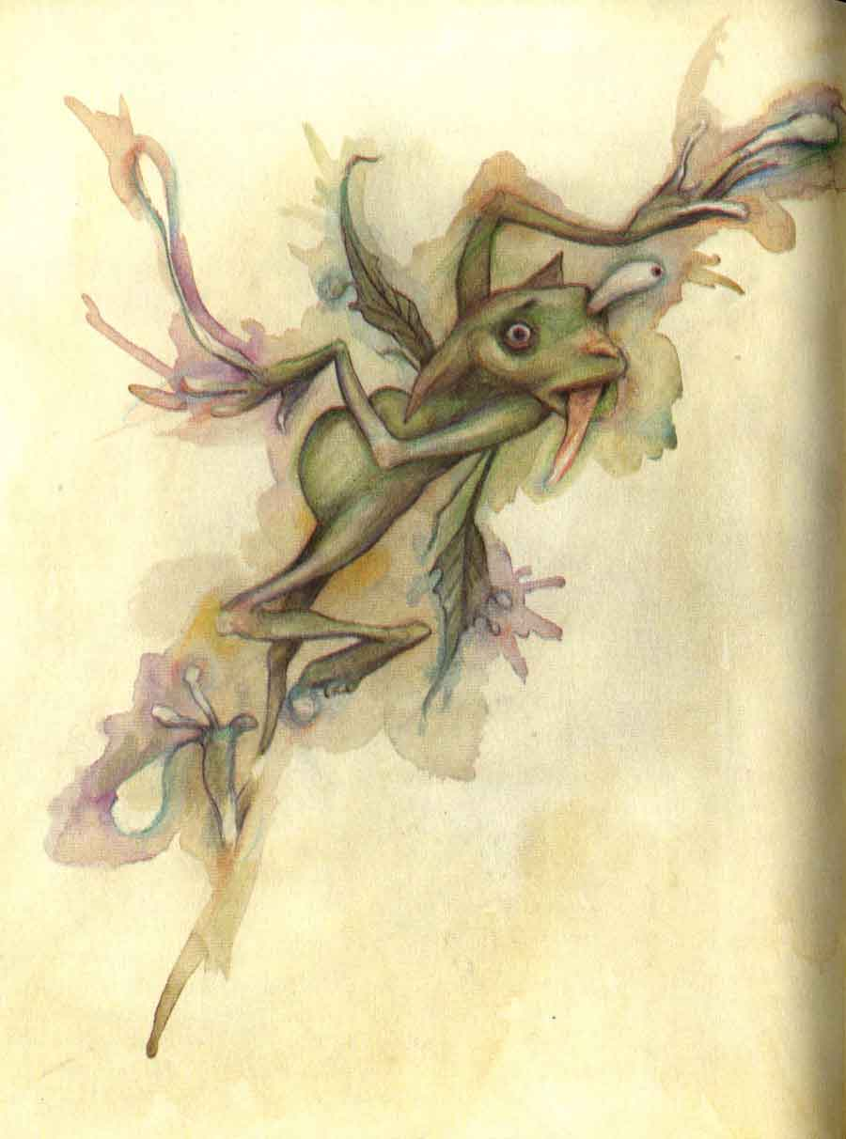

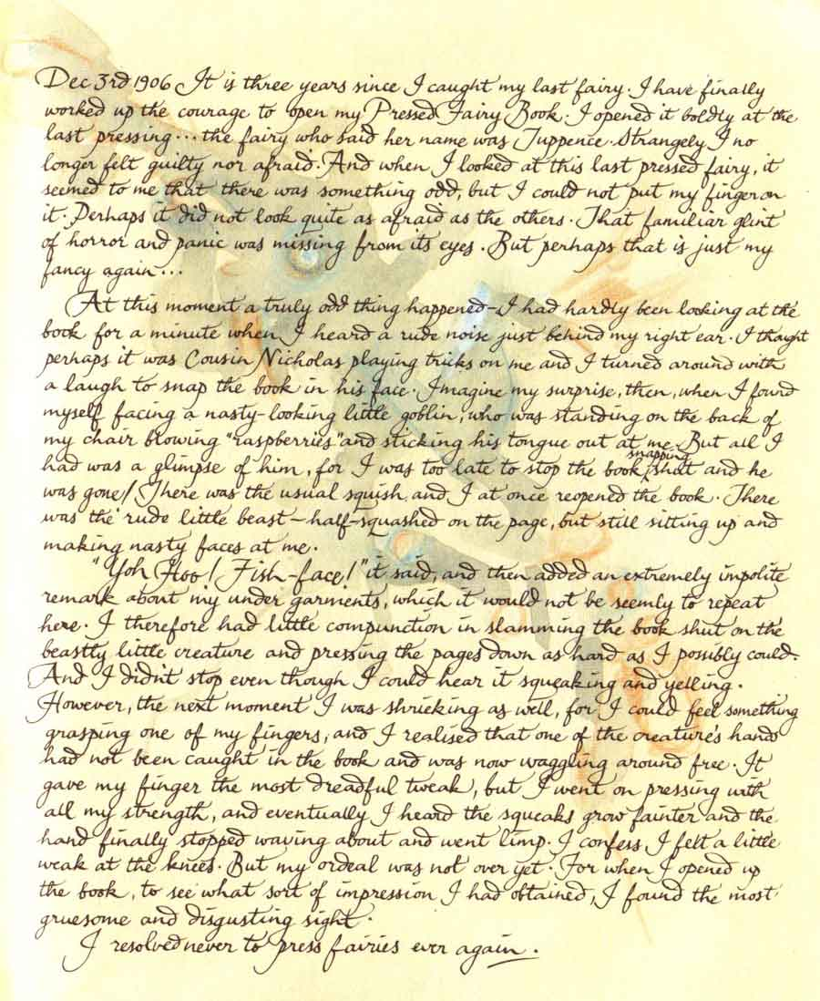
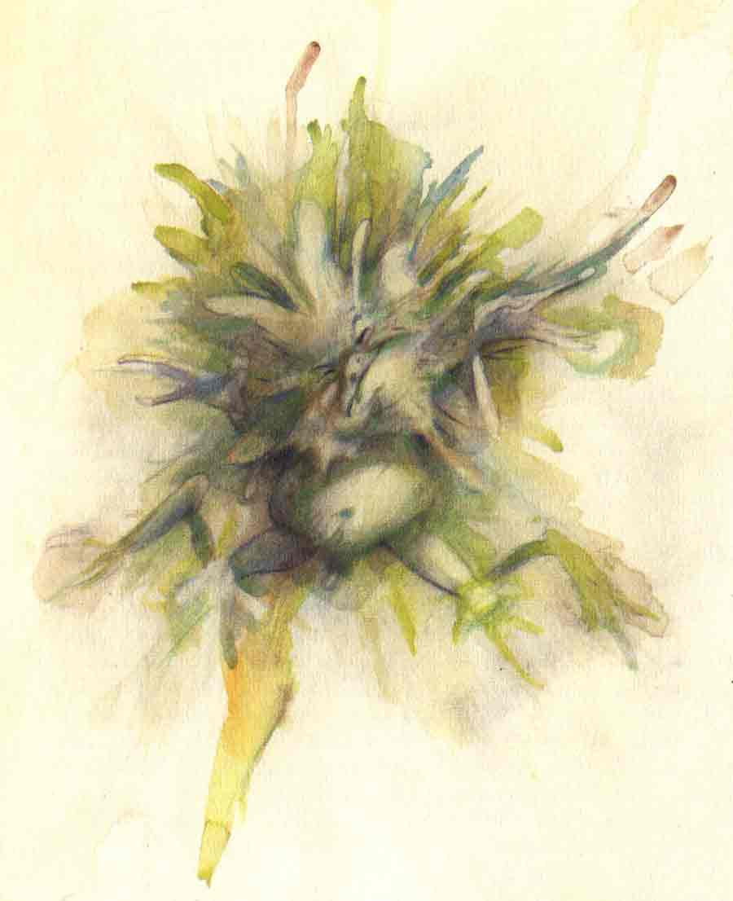
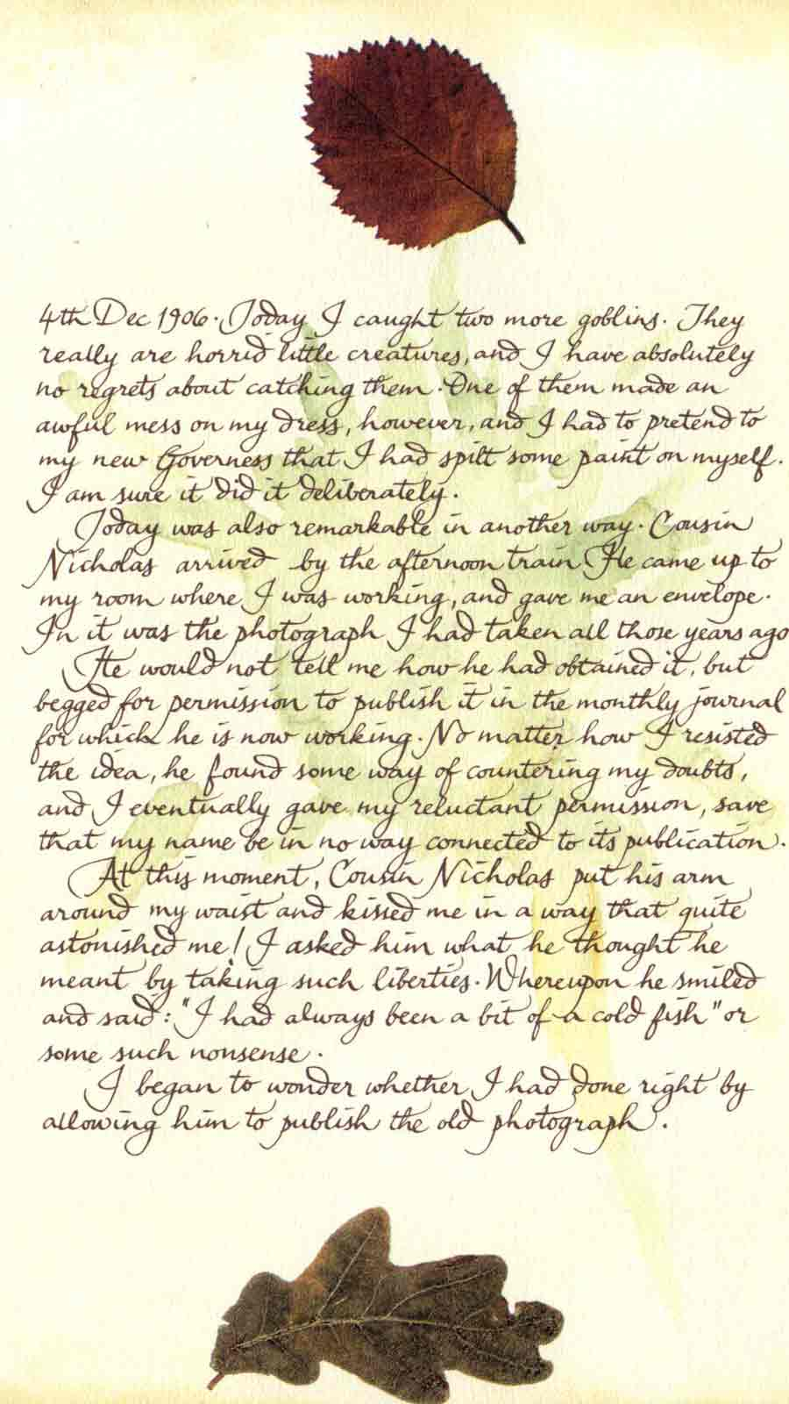
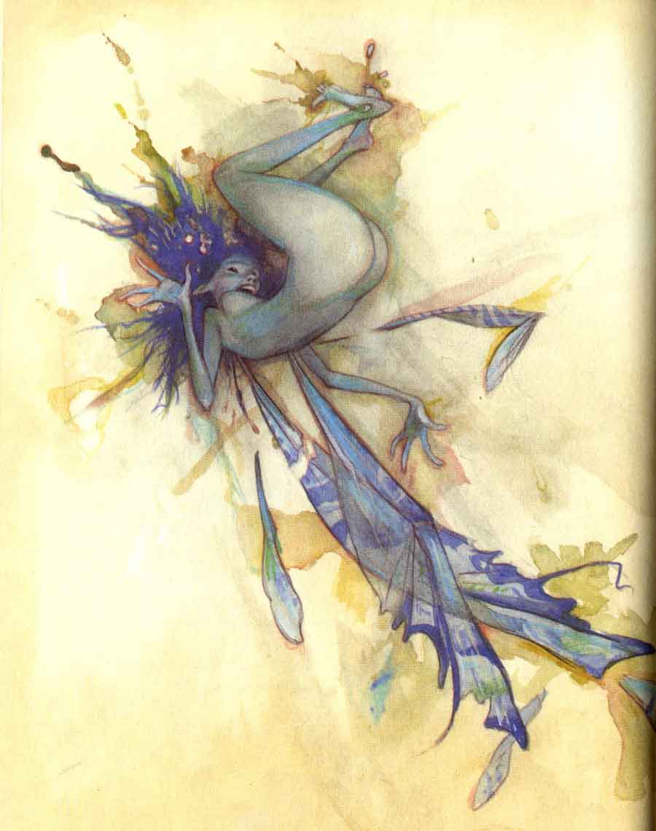

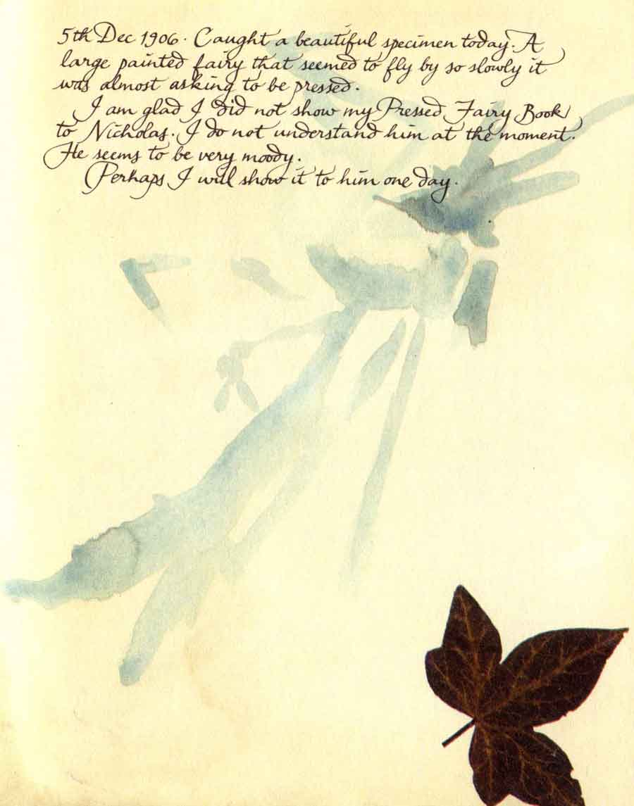

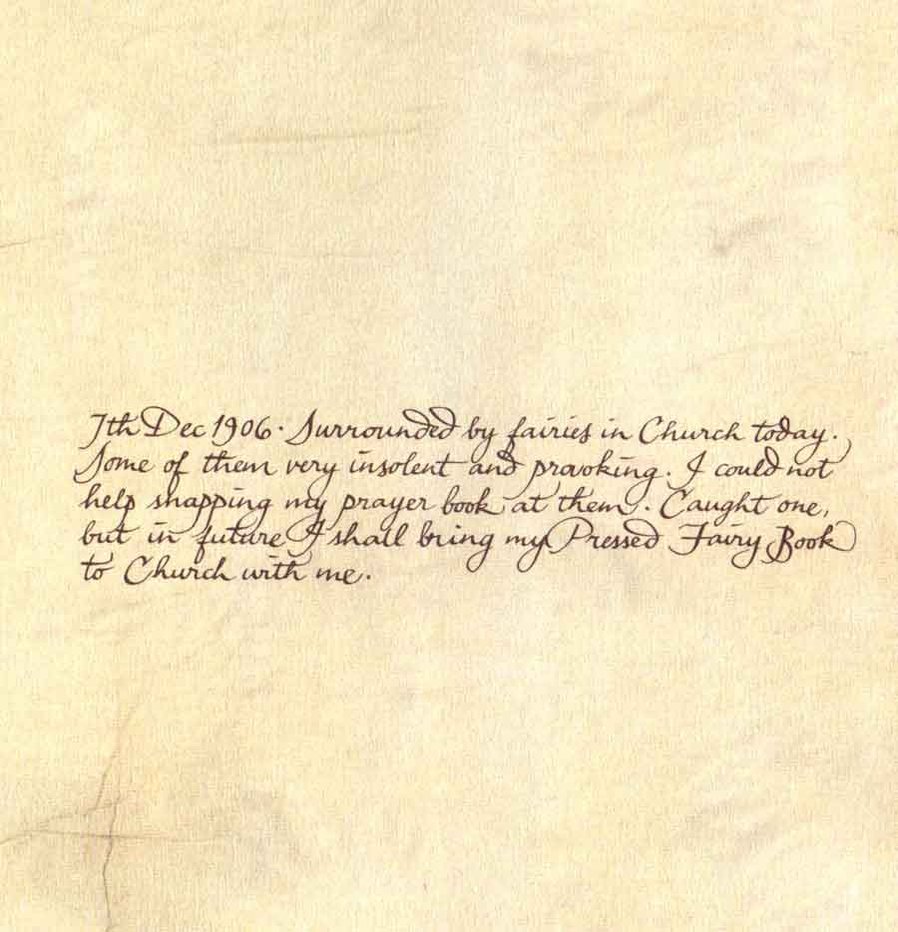
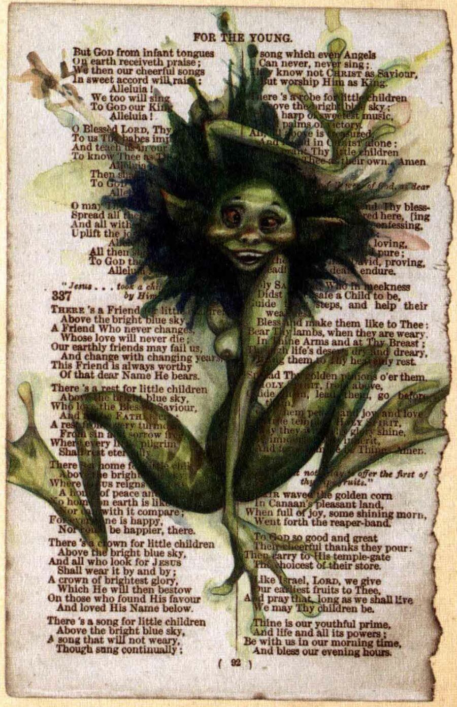
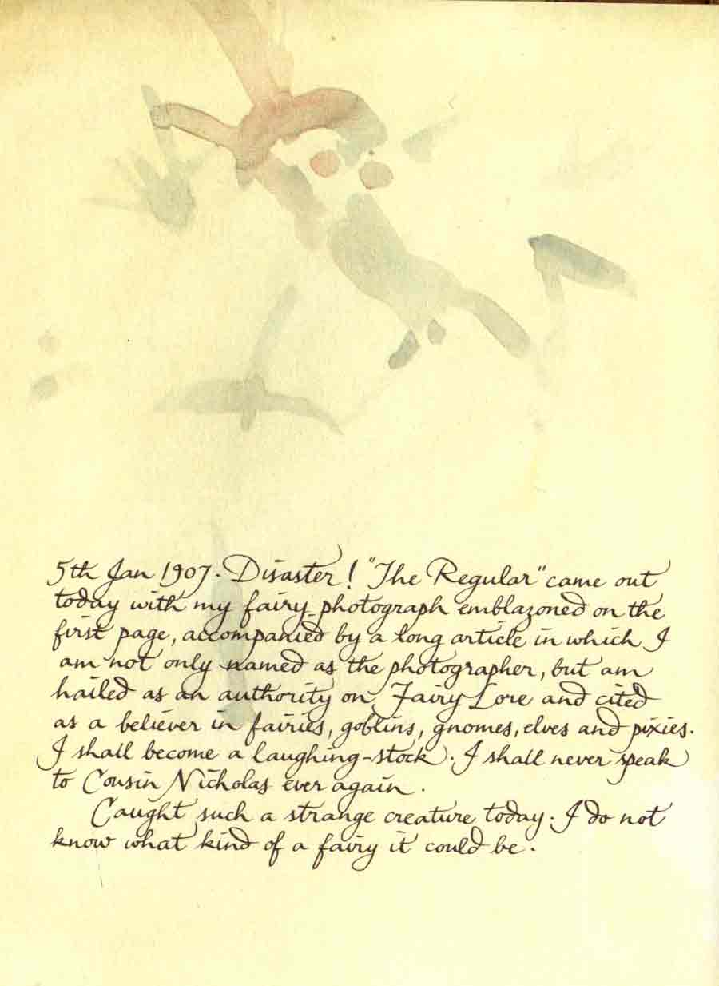
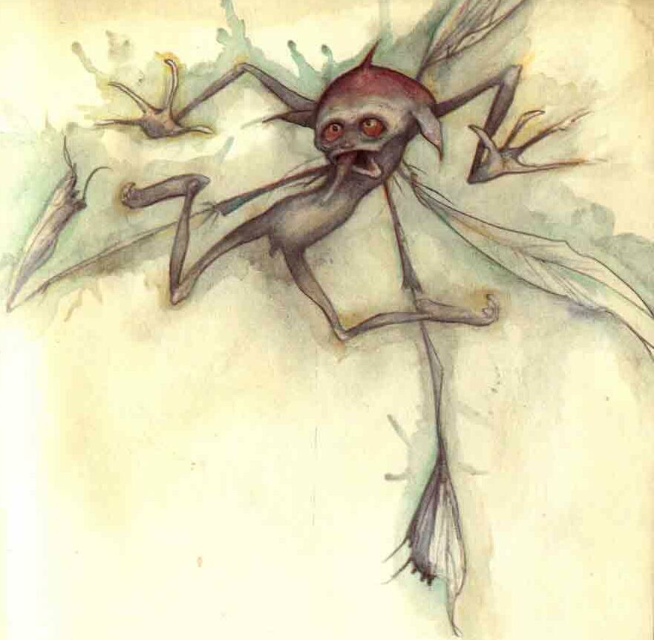

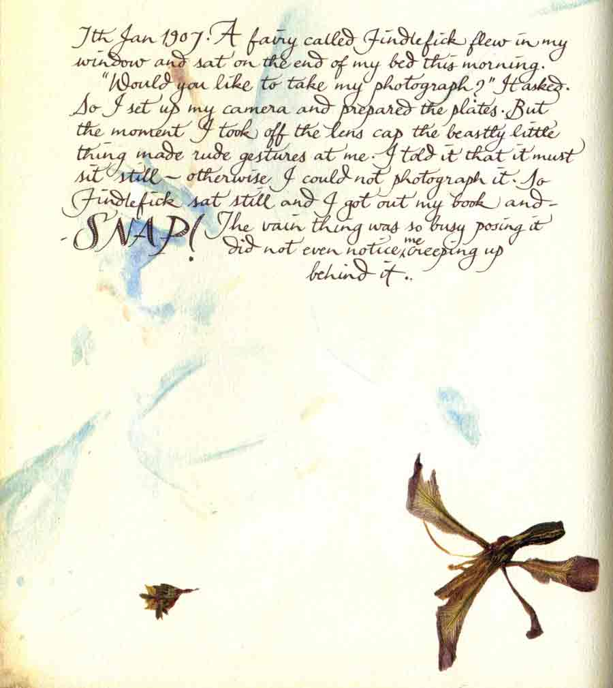

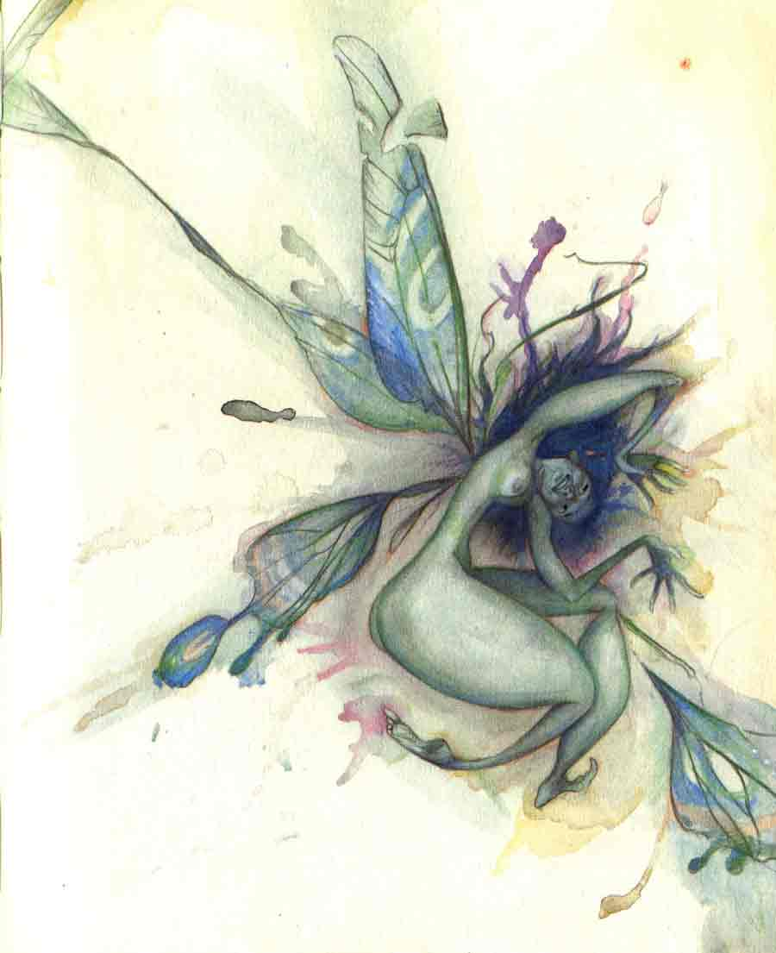

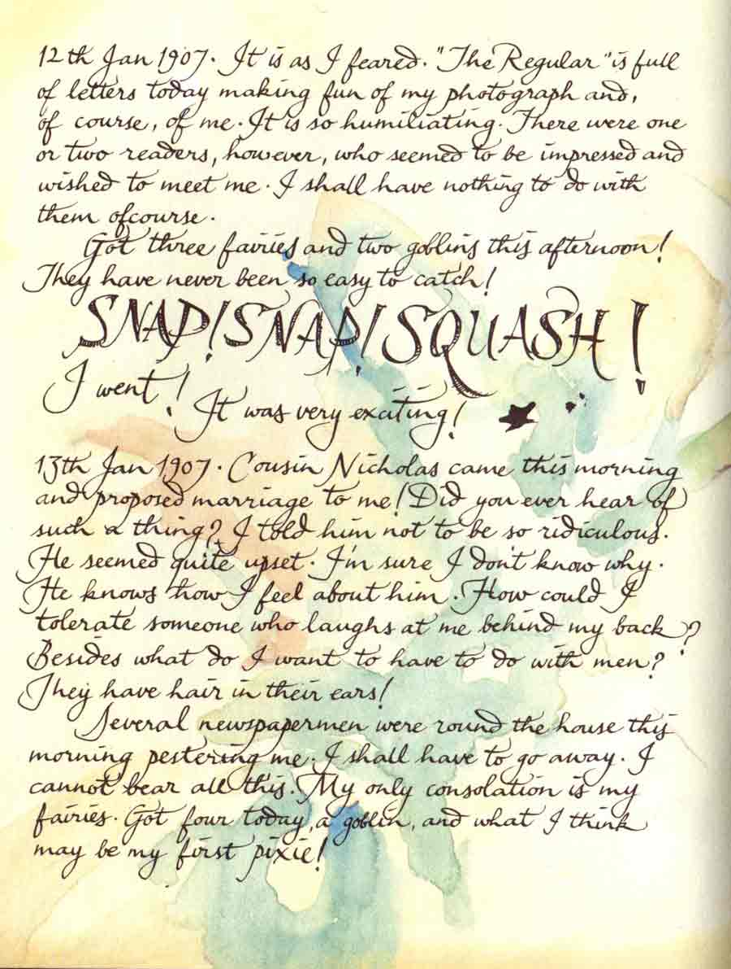

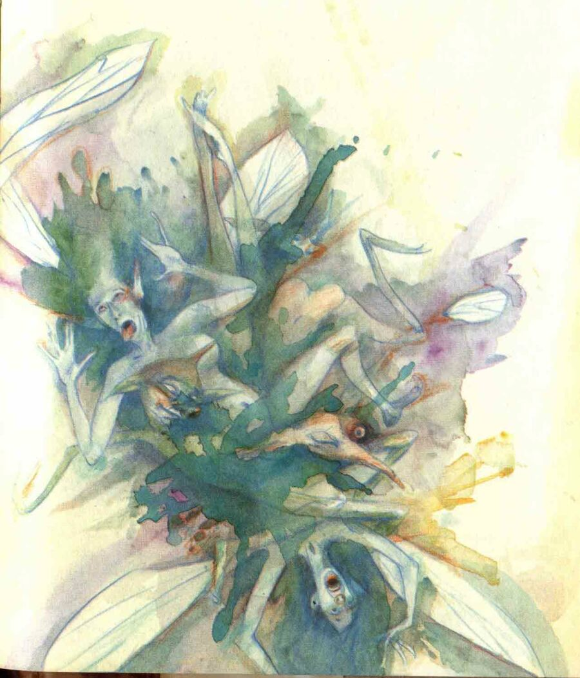

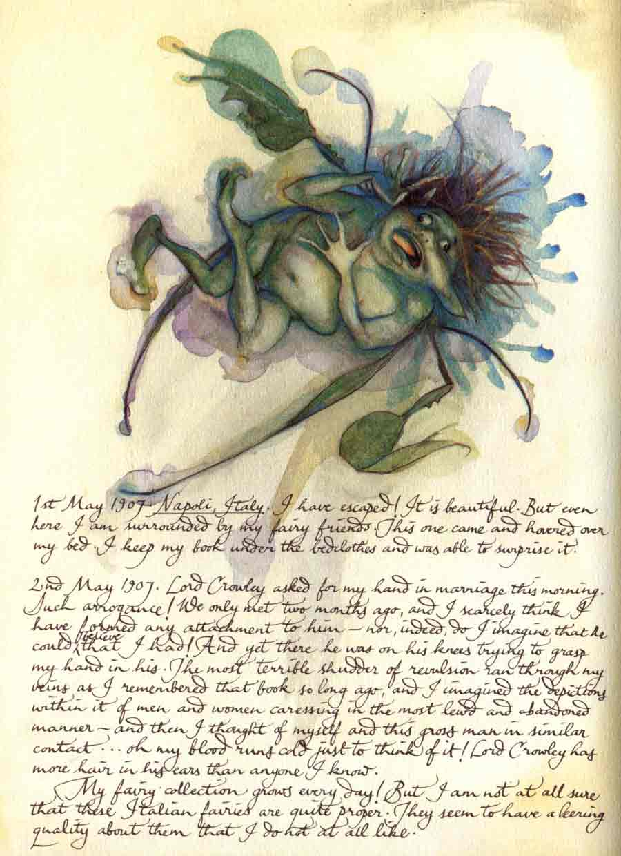

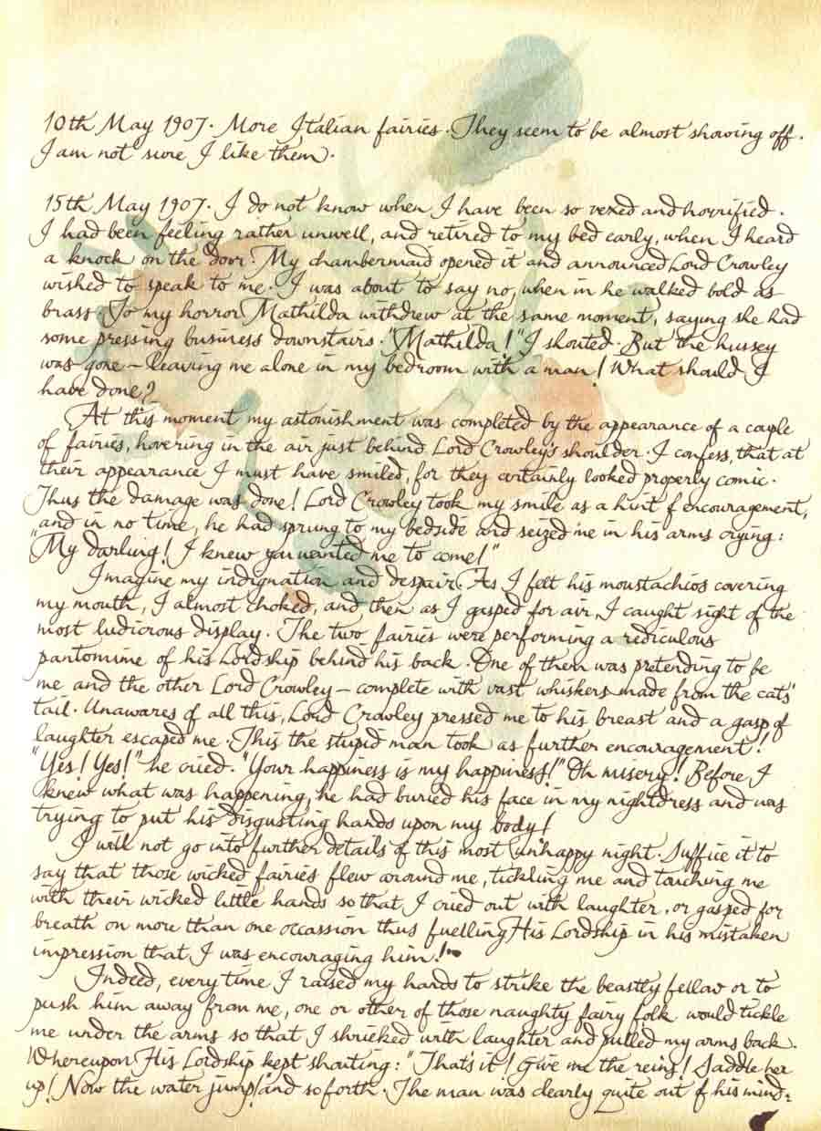

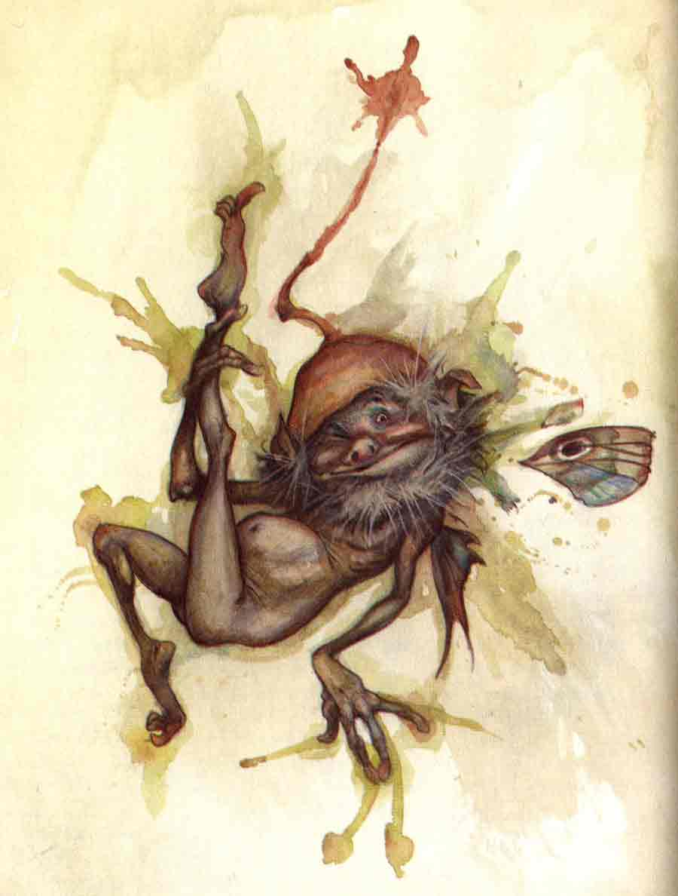

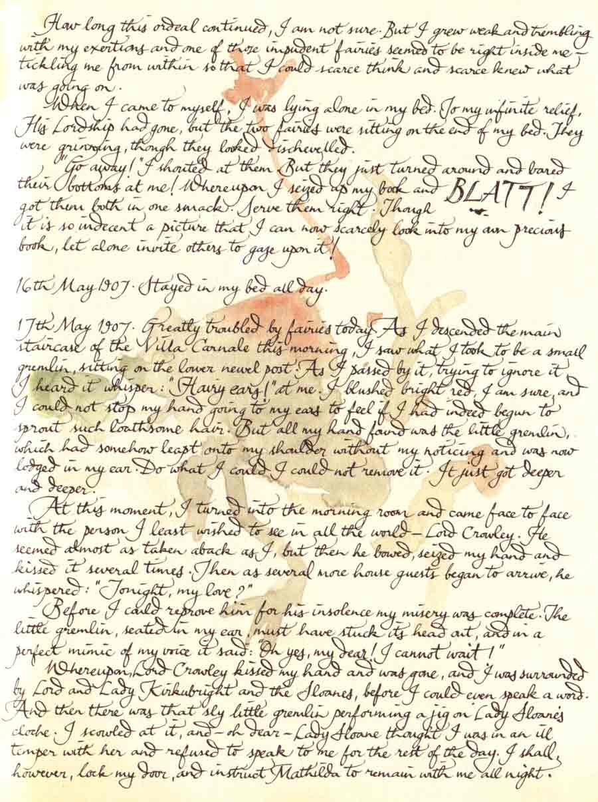
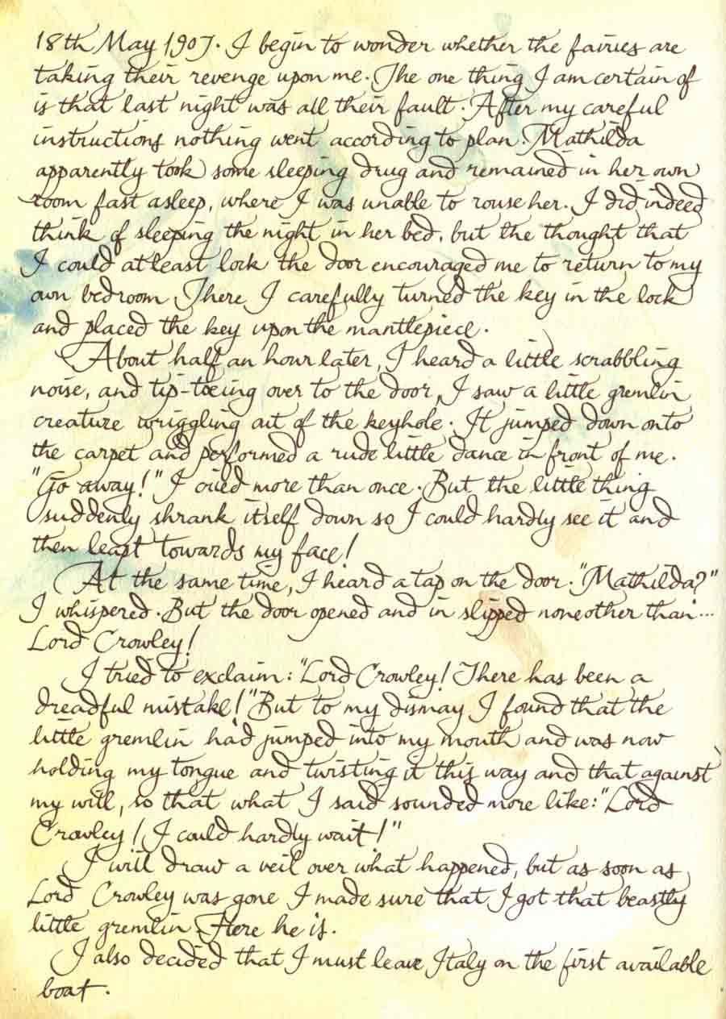

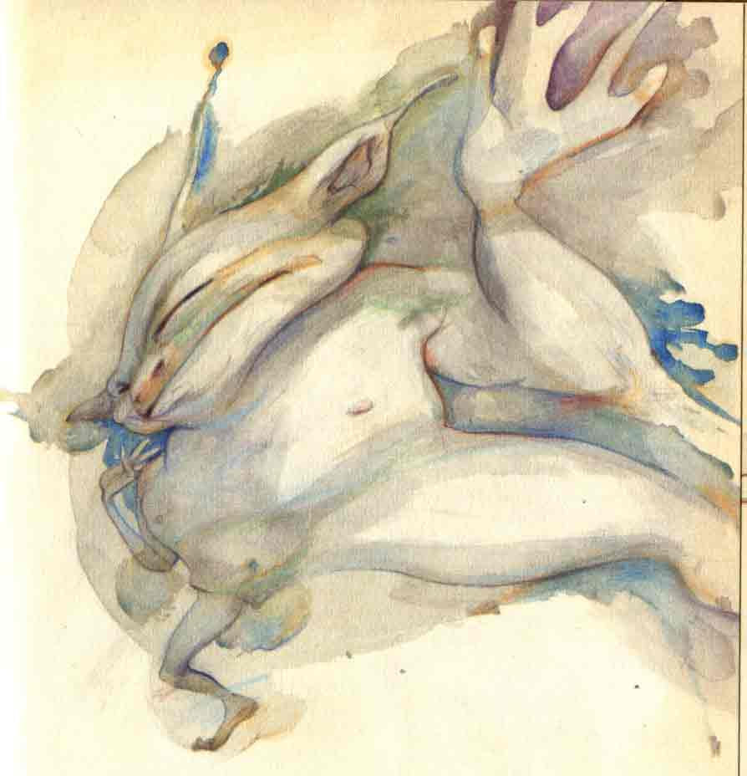

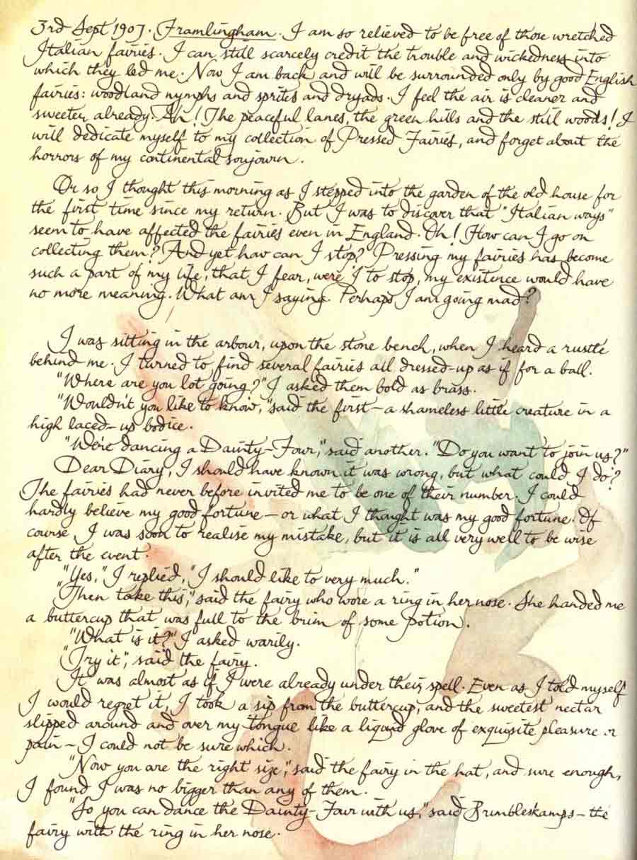

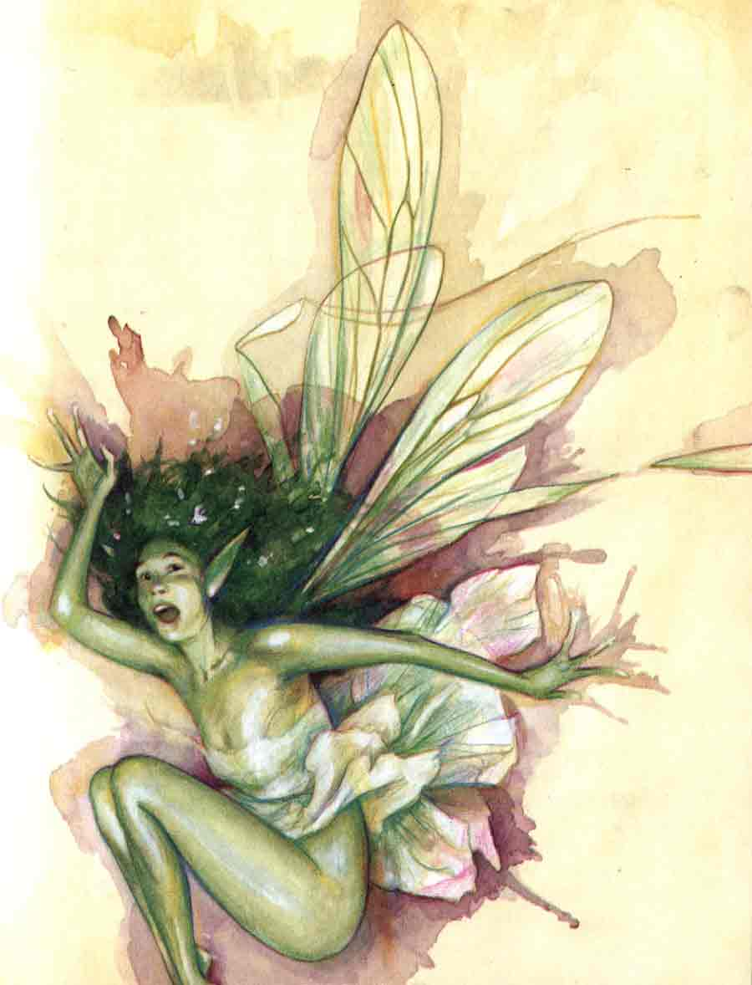

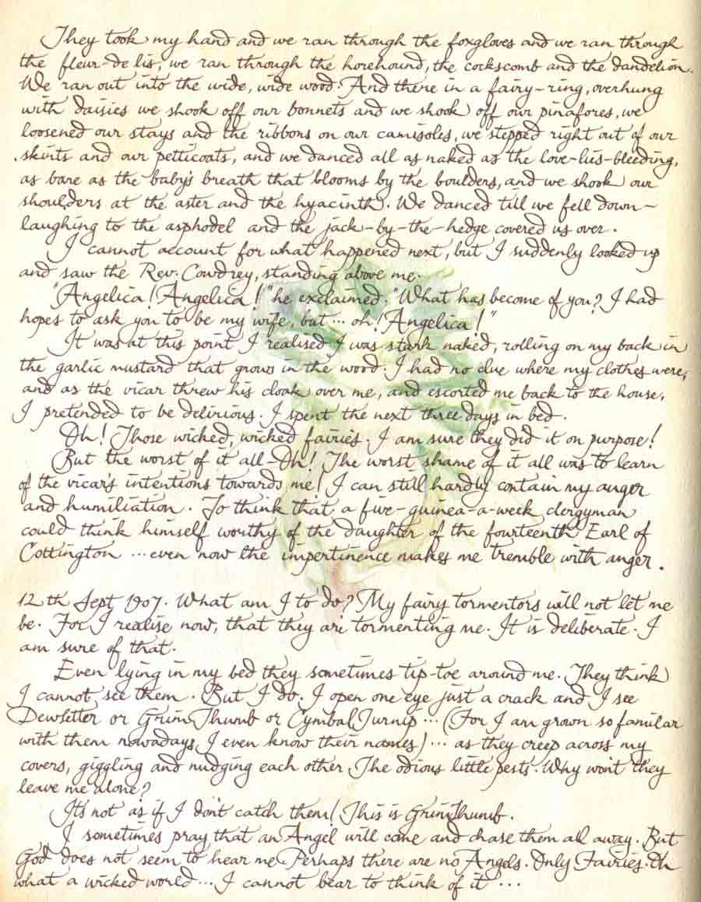

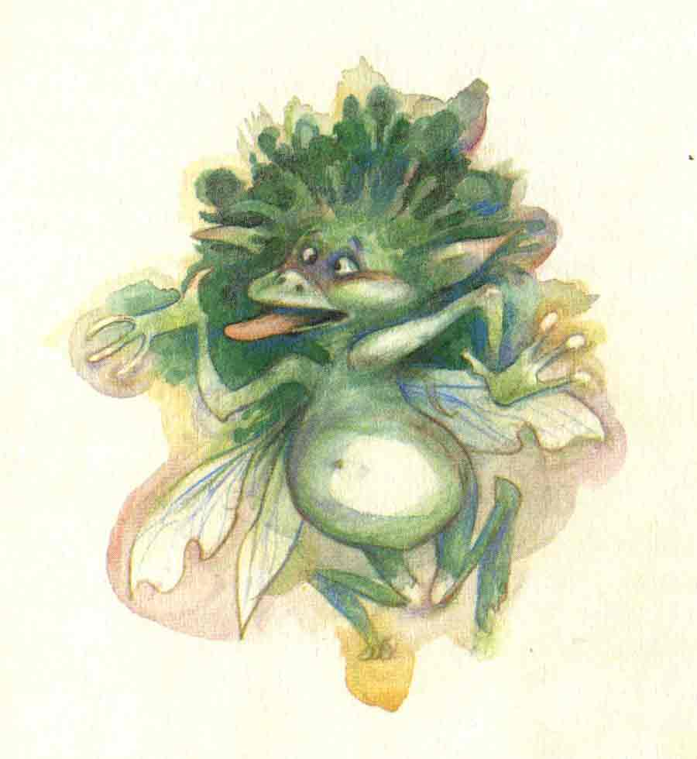

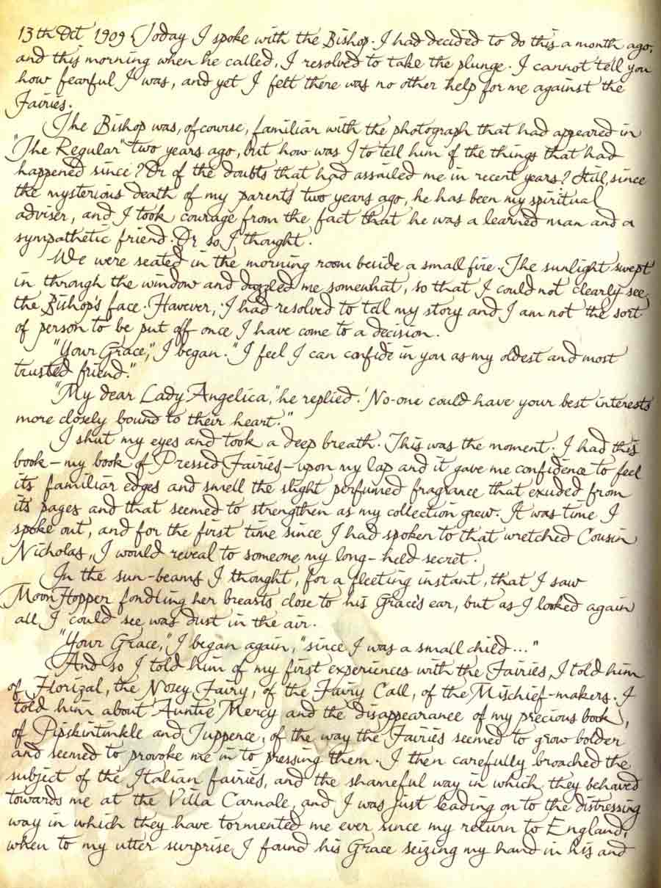

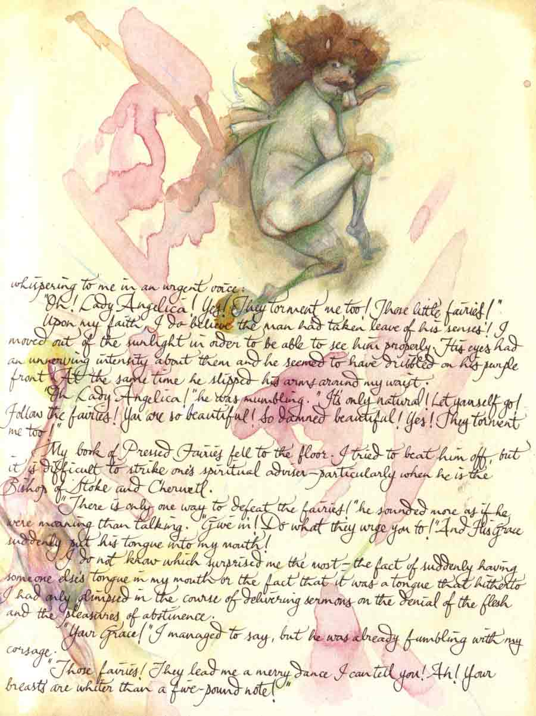

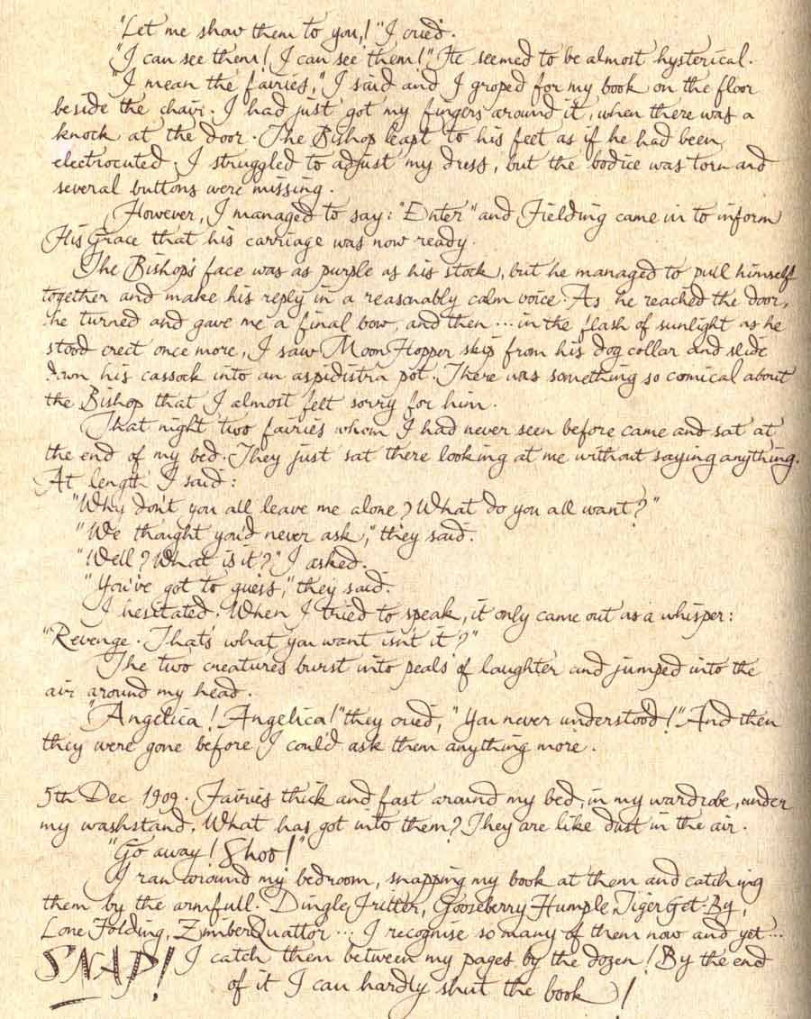

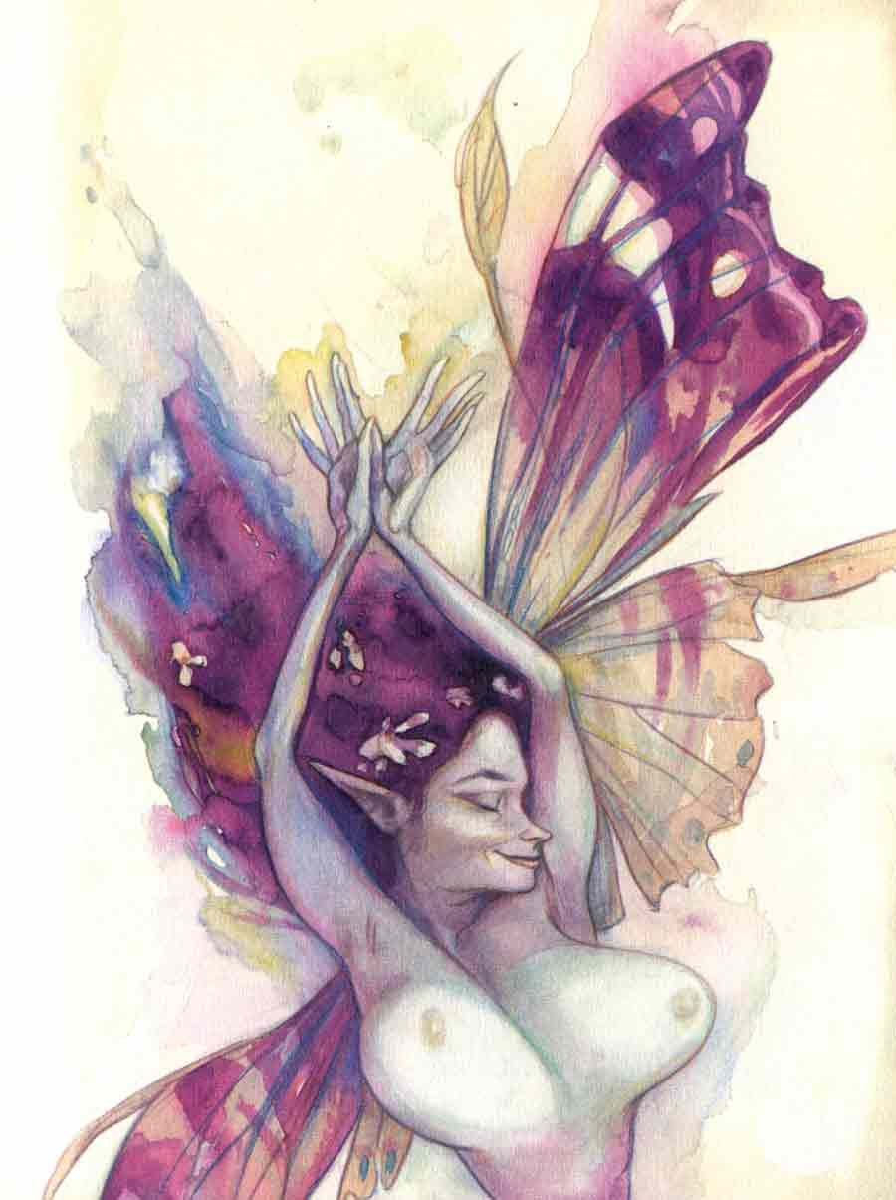

(The Following Section
Was Sealed By Lady
Cottington for
Protection of the Innocent)

