FROM THE TREE OF TIME

by Fred Saberhagen
from an idea from Eric Saberhagen

Illustrated by Barb Armata

(Published in Sorcerer’s Apprentice – Spring ’82 – Issue 14)

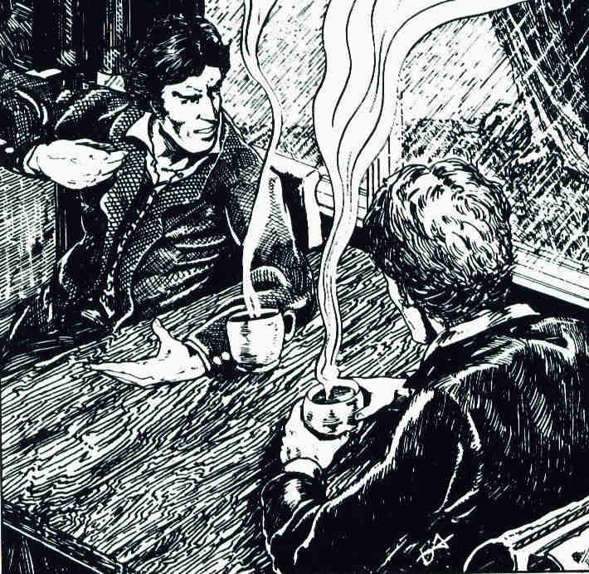

“Very well then,” said Count Dracula. “If you wish a story with a touch of mystification, I can provide one.”

It was on a raw, rainy spring night, not long ago, and the two of us were standing on a streetcorner of a northern city. Folk far madder and perhaps less probable than either the Prince of Wallachia or myself walked those streets as well. But in the presence of my companion I scarcely gave them a thought.

“I will be delighted,” I replied (naturally enough), “to hear whatever tale you may wish to tell.”

Dracula halted at a curb, the wet cold wind stirring his black hair as he stared moodily across the street. He had doubtless paused only to gather his thoughts, but a quartet of youths swaggering along on the other side of the street interpreted our hesitation as timidity. They loitered in their own walk, and one of their number called some obscenity in our direction. My companion did not appear to notice.

“I am sure you are aware” (he began his tale to me) “that with vampires, as with the greater mass of the breathing population, the vast majority are peaceable, law-abiding citizens. We seek no more, essentially, than breathers do: bodily nourishment (any animal blood will do for sustenance); the contemplation of beauty, and affection, as nourishment for the soul; an interesting occupation; a time and place in which to rest (some native soil being, in our case, very important for that purpose).

“It makes me laugh” — he laughed, and across the street four youths simultaneously remembered pressing business elsewhere — “yes, laugh, to contemplate the preposterous attributes that have been bestowed upon my branch of the human race by those breathing legendizers who have never known even one of us at first hand. Of course I am not talking about you, my friend. I mean those who have learned nothing since the last century, when the archfool Van Helsing could imagine that the symbols and the substance of religion are to us automatically repellant or even deadly. As you know, that is no more true of us than of — of some of the breathing gangsters who once made this very city legend.”

My friend paused, frowning, doubtless wishing that he had chosen some other comparison. I hastened to assure him that I would do all in my literary power to expunge from human thought the kinds of misinformation that he found so distasteful. He nodded abstractedly.

“Nevertheless” (he went on) “in our society as in yours, the rogue, the criminal, exists. I need not belabor the point that the psychopath who happens also to be a vampire is infinitely more dangerous than his mundanely breathing counterpart. Even apart from the fact that very few of your breathing people truly believe that we exist, effective countermeasures against our criminal element, while not impossible, appear to he uncommonly difficult for you to manage. The Cross, as I have said, is no deterrent at all — except perhaps to vampires of such religious nature that their consciences would be painfully affected by the sight — such probably do not pose you a major problem in any event.

“Garlic? Even less efficacious than it would be against some breathing ruffian — surely useful, if at all, only against the more fastidious and less determined. Mirrors? Useful to detect and identify us by our lack of any reflection; but with no application as weapons, except as they might be used to concentrate our great bane, natural sunlight. The older and tougher among us can bear some sun, you know, at least the cloudy, tempered sun of the high latitudes.

“Fire? By daylight, through which period we are compelled to retain whatever form we had at dawn — and moreover are likely to be resting in lethargic trance — yes, by daylight fire can he effective, whereas by night we easily avoid it.

“Ordinary bullets, blades of metal, clubs of stone, all can cause us momentary pain and superficial injury, but do us virtually no real damage at all. Any trifling harm inflicted soon disappears. Silver bullets are only advocated by those who confuse us with werewolves, or certain other creatures of the night.

“The best practical defense is doubtless to remain in your own house, admitting no one suspicious. No vampire can enter a true dwelling unless invited — but once invited, he or she may return at any time.

“And, if we consider the offensive means that ordinary breathing folk can hope to use successfully against us, almost the whole truth is contained in one short and simple word.”

By now we were strolling again. My companion was of course impervious to the chilling effects of wind and rain, but I was shivering. Taking note of this, Dracula gestured as we were passing the door of a decent-appearing tavern, and gratefully I preceded him in. We were seated in a dim, snug corner with mugs of Irish coffee before us — his of course remained untouched throughout our stay before he spoke again.

“That one word,” he said, “is wood. Ah, wood, that oh-so-nearly magical stuff, that once was living and now is not. Ah, wood . . . and that leads me to the story that I wished to tell.”

* * *

It was (Dracula continued) almost a century ago, and in another great city, one grimier and in some ways grander than this one, that I made acquaintance never mind now exactly how — with a certain professional investigator, a consulting detective whose name was then even better known than my own. We were an oddly matched pair, yet on good terms; he understood my nature better than most breathing folk have ever been able to do. Still I was greatly surprised one day when I received a message from him saying that he wished my help in a professional consultation. Naturally my curiosity was much aroused, and I agreed.

My friend the detective and I traveled down by train from London to a certain country estate in Kent. The house was a great gloomy pile, built during Elizabethan times. Its owner, besides being a man of considerable wealth, was something of an antiquarian, and also much interested in what he still called natural philosophy. It was not he, however, who had invited us to the estate, but his only child. She was a grown woman now, and married for a year. And it was she whose real name I cannot tell you even now, for at the time I swore that it would never pass my lips — she who conducted us on our arrival, with urgent speed, into a closed room for a private consultation. The room was large, and mostly lined with books, with new electric lights in its far corners, and on the huge desk an old-fashioned oil lamp, whose rays fell on a collection of curious items evidently brought together from the ends of the earth. I saw a whale’s tooth, a monkey’s skull, along with other items I did not immediately recognize. A small table at some distance from the desk held a microscope and various specimens. Along with their burden of books, the room’s many shelves held stuffed birds and animals.

“And now, your ladyship,” began my friend the detective, “we are at your service. You may speak as freely before Dr. Corday here” — he glanced in my direction — “as before myself.”

The lady, whose considerable beauty was obviously being worn away by some overwhelming fear or worry, now appeared on the verge of collapse. “Very well.” She drew a deep, exhausted breath. “I must be brief, for my father and my husband will both soon return, and I must save them, if I can . . .

“The incident that haunts me, that has driven me to the brink of madness, occurred almost exactly a year ago, and in this very room. I must confess to you that before I was married, or even knew Richard well, I was acquainted with a man, named Hayden. I have outlined to you already, sir, how that came to be —”

“You have indeed, your ladyship.” My companion gave an impatient nod. “Since our time is short, we had better concentrate on what happened between you and Hayden in this very room, as you say it was. That is the aspect of the case in which I most value Dr. Corday’s consultation.”

“You are right.” Our hostess paused again to collect herself, then plunged on. “I had not seen Hayden for many months. I was beginning to manage to forget him, when almost on the very eve of my wedding, he appeared here unexpectedly. I was alone in the house except for a few servants, my father being engaged on some last-minute business in London having to do with the arrangements.

“Hayden, of course, knew that I was alone. And his purpose in coming was of course an evil one. He had brought with him some letters — they were foolish letters indeed — that I had written him in an earlier day. The letters contained certain things that could have ruined me, had Hayden given them, as he threatened to do, to my prospective husband. I protested my innocence. He admitted it, but read from the letters certain phrases, words I had almost forgotten, that suggested otherwise. Hayden would destroy me, he swore, unless — unless ‘Here and now in this very room’ was how he put it I should should —”

For a moment the lady could not continue. My friend and I exchanged glances, of sympathy and determination, in a silent pledge that we would do everything possible to assist her. It must be hard for folk with experience only of the late twentieth century to grasp what a threat such letters could represent, to understand what impact the mere suggestion of a premarital affair could have had at that time and place, on one in her position. It would have been regarded by all her contemporaries as the literal ruin of the young lady’s life.

“I was innocent,” she repeated, when she was able to resume at last. “I swear to you both that I was. Yet that man had some devilish power, influence . . . I had broken free of it before, and as he faced me in this room I swore to myself that I would never allow it to gain the faintest hold on me again.

“ ‘Sooner or later you will have me,’ the villain said, sneering at me. ‘I have now been invited into your fine house, you see.’ Those were his words, and I have puzzled over them; alas, a greater and more horrible puzzle was to come.

“I retreated to the desk — I stood here in front of it, like this. Hayden was just there, and he advanced upon me. I cried at him to stay away. My hand, behind me on the desk, closed on a piece of stone — much like this one.” With that her ladyship raised what would now he called a geode from among the curios collected on the huge desk. “I raised it — like this — and warned him again to stop.

“Hayden only smiled at me — no, he sneered — as if the idea that I might refuse him, even resist him, were a childish fantasy that only a childish creature like myself — a mere woman — could entertain. He sneered at me, I say. His handsome face was hideously transformed, and it seemed to me that even his teeth were . . . were . . . and he came on toward me, his hands reaching out.”

The lovely narrator raised her chin. “I — hit him, gentlemen. With the stone. With all my strength. And — God help me — I think it was as much because of the way in which he looked at me, so contemptuously, as it was because of anything I feared that he might do.

“I hit him, and he fell backward, with a broad smear of blood across his forehead. I have the impression that only one of his eyes was still open, and that it was looking at me with the most intense surprise. He fell backward, and rolled halfway over on the carpet, and was still.

“I was perfectly sure looking down at his smashed face, that he was dead. Dead, and I swear to you that at that moment I felt nothing but relief. For a moment only. Then the horror began. Not an intrinsic horror at what I had done — that came to me too, but later — but horror at the fact that what I had just done was certain to be discovered, and at other discoveries that must flow from that. Even though I might — I almost certainly would — be able to plead self defense and avoid any legal penalty, yet inevitably enough information must be made public to bring ruin down upon me — and disgrace upon Richard, whom I loved . . .

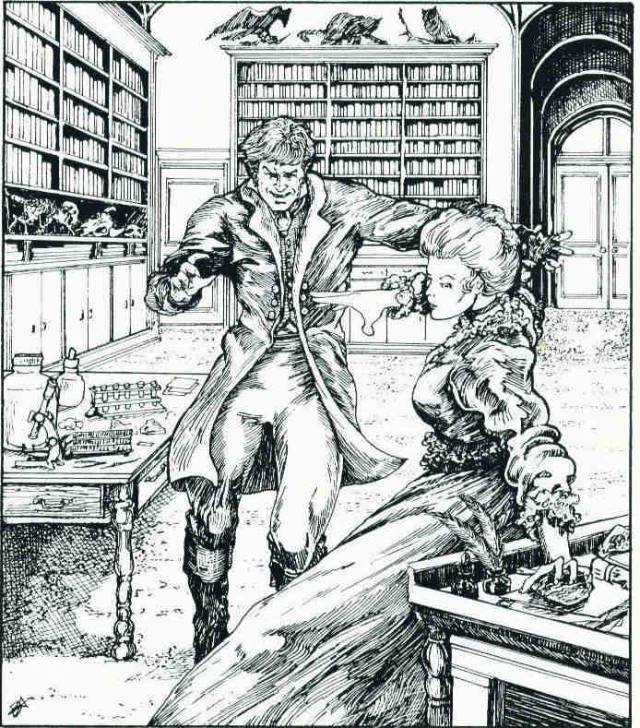

“I suppose that in that moment I was half mad with shock and grief. Not, you understand, grief for the one who, as I thought, lay dead —”

My friend interrupted. “As you thought?”

“As — let me finish, and in a moment you will understand.”

“Then pray continue.”

“My eye fell on the door of the lumber room — there.” It was a plain, small, inconspicuous door, set in the wall between bookcases, some eight or ten feet from the desk. “I seized Hayden by the ankles — to take him by the hands would have meant touching his skin, and the thought of that was utterly abhorrent to me — and I dragged him into there.”

“May I?”

“Of course.”

Taking up the lamp from the desk, my friend moved to open the small door, which was unlocked. The lamplight shining in revealed a dusty storage closet. Its walls and floor were of stone, its ceiling of solid wood; there was no window, or any other door. The chamber was half-filled with a miscellany of boxes, crates, and bundles, none larger than a bushel, and all covered with a fine film of dust that might well have lain undisturbed for the past year.

Our client joined us looking in. She said: “The room was very much as you see it now. My father uses it chiefly for storage of things he has brought back from his various travels and then never finds time to catalogue, or else judges at second thought to be not worthy of display.

“I dragged Hayden — or his body — in there, and left him on the dusty floor. Understand that this was not part of any thought-out plan for concealing what I had done. It was only a shocked reaction, like that of a child trying to hide the pieces of a broken vase. Hardly aware of what I was doing, I came back here to the middle of the room and picked up from the carpet the stone that had done the deed. I carried it into the lumber-room also, and threw it on top of that which lay on the floor already. I then came out of the lumber room and closed its door, and locked it — though it is rarely if ever locked — with a key I knew was kept in the top drawer of my father’s desk.

“Then, with mind still whirling in terror, I looked around. The letters, where were they? Still in Hayden’s pocket, for now I remember distinctly seeing him replace them there. It might be wise to get them out, but for the moment I could not think of touching him again.

“And there was blood on the carpet. I had noted that already, in my first frenzied panic. But now, as my mind made its first adjustment back toward sanity, I saw that the spots were only two or three in number, and so small against the dark pattern that no one entering the study casually would be in the least likely to notice them. Here, gentlemen, is where they were — over the past year they have faded almost to invisibility.”

My companion had crouched down and whipped out a magnifying glass, with which he scrutinized closely the indicated section of the carpet. He stood up frowning. “Pray continue,” he said again, his voice non-committal.

“I was still hovering near the desk, in a state of near-panic, not knowing what to do, when as in a nightmare I heard a brisk knock on the door to the hall, and the voice of my beloved Richard. A moment later, before I could say anything at all, the hall door opened and Richard came in. From the look on his face I knew immediately that he was aware at least of something gravely wrong.

“My fiance evidently already knew much more about Hayden than I had ever suspected. Perhaps the duke, Richard’s father, had employed investigators — to this day I do not know what had made my dear one suspicious of me. But he was full of suspicion on that day, and with cause — though not with as great cause as he feared.

“Richard confronted me. ‘He was seen coming in here, the man Hayden. Do you tell me that he is not here now?’

“I do not remember what I said in reply. I must however have looked the very picture of guilt.

“Richard looked quickly round the study, even peering behind pieces of furniture where a man might possibly have had room to lie concealed. It took him only a moment to do so; the furniture was then very much as it is now, and offered as you can see, little in the way of hiding places.

“He tried the door of the lumber-room then, and I was sure for a moment that my heart had stopped.

“This door is locked. Do you know, Louise, where the key is kept?”

“I understood perfectly that he would force the door at once if no key were available. Silently I went to the desk, and got the key from the upper drawer, where, in my confusion I had just replaced it; I handed it to Richard, still without a word. At that moment I knew with certainty that final ruin was upon me, and I could not bear another instant the horror of waiting for the blow to fall I thought that after Richard had seen what I had done, then, in that moment of his greatest shock, I might appeal to him. I could only hope that he loved me as truly and deeply as I did him.

“But his gaze was black and forbidding as he took the key from my hand and turned away. He was in the lumber-room for only a few moments, but I need not tell you what an eternity they seemed to me. When he reappeared, his face was altered; yet even as 1 gazed at him in despair, a sudden new hope was born within my breast. For his new expression was not so much one of horror or shock, as one expressing a great relief, even though mingled with shame and bewilderment.

“For a moment he could not speak. Then ‘Darling’, he said at last, and his voice cracked, even as mine had moments earlier. ‘Can you ever forgive me for having doubted you?’

“Without answering, I pushed past Richard to the door of the lumber-room. Everything inside, with one great exception, was just as I had seen it a few minutes earlier before I had locked the door. There were the dusty crates and cartons, untouched, certainly, by any human hand in the intervening time. There on the floor, in lighter dust and hardly noticeable, were the tracks left by my own feet on my first entrance, and by the horrible burden that I had dragged in with such difficulty. There was the stone with which I had struck the fateful blow — but the piece of stone lay now in the middle of the otherwise empty patch of bare floor. Of the body of the man I had struck down there was not the smallest trace.”

My friend the detective emitted a faint sigh, expressing what in the circumstances seemed a rather inhuman degree of intellectual satisfaction. “Most interesting indeed,” he murmured soothingly. “And then?”

“There is very little more that I can tell you. I murmured something to Richard; he, assuming my state of near-collapse was all his fault for behaving, as he said, brutally, made amends to the best of his ability. To make the story short, we were married as planned, Hayden’s name has never since been mentioned between us. Our life together has been largely uneventful, and in all outward aspects happy. But I tell you, gentlemen since that day I have lived in inward terror . . . either I am mad, and therefore doomed, and imagined the whole ghastly scene in which I murdered Hayden; or I did not imagine it. Then he was only stunned. He somehow extricated himself from that lumber-room. He is lying in wait for me. Somewhere, sometime . . . neither of you know him, what he can be like . . . he still has the letters, yet he has in mind some revenge that would he even more horrible . . . I tell you I can bear it no longer . . .” The lady sank into a chair, struggling to control herself.

The detective turned to me. “Dr. Corday, it is essential that we ascertain the — nature of this man Hayden,” A meaningful glance assured me what sort of variations in nature he had in mind.

I nodded, and addressed myself to the lady, who had now somewhat recovered. “At what time of day, madam, did these events occur? Can we be absolutely sure that they took place after dawn and before sunset?”

The lady looked for a moment as if she suspected that madness was my problem instead of hers. “In broad daylight, surely,” she replied al last. “Though what possible difference . . .”

I signed to my friend that I must speak to him in confidence. After a hurried apology to our client we withdrew to a far corner of the study. “The man she knocked down,” I informed the detective there, “could not possibly have been a vampire, because of the force of the blow that felled him was borne in stone, to which we are immune. Nor could he, even supposing him to be a vampire, have shifted form in broad daylight, and escaped as a mist from that closet under the conditions we have heard described; nor could he in daylight have taken on the form of a small animal and hidden himself somewhere among those crates and boxes.”

“You are quite sure of all that?”

“Quite.”

“Very good.” My friend received my expert opinion with evident satisfaction, which surprised me.

For my own part, it seemed to me that we were getting nowhere. “My life has been very long,” I added, and active, if not always well spent. I have seen madness . . . much madness. And I tell you that the lady here, if I am any judge, is neither mad nor subject to hallucinations.

“In that opinion I concur.” Still my friend did not appear nearly as disconcerted as it seemed to me he should. There was, in fact, something almost like a twinkle in his eye.

“Then what are we to make of this?” I demanded.

“I deduce . . .”

“Yes?”

Again the twinkle. “That one of her father’s trips abroad, before the wedding, took him to Arizona. But of course I must make sure.” And with that, leaving me in a state that I confess approached speechlessness, my friend went back across the room.

He approached our client, who still sat wearily in her chair, and extended both his hands. When she took them. wonderingly, he raised her to her feet. “One more question.” he urged her solemnly. “The stone with which you struck down Hayden — where is it now? Surly it is not one of those still on the desk.”

“No,” the lady marveled. “I could not bear to leave it there.” Going back to the door of the lumber-room, she reached inside, and from a shelf took down a pinkish stone of irregular, angular shape, a little larger than a man’s fist. This she presented to my friend.

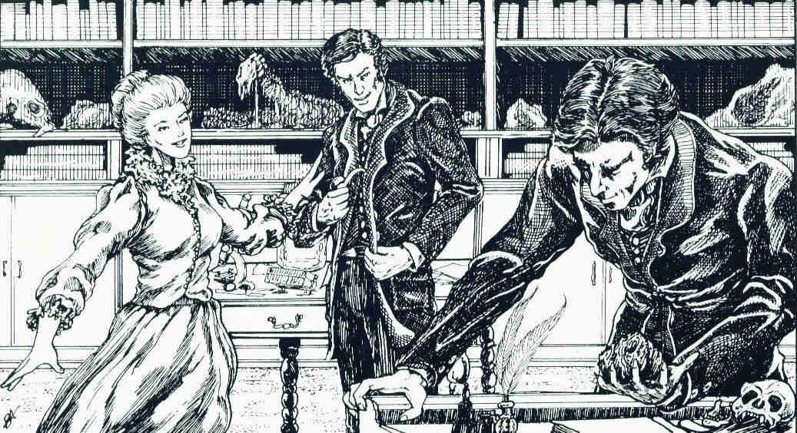
He turned it over in his hands, and set it back upon he desk A confident smile now transformed his face. “It is my happy duty to inform you,” he said at once, “that the man you knew as Hayden will never bother you again; you may depend upon it.”

* * *

Dracula paused here in his narration. “In a moment I was able to add my own assurances for what they were worth, to those of the famed detective. That was after I had walked over to the desk and looked at he weapon for myself. I knew then that the man struck down with it could indeed have been a vampire; nay, that he must have been. For when he died of the effects of the blow, there on the floor of the lumber-room, his body, as is commonly the case with us, had at once undergone a dissolution to dust, and less than dust. His clothing including the letters in his pocket, had, as would be expected disappeared as well. No humanly detectable trace was left when the fiance opened the door a few moments later.”

“A vamipire?” I protested. “But, he was struck down with a stone . . .”

“I was looking,” said Dracula softly, “at a choice Arizona specimen of petrified wood.”

* * * *

Fred Saberhagen is an amazing writer of both SF and fantasy. He may be best known for his Beserker stories, and for the Empire of the East fantasy/sf epic. His tales of Dracula and Sherlock Holmes (of which this story is one) have delighted readers with the unusual turn of viewpoint unique to his depiction if the famous characters. Saberhagen’s full-length novels in this vein include The Holmes-Dracula File, The Dracula Tape, Thorn, and An Old Friend of the Family. Vampires may not he exactly what you think!

* * *

Scanned and Proofed by Amigo da Onça

