THE GIRL IN HIS MIND

By ROBERT F. YOUNG

Every man's mind is a universe with countless places in which he can hide — even from himself!

**T**he dance that the chocoletto girl was performing was an expurgated version of the kylee sex ritual which the Louave maidens of Dubhe 7 practiced on the eve of their betrothal. Expurgated or not, however, it was still on the lascivious side. The G-string that constituted the chocoletto girl's entire costume put her but one degree above the nakedness which the original dance demanded. Nathan Blake's voice was slightly thick when he summoned the waiter who was hovering in the shadows at the back of the room. "Is she free?" he asked.

"l do not know, mensakin. Perhaps."

Blake resumed watching. The girl's movements were a delicate blend of love and lust. Her face accompanied her body, eyes half- lidded one moment to match the languid motion of her limbs, wide and feral the next to match the furious bump and grind of her hips. For a chocoletto she was light-skinned — more bronze, really, than brown. But then, the word "chocoletto", coined by the early beche-lar-mer traders, was misleading, and few of the natives of Dubhe 4's southernmost continent lived up to it completely.

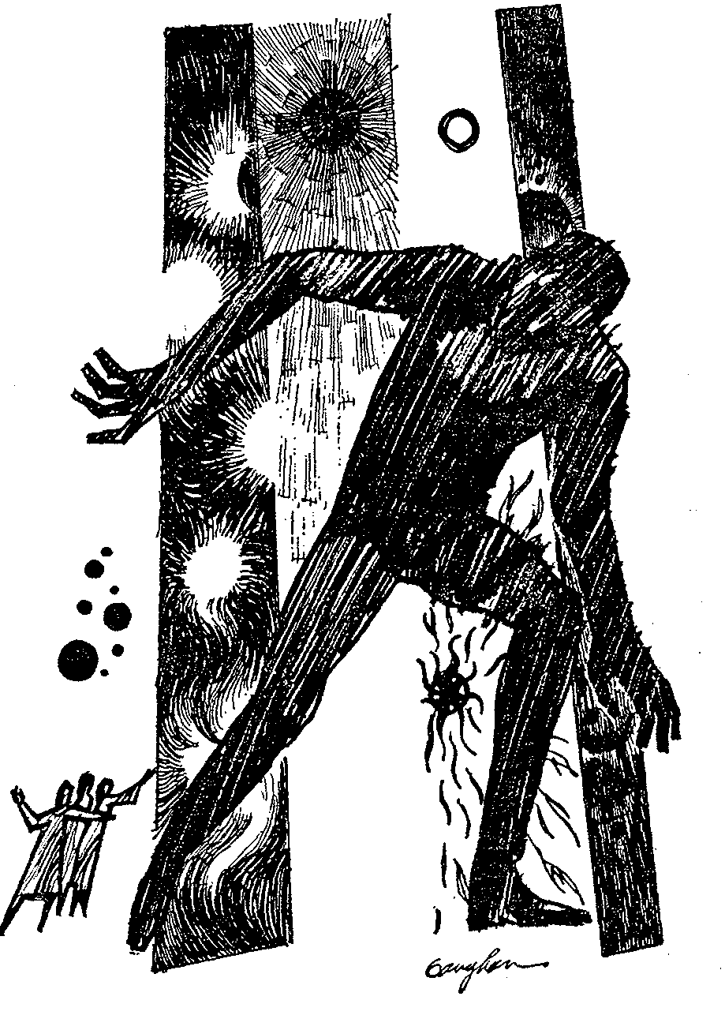

She was beautiful too. Her high-cheekboned face was striking — the eyes dark-brown and wide-apart, the mouth sensuous, the teeth showing in a vivid white line between the half-parted purple lips. And her body was splendid. Blake had never seen anyone quite like her.

He beckoned to her when the dance was over and, after slipping into a white thigh-length tunic, she joined him at his table. She ordered Martian wine in a liquid voice, and sipped it with a finesse that belied her cannibalistic forebears. "You wish a night?” she asked.

Blake nodded. "If you are free."

"Three thousand quandoes."

He did not haggle, but counted out the amount and handed it to her. She slipped the bills into a thigh sheath-purse, told him her hut number and stood up to leave. "I will meet you there in an hour," she said.

Her hut was as good a place to wait for her as any. After buying a bottle of native whiskey at the bar, Blake went out into the Dubhe 4 night and made his way through the labyrinthine alleys of the native sector. In common with all chocoletto huts, Eldoria's was uncared for on the outside, and gave a false impression of poverty. He expected to find the usual hanger-on waiting in the anteroom, and looked forward to booting him out into the alley. Instead he found a young girl —

A human girl.

He paused in the doorway. The girl was sitting cross-legged on a small mat, a book open on her lap. Xenophon's *Anabasis.* Her hair made him think of the copper-colored sunrises of Norma 9 and her eyes reminded him of the blue tarns of Fornax 6. "Come in," she said.

After closing the door, he sat down opposite her on the guest mat. Behind her a gaudy arras hid the hut's other room. "You are here to wait for Eldoria?" she asked.

Blake nodded. "And you?"

She laughed. "I am here because I live here," she said.

He tried to assimilate the information, but could not. Perceiving his difficulty, the girl went on, "My parents indentured themselves to the Great Starway Cartel and were assigned to the rubber plantations of Dubhe 4. They died of yellow-water dysentery before their indenture ran out, and in accordance with Interstellar Law I was auctioned off along with the rest of their possessions. Eldoria bought me."

Five years as a roving psycheye had hardened Blake to commercial colonization practices; nevertheless, he found the present example of man's inhumanity to man sickening.

"How old are you?" Blake asked.

"Fourteen."

"And what are you going to be when you grow up?"

"Probably I shall be a psychiatrist. Eldoria is sending me to the mission school now, and afterward she is going to put me through an institute of higher learning. And when I come of age, she is going to give me my freedom."

"I see," Blake said. He indicated the book on her lap. "Homework?"

She shook her head. "In addition to my courses at the mission school, I am studying the humanities."

"Xenophon," Blake said. "And I suppose Plato too."

"And Homer and Virgil and Aeschylus and Euripides and all the rest of them. When I grow up I shall be a most well-educated person."

"I'm sure you will be," Blake said, looking at the arras.

"My name is Deirdre."

"Nathan," Blake said. "Nathan Blake."

"Eldoria will be arriving soon. I must go and prepare her dais."

**S**he got up, parted the arras, and slipped into the next room. Shame flamed in Blake's cheeks, and for a moment he considered leaving; then he remembered Eldoria's dance, and he went right on sitting where he was.

Presently the girl returned, and not long afterward the cloying scent of native incense crept beneath the arras and permeated the anteroom. She sat sideways on the mat this time, and he caught her face in profile. There was a suggestion of saintliness in the line of the nose and chin, a suggestion made all the more poignant by the slender column of the neck. He shifted uncomfortably on the guest mat. She had taken up the *Anabasis* again, and silence was pounding silent fists upon the walls.

He was relieved when Eldoria finally arrived. She ushered him into the next room immediately. It was slightly larger than the anteroom, and much more richly appointed. A thick carpet the color of Martian waterways lay upon the floor, contrasting pleasantly with the golden tapestries that adorned all four walls. The sleeping dais was oval and took up nearly half the floor space. It was strewn with scarlet cushions.

Blake sat down upon it. Nervously he watched Eldoria slip out of her white street robe, his eyes moving back and forth from her smooth dark skin to the arras. The incense thickened around him.

She noticed the back-and-forth movement of his eyes. "You need not fear the little one," she said, laying her hand upon his knee. "She will not enter."

"It's not that so much," Blake said.

"What?" The warm bronze shoulder was touching his...

He rose up once in the night, thinking to find his hotel bed. His next awakening was in the grayness of dawn, and he got up and dressed and moved silently to the doorway. The girl slept just without the arras on a thin sleeping-mat, and he had to step over her to gain the anteroom. In sleep, a strand of her copper-colored hair had tumbled down across her forehead and lay like a lovely flower upon the virginal whiteness of her skin. There was something saintly about her quiet face.

When he reached the alley he began to run, and he did not stop running till the chocoletto sector was far behind him.

**T**he hill was a memory-image and Aldebaran 12 rain-country hills were notoriously steep. Blake was breathing hard when he reached the crest.

Before him lay a memory-image of a section of Deneb 1 wasteland. The image extended for no more than half a mile, but Blake was annoyed that he should have remembered even that much of the wretched terrain. Ideally, a man's mind-country should have been comprised only of the places and times he wanted to remember. Practically, however, that was far from being the case.

He glanced back down into the rain-pocked valley that he had just crossed. The rain and the mist made for poor visibility. He could only faintly distinguish the three figures of his pursuers. The trio seemed a little closer now.

Ever since he had first set foot into his mind, some ten hours ago, they had been on his trail, but for some reason he had been unable to bring himself to go back and find out who they were and what they wanted. Hence he was as vexed with himself as he was with them.

After resting for a few minutes, he descended the hill and started across the Deneb 1 wasteland. It was a remarkably detailed materialization, and his quarry's footprints stood out clearly in the duplicated sand.

Sabrina York did not even know the rudiments of the art of throwing off a mind-tracker. It would have done her but little good if she had, for twelve years as a psycheye had taught Blake all the tricks. Probably she had taken it for granted that the mere act of hiding out in her tracker's mind was in itself a sufficient guarantee of her safety. After all, she had no way of knowing that he had discovered her presence.

Mind-country was as temporally inconsecutive as it was topographically incongruous, so Blake was not surprised when the Deneb 1 wasteland gave way to an expanse of boyhood meadow. Near the meadow was the house where Blake had lived at a much later date. In reality, the places were as far apart in miles as they were in years, but here in the country of his mind they existed side by side, surrounded by heterogeneous landscapes from all over the civilized sector of the galaxy and by the sharply demarcated spectra of a hundred different suns. A few of the suns were in the patchwork sky — Sirius, for example, and its twinkling dwarf companion. Most of them, however, were present only in their remembered radiance. To add to the confusion, scattered night memories interrupted the hodgepodge horizon with columns of darkness, and here and there the gray column of a dawn or dusk memory showed.

The house was flanked on one side by a section of a New Earth spaceport and on the other by an excerpt of an Ex-earth city-block. Behind it flowed a brief blue stretch of Martian waterway.

Sabrina's footsteps led up to the front door, and the door itself was ajar. Perhaps she was still inside. Perhaps she was watching him even now through one of the remembered windows. He scanned them with a professional eye, but saw no sign of her.

Warily he stepped inside, adjusting the temperature of his all-weather jacket to the remembered air-conditioning. His father was sitting in the living room, smoking, and watching 3V. He had no awareness of Blake. At Blake's entry he went right on smoking and watching as though the door had neither opened nor closed. He would go right on smoking and watching till Blake died and the conglomeration of place-times that constituted Blake's mind-world ceased to be. Ironically, he was watching nothing. The 3V program that had been in progress at the time of the unconscious materialization had failed to come through.

**T**he memory was a treasured one —the old man had perished in a 'copter crash several years ago — and for a long while Blake did not move. He had never been in his own mind before. Consequently he was more affected that he might otherwise have been. Finally, stirring himself, he walked out into the kitchen. On a shelf above the sink stood a gaily colored box of his mother's favorite detergent with a full-length drawing of Vera Velvet-skin, the company's blond and chic visual symbol, on the front. His mother was standing before the huge automatic range, preparing a meal she had served twenty-three years ago. He regarded her with moist eyes. She had died a dozen years before his father, but the wound that her death had caused had never healed. He wanted to go up behind her and touch her shoulder and say, "What's for supper, mom?" but he knew it would do no good. For her he had no reality, not only because he was far in her future, but because in his mind-world she was a mortal and he, a god — a picayune god, perhaps, but a real one.

As he was about to turn away, the name-plate on the range caught his eye, and thinking that he had read the two words wrong, he stepped closer so that he could see them more clearly. No, he had made no mistake: the first word was "Sabrina", and the second was "York".

He stepped back. Odd that a kitchen range should have the same name as his quarry. But perhaps not unduly so. Giving appliances human names had been common practice for centuries. Even a name like "Sabria York", while certainly not run-of-the-mill, was bound to be duplicated in real life. Nevertheless a feeling of uneasiness accompanied him when he left the kitchen and climbed the stairs to the second floor.

He went through each room systematically, but saw no sign of Sabrina York. He lingered for some time in his own room, wistfully watching his fifteen-year-old self lolling on the bed with a dog-eared copy of *The Galaxy Boys and the Secret of the Crab Nebula*, then he stepped back out into the hall and started to descend the stairs.

At the head of the stairs a narrow window looked out over the front yard and thence out over the meadow He glanced absently through the panes, and came to an abrupt halt. His three pursuers were wading through the long meadow grass less than a quarter of a mile away — not close enough as yet for him to be able to make out their faces, but close enough for him to be able to see that two of them were wearing dresses and that the third had on a blue skirt and blouse, and a kepi to match. He gasped. It simply hadn't occurred to him that his pursuers might be women. To his consternation he discovered that he was even more loath to go back and accost them than he had been before. He actually had an impulse to flee.

He controlled it and descended the stairs with exaggerated slowness, leaving the house by way of the back door. He picked up Sabrina's trail in the back yard and followed it down to the Martian waterway and thence along the bank to where the waterway ended and a campus began. Not the campus of the university which he had visited two days ago to attend his protegee's graduation. It was not a placetime that he cared to revisit, nor a moment that he cared to relive, but Sabrina's trail led straight across the artificially stunted grass toward the little bench where he and Deirdre Eldoria had come to talk after the ceremony was over. He had no choice.

**T**he bench stood beneath a towering American elm whose feathery branches traced green arabesques against the blue lune sky. A set of footprints slightly deeper than its predecessors indicated that Sabrina had paused by the trunk. Despite himself Blake paused there too. Pain tightened his throat when he looked at Deirdre's delicate profile and copper-colored hair, intensified when he lowered his eyes to the remembered blueness of her graduation dress. The diamond brooch that he had given her as a graduation present, and which she had proudly pinned upon her bodice for the whole wide world to see, made him want to cry. His self-image of two weeks ago shocked him. There were lines on the face that did not as yet exist, and the brown hair was shot with streaks of gray that had yet to come into being. Lord, he must have been feeling old to have pictured himself like that!

Deirdre was speaking. "Yes," she was saying, "at nine o'clock. And l should very much like for you to come."

Blake Past shook his head. "Proms aren't for parents. You know that as well as I do. That young man you were talking with a few minutes ago — he's the one who should take you. He'd give his right arm for the chance."

"I'll thank you not to imply that you're my father. One would think from the way you talk that you are centuries old!"

"I'm thirty-eight," Blake Past said, "and while I may not be your father, I'm certainly old enough to be. That young man—"

A pink flush of anger climbed into Deirdre Eldoria's girlish cheeks. "What right has *he* got to take me! Did *he* scrimp and go without in order to put me through high school and college? Has *he* booked passage for me to New Earth and paid my tuition to Trevor University?"

"Please," Blake Past said, desperation deepening his voice. "You're only making everything worse. After majoring in Trevorism, you certainly ought to realize by now that there was nothing noble about my buying you after Eldoria died. I only did it to ease my conscience—"

"What do *you* know about conscience?" Deirdre demanded. "Conscience is a much more complex mechanism than most laymen realize. Guilt feelings aren't reliable criteria. They can stem from false causes — from ridiculous things like a person's inability to accept himself for what he is." Abruptly she dropped the subject. "Don't you realize, Nate," she went on a little desperately, "that I’m leaving tomorrow and that we won't see each other again for years and years?"

"I'll come to New Earth to visit you,” Blake said. "Venus is only a few days distant on the new ships."

She stood up. "You won't come — I know you won't" She stamped her foot. "And you won't come to the prom either. I know that too. I knew it all along; Sometimes I'm tempted to —" Abruptly she broke off. "Very well then," she went on, "I'll say good-by now then."

Blake Past stood up too. "No, not yet. I'll walk back to the sorority house with you."

She tossed her head, but the sadness in her tarn-blue eyes belied her hauteur. "If you wish," she said.

**B**lake Present watched them set out side by side toward the remembered halls of learning that showed in the distance. There had been other people present on the campus that afternoon, but as they had failed to register on Blake Past's mind, they did not exist for Blake Present. All that existed for Blake Present were the diminishing figures of the girl and the man, and the pain that was constricting his throat.

Wretchedly he turned away. As he did so he saw the three shadows lying at his feet and knew that his pursuers had at last caught up to him.

His first reaction when he faced them was amazement. His next reaction was shock. His third was fear.

His amazement resulted from recognition. One of the three women arrayed before him was Miss Stoddart, his boyhood Sunday-school teacher. Standing next to her in a familiar blue uniform was Officer Finch, the police woman who had maintained law and order in the collective elementary school he had attended. Standing next to Officer Finch was blond and chic Vera Velvetskin, whose picture he had seen on box after countless box of his mother's favorite detergent.

His shock resulted from the expressions on the three faces. Neither Miss Stoddard, nor Officer Finch ever particularly liked him, but they had never particularly disliked him either. This Miss Stoddart and this Officer Finch disliked him, though. They hated him. They hated him so much that their hatred had thinned out their faces and darkened their eyes. More shocking yet, Vera Velvetskin, who had never existed save in some copywriter's mind, hated him too. In fact, judging from the greater thinness of her face and the more pronounced darkness of her eyes, she hated him even more than Miss Stoddart and Officer Finch did.

His fear resulted from the realization that his mind-world contained phenomena it had no right to contain — not if he was nearly as well-adjusted as he considered himself to be. The three women standing before him definitely were not memory-images. They were too vivid, for one thing. For another, they were aware of him. What were they, then? And what were they doing in his mind?

He asked the two questions aloud.

Three arms were raised and three forefingers were pointed accusingly at his chest. Three pairs of eyes burned darkly. "You ask us that?" Miss Stoddart said. "Callous creature who did a maiden's innocence affront!" said Officer Finch. "And sought sanctuary in ill-fitting robes of righteousness!" said Vera Velvetskin. The three faces moved together, blurred and seemed to blend into one. The three voices were raised in unison: "You know who we are, Nathan Blake. *You* know who we are!"

Blake stared at them open-mouthed. Then he turned and fled.

**III**

**I**t had taken man a long time to discover that he was a god in his own right and that he too was capable of creating universes. Trivial universes, to be sure, when compared with the grandeur and scope of the objective one, and peopled with ghosts instead of human beings; but universes nonetheless.

The discovery came about quite by accident. After projecting himself into a patient's memory one day, a psychology named Trevor suddenly found himself clinging to the slope of a traumatically distorted mountain. His patient was beside him.

The mountain proved to be an unconscious memory-image out of the patient's boyhood, and its country proved to be the country of the patient's mind. After many trials and errors, Trevor managed to get both himself and his patient back to the objective world, and not long afterward he was able to duplicate the feat on another case.

The next logical step was to enter his own mind, and this he also succeeded in doing.

It was inevitable that Trevor should write a book about his discovery and set about founding a new school of psychology. It was equally inevitable that he should acquire enemies as well as disciples. However, as the years passed and the new therapy which he devised cured more and more psychoses, the ranks of his disciples swelled and those of his enemies shrank. When, shortly before his death, he published a paper explaining how anyone could enter his or her own mind-world at will, his niche in the Freudian hall of fame was assured.

The method employed an ability that had been evolving in the human mind for millennia — the ability to project oneself into a past moment — or to use Trevor s term, a past "place-time". Considerable practice was required before the first transition could be achieved, but once it was achieved, successive transitions became progressively easier. Entering another person's mind-world was of course a more difficult undertaking, and could be achieved only after an intensive study of a certain moment in that person's past. In order to return to the objective world, it was necessary in both cases to locate the most recently materialized place-time and take one step beyond it.

By their very nature, mind-countries were confusing. They existed on a plane of reality that bore no apparent relationship to the plane of the so-called objective universe. In fact, so far as was known, this secondary — or subjective — reality was connected to so-called true reality only through the awareness of the various creators. In addition, these countries had no outward shape in the ordinary sense of the word, and while most countries contained certain parallel images, these images were subject to the interpretation of the individual creator. As a result they were seldom identical.

**I**t was inevitable that sooner or later some criminal would hit upon the idea of hiding out in his own mind-world till the statute of limitations that applied to his particular crime ran out, and it was equally inevitable that others should follow suit. Society's answer was the psyche-police, and the psyche-police hadn't been in action very long before the first private psycheye appeared.

Blake was one of a long line of such operators.

So far as he knew, the present case represented the first time a criminal had ever hidden out in the pursuer's mind. It would have been a superb stratagem indeed if, shortly after her entry, Sabrina York had not betrayed her presence. For her point of entry she had used the place-time materialization of the little office Blake had opened on Ex-earth at the beginning of his career. Unaccountably she had ransacked it before moving into a coterminous memory-image.

Even this action wouldn't have given her away, however, if the office hadn't constituted a sentimental memory. Whenever Blake accepted a case he invariably thought of the bleak and lonely little room with its thin-gauge steel desk and battered filing cabinets, and when he had done so after accepting his case—or was it before? He couldn't quite remember—the mental picture that had come into his mind had revealed open drawers, scattered papers and a general air of disarray.

He had suspected the truth immediately, and when he had seen the woman's handkerchief with the initials "SB" embroidered on it lying by one of the filing cabinets he had known definitely that his quarry was hiding out in his mind. Retiring to his bachelor quarters, he had entered at the same place-time and set off in pursuit.

Her only advantage lost, Sabrina York was now at his mercy. Unless she discovered his presence and was able to locate his most recently materialized place-time before he overtook her, her capture was assured.

Only two things bothered Blake. The little office was far in his past, and it was unlikely that anyone save the few intimate acquaintances whom he had told about it were aware that it had ever existed. How, then, had a total stranger such as Sabrina York learned enough about it to enable her to use it as a point of entry?

The other thing that bothered him was of a much more urgent nature. He had been in enough minds and he had read enough on the subject of Trevorism to know that people were sometimes capable of creating beings considerably higher on the scale of mind-country evolution than ordinary memory-ghosts. One woman whom he had apprehended in her own mind had created a walking-talking Virgin Mary who watched over her wherever she went. And once, after tracking down an ex-enlisted man, he had found his quarry holed up in the memory-image of an army barracks with a ten-star general waiting on him hand and foot. But these, and other, similar, cases had to do with maladjusted people, and moreover, the super-image in each instance had been an image that the person involved had *wanted* to create. Therefore, even assuming that Blake was less well-adjusted than he considered himself to be, why had he created three such malevolent super-images as Miss Stoddart, Officer Finch, and Vera Velvetskin?

**T**hey followed him off the campus into a vicarious memory-image of Walden Pond, Thoreau's shack, and the encompassing woods. Judging from the ecstatic "oh's" and "ah's" they kept giving voice to, the place delighted them. Once, glancing back over his shoulder, he saw them standing in front of Thoreau's shack, looking at it as though it were a doll's house. Not far away, Thoreau was sitting in under a tall pine, gazing up into the branches at a bird that had come through only as a vague blur of beak and feathers.

Blake went on. Presently the Walden Pond memory-image gave way to a memory-image of an English park which the ex-Earth government had set aside as a memorial to the English poets and which had impressed Blake sufficiently when he had visited it in his youth to have found a place for itself in the country of his mind. It consisted of reconstructions of famous dwellings out of the lives of the poets, among them, a dwelling out of the life of a poet who was not in the strictest sense of the word English at all — the birthplace of Robert Burns. Oddly enough, it was Burns's birthplace that had impressed Blake most. Now the little cottage stood out in much more vivid detail than any of the other famous dwellings.

Sabrina York must have been attracted to the place, for her footprints showed that she had turned in at the gate, walked up the little path and let herself in the door.

They also showed that she had left by the same route, so there was no reason for Blake to linger. As a matter of fact, the fascination that had brought the place into being had been replaced by an illogical repugnance. But repugnance can sometimes be as compelling a force as fascination, and Blake not only lingered but went inside as well.

He remembered the living room distinctly —the flagstone floor, the huge grill-fronted hearth, the deeply recessed window, the rack of cups and platters on the wall, the empty straight-backed chair standing sternly in a corner, the bare wooden table —

He paused just within the doorway. The chair was no longer empty, the table no longer bare.

A man sat on the former and a bottle of wine stood on the latter. Moreover, the room showed signs of having been lived in for a long time. The floor was covered with tracked-in dirt and the walls were blackened from smoke. The grill-work of the hearth was begrimed with grease.

**W**hatever else he might be the man sitting at the table was not an image out of the past. He was too vividly real. He was around Blake's age, and about Blake's height and build. However, he was given to fat. His paunch contrasted jarringly with Blake's trim waist. His vaguely familiar face was swollen — probably from the wine he had drunk — and his too-full cheeks were well on the way to becoming jowls. His bloodshot eyes were underscored with shadows, and his clothing consisted of odds and ends out of Blake's past: a tattered, too-tight pullover with the letter "L" on the front, a pair of ragged red-plaid hunting breeches and a pair of cracked riding-boots.

Blake advanced across the room and picked up the bottle. One sniff told him that it came from a memory-image of a Martian wine-cellar. He set the bottle back down. "Who are you?" he demanded.

The man looked up at him sardonically. "Call me Smith," he said. "If I told you who I really am, you wouldn't believe me."

"What are you doing in my mind?"

"You should know the answer to that one. You put me here."

Blake stared. "Why. I've never even seen you before!"

"Granted," Smith said. "But you used to know me. As a matter of fact, you and I used to get along together famously." He reached around and got a cup off the wall-rack "Pull up a chair and have a drink. I've been expecting you."

Bewildered, Blake sat but shoved the cup aside "I don't drink," he said.

"That's right." Smith said. "Stupid of me to forget." He took a swig out of the bottle, set it back down. "Let's see, it's been seven years now. Right?"

"How the devil did you know?"

Smith sighed. "Who should know better than I? Who indeed? But I guess I can't kick too much. You certainly materialized enough of the stuff in your — shall we say 'wilder'? — days." He shook his head. "No, I can't say I've suffered in that respect."

Comprehension came to Blake then. He had heard of the parasites who lived in other person's minds, but this was the first time he had ever happened to run across one. "Why, you're nothing but a mind-comber," he said. "I should have guessed!"

Smith looked hurt. "You do me a grave injustice, friend. A very grave injustice. And after my being so considerate of this cottage and using the back door and everything! The young lady who stopped by a little while ago was much more understanding than you are."

"You talked with her then?" Blake asked. He suppressed a shudder. For some reason it horrified him that his quarry should be aware that so despicable a creature inhabited his mind. "What — what does she look like?"

*"You* know what she looks like."

"But I don't. I took the case on such short notice that I didn't have a chance to get a picture or even a description of her."

Smith regarded him shrewdly. "What did she do?"

"She murdered her father," Blake said.

Smith guffawed. "I should have known it would be something like that. Ties in perfectly. By the way, what's her name?"

"Sabrina York — not that it's any of your business."

"Oh, but it is my business — as much my business as yours. As a matter of fact, I'm going to help you find her."

Blake stood up. "No, you're not," he said. "You're going to get out of my mind and you're going to stay out —"

He paused as a knock sounded on the door. Smith answered it, and a moment later Miss Stoddart, Officer Finch and Vera Velvetskin filed into the room and arrayed themselves before Blake. Again three arms were raised; again three forefingers were pointed accusingly at his chest. "Wretched creature!" said Miss Stoddart. "Consorting with so foul a fiend!" said Officer Finch. "And in so vile a den of iniquity!" said Vera Velvetskin.

**F**or a while Smith just stood there staring at the three visitors. Then he turned toward Blake. "Well, I'll be damned!" he said. "You really do have an overactive conscience, don't you!" He faced the three women again. "Get off his back, you creeps! Can't you see he's got enough troubles without you dogging his footsteps?" He opened the door. "Out, all of you, before I throw you out!"

Three frightened looks settled on the three thin faces, but neither Miss Stoddart nor Officer Finch nor Vera Velvetskin made a move in the direction of the door till Smith advanced upon them with lowering countenance. Then they fairly scampered from the room. Officer Finch was the last in line, and Smith helped her along with the toe of one of Blake's cracked boots. The shriek she emitted coincided with the slamming of the door.

Smith leaned weakly against the door and began to laugh. "Shut up," Blake said, "and tell me who they are!"

Tears were rolling down Smith's blotchy cheeks. *"You* know who they are. You created them, didn't you? The skinny one is the one who told you about Moses in the bulrushes and the husky one is the one who saw to it that you didn't step out of line in school and the one with the nice shape is the one you associate with the immaculateness of your mother's kitchen sink. Spiritual virtue, civil virtue—and physical virtue!"

"But why did I create them?" Blake demanded. "And why are they following me around like a bunch of vindictive harpies?"

"There!" Smith said. "You almost had it. Not harpies, though—Furies. Erinyes. Tisiphone, Megaera, Alecto. You created them because you wanted to punish yourself. You created them because you can't accept yourself for what you are. You created them because even after putting me in exile you're still conscience-crazy, and they're following you around and bugging you because you want them to follow you around and bug you — because you want to reminded, of what a heel you think you are. You always were a Puritan in wolfs clothing, Blake."

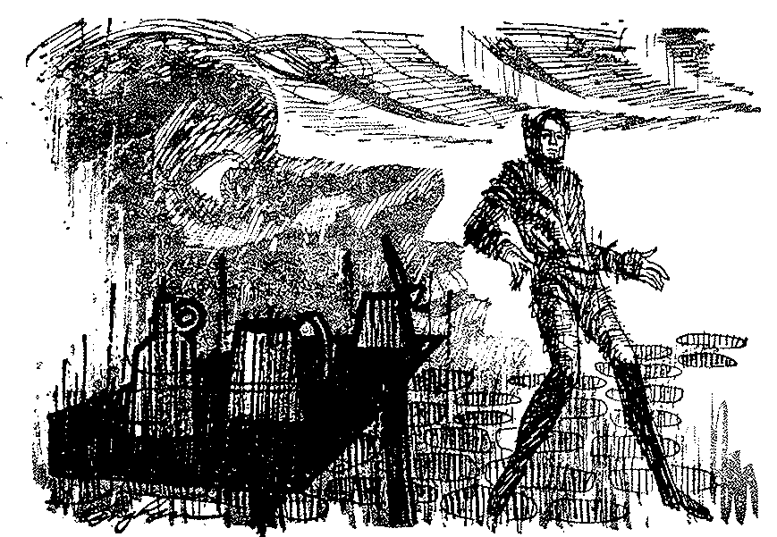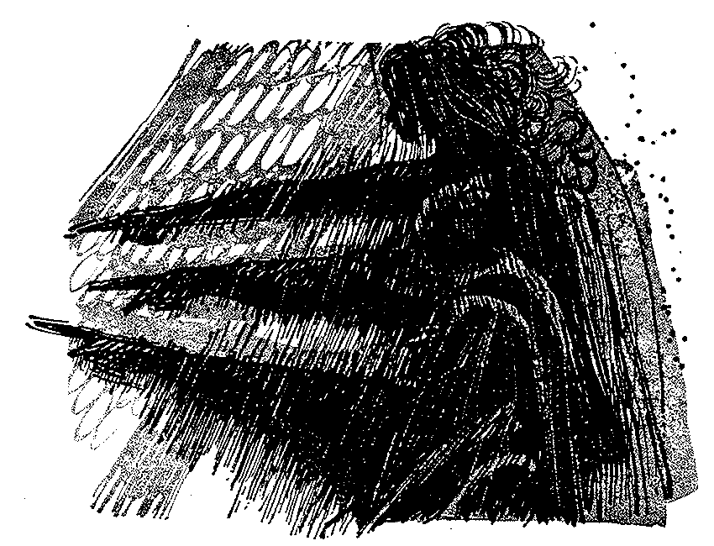

The remark angered Blake to the extent that it dispelled his amazement. He shoved Smith away from the door and opened it. "All that may be," he said, "and maybe I did know you once upon a time. But don't let me find you here when I get back. Understand?" He paused in the doorway, frowning. "Tell me one more thing, though. Why Burns's birthplace? Why should a memory-image like this appeal to a mindcomber?"

Smith grinned. "Bobby Burns has always fascinated me — just as he has you. Or should I say 'us'?" The grin turned into a leer, and he picked up the bottle and waved it back and forth like a baton —

*My love, she's but a lassie yet,*

*My love, she's but a lassie yet;*

*We'll let her stand a year or twa,*

*She'll no be half sae saucy yet;*

*I rue the day I sought her O!*

*I rue the day I sought her O!*

*Wha gets her needs na say he's woo'd,*

*But he may say he has bought her O.*

Furious, Blake strode down the path, Smith's taunting laughter sounding in his wake.

The three Erinyes were waiting for him at the gate, and fell in behind him when he turned down the lane. He lost Sabrina's trail in front of the farmhouse where Coleridge wrote *Kubla Khan,* picked it up again opposite the Mitre Tavern. Presently it veered right, passed between Milton's birthplace and Stratford-on-Avon, and entered a night-image. He was halfway down a dim-lit street, the Erinyes just behind him, before he realized where he was.

**D**isciplined trees stood at attention along two suburban strips of lawn. Beyond them, half-remembered houses showed. One of them stood out vividly — a round, modernesque affair surrounded by a quarter-acre of grass and shrubs and flowers. It was the house he had rented while Deirdre Eldoria was attending high school. It was a house he had hoped never to see again.

He was seeing it now, though, and he was going to see it at much closer quarters, for Sabrina's footprints led straight across the remembered lawn to the very doorstep. She had not gone in, however, he discovered presently; instead, she had forsaken the door for a concave picture window through which bright light streamed out onto the grass. The depth of a pair of her footprints showed that she had stood there for a long time, peeking into his past. Despite himself, Blake peeked too. So did the three Erinyes.

The room was a far cry from the one he had just left. The hearth was built of meticulously mortared red bricks. The thick rag was a two-dimensional garden of multicolored flowers. There were exquisite tables and flower-petal stools. There were deep chairs that begged to be sat in. A sybaritic sofa occupied an entire wall.

On the sofa sat a man and a girl. The man was himself at the age of thirty-four. The girl was Deirdre Eldoria, at the age of seventeen.

Blake Past was helping her with her lessons. The moment was a composite of a hundred similar scenes. Now she raised her eyes from the book on her lap, and Blake Past caught her girlish profile. . , and Blake Present, standing in the soft and scented darkness of the remembered spring night with the three Erinyes breathing down the back of his neck, caught it too, and both Blakes knew pain. Now she returned her attention to the book, and Blake Past leaned forward in order to read the passage that she was in doubt about. And as he did so, her copper-colored hair touched his cheek and the warm tingle of the contact traveled down through the years to Blake Present.

Overcome by the poignancy of the moment, he stepped back from the window, colliding with the three Erinyes as he did so. They moved a little distance away, arrayed themselves, and started to raise their right arms. "Oh, can it!" Blake said disgustedly. In the darkness behind him, someone laughed. *"My love, she's but a lassie yet,"* Smith sang in a cracked baritone. *"We'll let her stand a year or twa, she'll no be half sae saucy yet!"*

Blake whirled, and flashed his light into the shadows. The light picked up Smith's retreating figure. "Get out of my mind!" Blake shouted. "Do you hear me? Get out of my mind.'"

Laughter danced in the darkness, silence ensued. Turning back toward the window, Blake saw that Blake Past and Deirdre Yesterday were leaving the living room. He watched them come out the front door, walk around the corner of the house and start down a starlit garden path.

Forsaking Sabrina's trail, he followed them along the path, the Erinyes at his heels, and watched them sit down on a little white bench beside a rose-riotous trellis. As he watched, Blake Past broke one of the roses free and pinned it in Deirdre's cupreous hair.

Blake Present plunged away from the moment and picked up Sabrina's trail again. *Why did I sit there beside her?* he demanded silently of the remembered stars. *Sit there beside her like her lover when the roses were in bloom? Father-protector — father-fool! I slept with her mistress, and I would have been her Naoise! Within earshot of her conched ear I lay with her black whore-mother, and when the satyr in me was replete I stepped over her thin child's body and ran away!*

Behind him in the night, the Erinyes hissed and murmured to each other gloatingly.

**S**abrina's trail bad been erratic before. Now it became even more so. It approached this boundary and that, only to veer off in another direction. Sometimes it doubled back upon itself, and each time Blake was able to cut down on her lead. He should have been elated. Strangely, however, he was not. Instead, a feeling of uneasiness afflicted him, increasing as the distance between them shrank.

At length, after detouring around an impassable memory-image of deep space, the trail extended into what at first appeared to be a vast woodland park. It was not a park, though. It was a Dubhe 4 rubber plantation. Blake groaned. Did he have to relive this sequence too?

Apparently he did. Sabrina's footprints were deep and undeniable in the soft earth. They pointed unerringly in the remembered direction. Had she discovered that he was following her? Was she deliberately torturing him by making him backtrack along a mental trail that he wanted desperately to avoid? It would certainly seem so.

He forced himself to move forward among the gray ghosts of trees. He crossed a shallow, scum-covered stream, leaping from rock to rock, and afterward climbed a hill. Hearing a loud splash behind him, he turned and looked back.

Miss Stoddart, in trying to cross the stream, had lost her balance and fallen in, and Officer Finch and Vera Velvetskin were trying to help her to her feet. As he watched, they too lost their balance and joined their companion in the greenish water. There followed a period of hysterical floundering, after which the trio waded dripping and bedraggled to the bank.

Blake would have laughed, had not the place-time oppressed him. Descending the opposite slope of the hill, he entered a wide valley. Presently he glimpsed the buildings of the Great Starway Cartel processing plant through the trees.

The overseer's bungalow was visible just to the left, and it was toward this latter structure that Sabrina's footprints pointed. The original clearing had swarmed with chocolettos. Blake's, however, did not. In his single-mindedness of six years ago he had had eyes for only two people — the overseer and Deirdre.

Stepping into the clearing, he saw the man now — the bearded bestial face, the long arms, the large and hairy hands — and he saw the fifteen-year old girl lying on the ground where the man had thrown her after she had slapped his face. After a moment he saw himself of six years ago step out of the grove of rubber trees and advance white-faced into the scene,

"No!" the girl lying on the ground cried. "He'll kill you!"

Blake Past ignored her. The overseer had drawn a knife. Now the knife flashed, and a streak of crimson appeared on Blake Past's arm. The knife flashed again, but this time it described a large arc and landed a dozen feet away. Now the overseer's throat was between Blake Past's hands, and the bearded face was changing colors. It grew green first, then blue. Blake Past shook the man several times before letting him slip to the ground. He dropped a handful of *quandoe-*notes on the heaving chest.

"That’s what you paid for her," he said. He withdrew a paper from his breast pocket, unfolded it and held it before the gasping overseer's eyes. "Sign it," he said, handing it to him.

**T**he overseer did so, lying on his side. Blake Past pocketed the paper and helped the girl to her feet. The tarn-blue eyes were wide in the thin child's face. '"Eldoria died," she blurted. "They —"

Blake Past nodded. "I know. But they can't sell you any more. I own you now."

"I am glad," the girl said. "I knew from the first moment I saw you that you were noble. I shall like being your slave, and I will serve you very faithfully.”

Blake Past looked away. Blake Present lowered his eyes. "Can you walk?" Blake Past asked.

"Oh, yes. I am very strong."

She took a step forward, swayed and would have fallen, had not Blake Past caught her. "I — I guess I am not quite as strong as I thought," she said. "But I shall recuperate swiftly. Why did you come back, *mensakin* Blake?"

"I came back to buy you from Eldoria," Blake Past said. He did not add that the memory of her saintly face as he had seen it when he stepped over her had lasted a whole year, or that his dreams of her had made a mockery of his sleep. "When I found out that Eldoria had died and that you had been sold again, I came directly here."

"You will not be sorry. I will make you an excellent slave."

"I didn't buy you for that reason. I bought you to give you your—"

"There is one request I would like to make, however,"" the girl interrupted. "I would like to take 'EIdoria' as my surname. She was very kind to me, and I would like to repay her in some way."

"Very well," Blake Past said. " 'Deirdre Eldoria' it will be, then."

He picked her up and carried her into the grove. Blake Present watched them till they disappeared among the trees. He knew where Blake Past was taking her — had taken her. Back to the settlement, and from there to the spaceport, and thence to Ex-earth. Ex-earth and high school, then college —

She had never been his slave, though. He had been hers.

**S**abrina's trail circled back into the grove and left the place-time by a different route. Immediately it became erratic again. It was evident to Blake that she was searching for a particular memory-image and that she was having trouble finding it. Perhaps she knew of some moment in his past where she would be safe even from him.

When he stepped into the little Dubhe 4 settlement he instinctively assumed that it was on the same chronological plane as the plantation place-time. However, the darkness that instantly enclosed him and the stars that sprang to life in the sky apprised him that such could not possibly be the case. This was the Dubhe 4 settlement of seven years ago. This was the night he had sat in the chocoletto cafe and watched Eldoria dance — the night he had kept a tryst with her in her hut; the night he had first seen Deirdre.

But why had Sabrina come here? Where in this wretched little memory-image did she expect to find sanctuary?

Suddenly he knew. Eldoria's hut. He would rather die than enter it again, and somehow Sabrina must have discovered his attitude. Probably even now she was within those four remembered walls, laughing at him.

Anger kindled in him. The effrontery of her! Daring to pre-empt a moment that belonged solely to him! He would enter the hut if it killed him. If he had to, he would tear down its walls and banish its memory forever from the country of his mind.

With the aid of his pocket torch, he found her footprints in the dust. He followed them down the street, the three Erinyes tagging doggedly along behind him. The trail, erratic no longer, led straight to the labyrinthine alleys of the native sector and thence along the shortest route to Eldoria's hut. For a person who had never been to Dubhe 4, Sabrina York certainly knew her way around.

Maybe, though, she had been to Dubhe 4. He knew very little about her. He knew nothing at all, in fact, save that she had murdered her father. He did not even know how she had murdered him, or why. Abruptly Blake shoved the matter from his mind. It wasn't his business to know how or why she had done the deed. It was his business to find and apprehend her.

Presently, in the darkness before him, he made out a motionless white-robed figure. He approached it warily, found to his consternation that it was frozen in the act of taking a step forward. He shone his light into the face. It was dark bronze in hue. The eyes were wide apart, and the teeth showed in a vivid white line between half-parted purple lips. Eldoria, on her way to keep her tryst with him...

But why didn't she move on? Suddenly Blake knew. In treating a patient, Trevorite psychologists sometimes froze certain place-times in his past in order to study them in greater detail. The girl in Blake's mind had either frozen the Dubhe 4 place-time herself, then, or had hired a professional to do the job.

Clearly she had something up her sleeve about which Blake knew nothing.

He went on, not quite so confidently now. He had proceeded less than a dozen steps when he saw the brooch. It was lying in the dust just to the left of one of Sabrina's footprints, and it threw back the light of the torch in glittering shards that hurt his eyes. Disbelievingly, he picked it up. The Erinyes clustered around him to see what he had found. They were still wet and dishelved and reeked of the piercing odor of decayed algae. They looked anything but happy.

Blake turned the brooch over in the palm of his hand. The inscription on the back leaped up and smote him right between the eyes, and he staggered and nearly fell. *To Deirdre Eldoria*. he read, *from Nathan Blake.*

He stood there numbly for a long while, not thinking—unable to think. Finally he slipped the brooch into his pocket and moved on.

**H**e was trembling when he reached the door of Eldoria's hut. The footprints led straight up to to the threshold and came to an end. Diffidently he touched the primitive knob, turned it and pushed the door open. He stepped inside and closed the door in the faces of the three Erinyes. The remembered anteroom seemed smaller and more sordid than the original, but he knew that it was really no different. He had remembered it accurately enough. It was he who was different, not the room.

Opposite the door, Deirdre Yesterday sat immobile before the arras. Equally immobile, Blake Past sat facing her. Deirdre Yesterday's lips were parted in the midst of uttering a soundless word. The *Anabasis* lay open on her lap.

Blake Present found it difficult to breathe. The difficulty stemmed from a physical, as well as an emotional source. Someone was burning incense.

He wiped his forehead. Then, bracing himself, he walked over to the arras, parted it and stepped into the inner room.

The inner room was empty.

A small notebook lay upon the dais among the scattered scarlet cushions. Near it was a faint depression in the foamy coverlet. Blake picked up the notebook. The first page contained a hastily written message:

*Nate dearest, I've lost my nerve, and by the time you read this I shall have run away. Please forgive me for disobeying you. I wanted desperately to fulfill your wishes by going to New Earth and attending Trevor University, and now I shall, because sitting here in this little room I have faced at last the very real possibility that you really do not love me. I had hoped that by entering your mind and leading you back through our moments together to the moment when we met and by freezing that moment and letting you find me in this room, you would be shocked into associating me with Eldoria rather than with the naive little girl sitting outside the arras — with sex, rather than with saintliness; that I could bring you to understand that the little-girl image you have of me is as unrealistic as the father-image you have of yourself. But the passing moments have made me realize that all this while I have been deluding myself with false hopes and that I am merely hopelessly in love with a man who does not regard me as a woman at all, who —*

**H**ere the message broke off as abruptly as it had begun. There was a mist before Blake's eyes, and he could not swallow. He bent down and felt the depression in the coverlet. It was still warm. There had been no footprints leading *away* from the hut, he remembered.

Straightening, he surveyed the golden tapestries that adorned the room's four walls. It was not at all difficult to pick out the one behind which she was standing. It was difficult, though, to go over and raise it. Her face was pale, and the khaki hiking suit she was wearing made it seem all the more so. She stepped out of her hiding place, and he let the tapestry fall into place behind her.

She would not meet his eyes. "In another moment I would have been gone," she said. "Oh, Nate, why did you come so soon!"

Suddenly the arras parted, and Smith stepped into the room. Without pausing, he advanced across the resilient carpet, shoved Blake aside and took Deirdre into his arms. He grasped her hair, pulled her head back and bent his evil face toward hers.

Outraged, Blake seized the man's shoulder, spun him around and struck him in the mouth. Instantly his own mouth went numb, and he tasted blood.

He knew who Smith was then.

Glancing into Deirdre's eyes, he saw that she knew too, and realized that she had known all along.

He had read of the personality-splits that sometimes occurred when there was an acute conflict between the Puritan and satyr, or the good and evil, components of the psyche. But never having previously run across a real-life example he had failed to tumble to the truth when he had entered Burns's birthplace cottage and seen Smith sitting at the table.

When such splits occurred, the stronger component took over completely and the weaker component was exiled to the country of the mind. In Blake's case, the Puritan component had been the stronger, and the satyr component the weaker. Hence the latter had had to go. Smith, therefore, was but another aspect of himself — a flesh-and-blood alter ego who was overplaying his role in an attempt to force Blake into a response that would make the two of them one again.

Knowing who Smith was supplied Blake with the answer to who Sabrina York was.

Unconsciously he had been aware all along of Smith's presence in the English park image. When he discovered that Deirdre had entered his mind he had been so utterly horrified over the prospect of her running into his depraved alter ego that he had unconsciously concealed her presence from himself by supplying her with a fictitious identity. She had deliberately ransacked the little office and left her handkerchief behind in the process in order to apprise him of her whereabouts and to induce him to follow her, but he had rejected the initials "D. E." on her handkerchief and substituted the initials of the first name that came into his mind—Sabrina York. Next he had needed a logical reason to go after her and bring her back. His profession had supplied part of it, and his father-complex had supplied the other.

In entering his mind instead of going to New Earth, Deirdre had disobeyed him and thus, after a fashion, had symbolically destroyed him. Hence "Sabrina York" had become the murderer of her father, and Blake had set out in pursuit of her in his capacity as a psycheye. Deirdre had been careful to leave a clear trail, and the reason she had dropped her brooch was to assure him that he was on the right track.

Smith was wiping his mouth and grinning at the same time. Now he advanced upon the girl again. Twenty years fell from Blake's shoulders as he shoved the man aside. The column of Deirdre's neck was strong and shapely. Her breasts were in full and virginal bloom. *Who is she that looketh forth as the morning, fair as the moon, clear as the sun, and terrible as an army with banners?* Hungrily Blake took her in his arms.

When, a long time later, he released her, Smith had disappeared.

The three Erinyes were standing forlornly in the street when Blake and Deirdre left the hut. The hatred had vanished from their faces and they were looking at each other as though they had just lost their last friend. Certainly they had lost their *raison d'etre.* Blake sighed. Having created them, he was responsible for their welfare. Now that they were unemployed it was up to him to do something about it.

Deirdre was regarding them with wide eyes. "Eumenides yet!" she gasped. "Oh, Nate, if you aren't the darndest!"

Blushing, Blake took her arm and beckoned to the Erinyes to follow him. He led the way cross-country to the Walden Pond image. Thoreau was still sitting under the tall pine, gazing raptly up at the blurred bird. The sunlight was warm and benign. Blake almost wished he could remain there himself. He had always been partial to Walden Pond.

He faced the three Erinyes.

He left them planning their new way of life;

Being human, he would probably have need of them again.

END