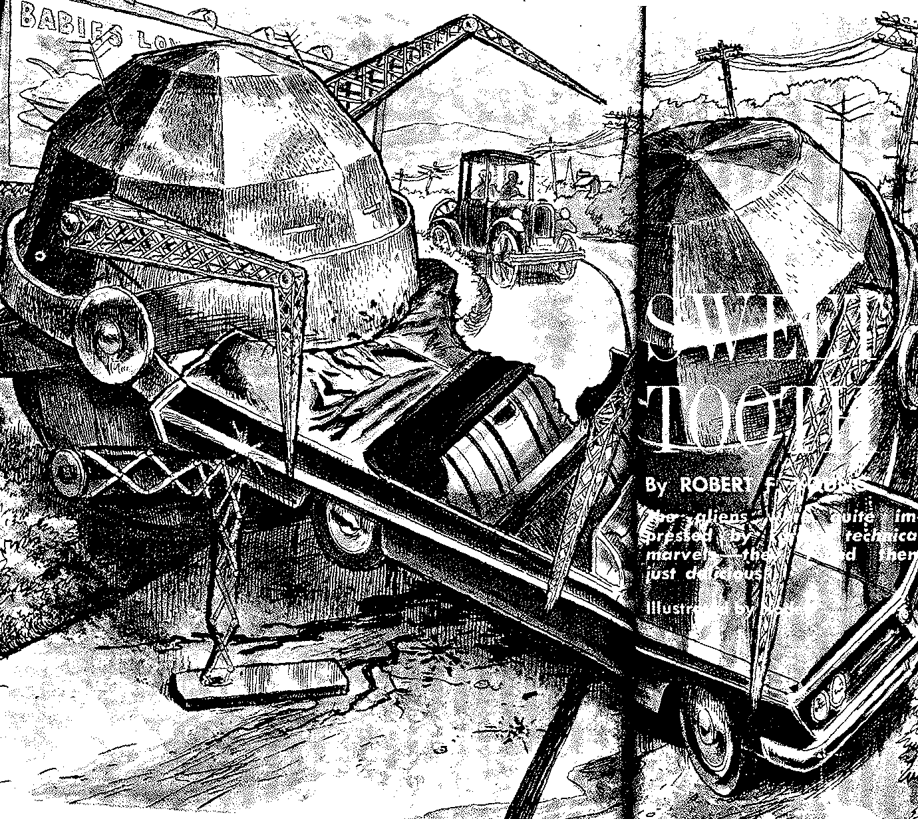

**S**UGARDALE THREE miles, the state highway sign said. Dexter Foote turned into the side road that the arrow indicated.

He had no way of knowing it at the time, but by his action he condemned his new convertible to a fate worse than death.

The side road meandered down a long slope into a wooded hollow where a breeze born of cool bowers and shaded brooks made the July afternoon heat less oppressive. A quantity of the pique that had been with him ever since setting forth from the city departed. There were worse assignments, after all, than writing up a fallen star.

Abruptly he applied the brakes and brought the convertible to a screeching halt. His blue eyes started from his boyish face.

Well they might. The two Humpty Dumptyish creatures squatting in the middle of the road were as big as heavy tanks and, judging from their “skin tone,” were constructed of similar material. They had arms like jointed cranes and legs like articulated girders. Their scissors-like mouths were slightly open, exposing maws the hue of an open hearth at tapping time. Either they were all body and no head, or all head and no body. Whichever was the case, they had both eyes and ears. The former had something of the aspect of peek holes in a furnace door, while the latter brought to mind lopsided TV antennae.

As Dexter watched, the foremost of the two metallic monsters advanced upon the convertible and began licking the chrome off the grill with a long, tong-like tongue. Meanwhile, its companion circled to the rear and took a big bite out of the trunk. There was an awesome CRUNCH! and the convertible gave a convulsive shudder.

At this point, Dexter got out and ran. More accurately, he jumped out and ran. A hundred feet down the road, he stopped and turned. He was just in time to see monster No. 1 bite off the right headlight. CRUNCH! Not to be outdone, monster No. *2* bit off the right taillight. CRUNCH-CRUNCH! An acrid odor affronted Dexter’s nostrils, and he discerned a faint yellow haze hovering about the convertible. The rear wheels went in two bites. The 250 H.P. motor required three. CRUNCH-CRUNCH-CRUNCH! The upholstery caught fire and began to burn. A gout of flame shot up as the gas tank exploded. Far from discouraging the two monsters, the resultant inferno merely served to whet their appetities. CRUNCH-CRUNCH-CRUNCH-CRUNCH!

Dexter’s shoulders sagged, and the spot next to his heart that the convertible had shared with his best girl gave a spasmodic twinge. Removing his suitcoat and slinging it over his shoulder, he turned his back on the grisly repast and set out sadly for Sugardale.

He had not gone far before his stalled thought-processes got into gear again.

**T**HE FALLING star he had been assigned by his editor to write up had been an unusually brilliant one according to the report the paper had received. Maybe its unusualness did not stop there. Maybe it was something more than a mere meteorite. Certainly the two monsters could not be classified as local woodland creatures.

All of which was fine as far as copy was concerned. But it didn’t bring his convertible back.

Presently he saw two sizable deposits of slag at the side of the road, and approaching them more closely, he discovered that they were still warm. Could they be the remains of a previously devoured automobile? he wondered. What an ignominious fate indeed to overtake a car! He looked at the two deposits once more before moving on. All he could think of were two piles of elephant dung.

A mile and half later, he emerged in a small valley that sported a handful of houses, a scattering of business places, a church or two and a goodly number of trees. A roadside sign informed him that he had reached his destination, that its population was 350, and that its speed limit was 20 mph. The population, however, was nowhere in evidence, and the speed limit seemed silly in view of the absence of cars.

A scared-looking housewife, upon whose door he knocked, told him he’d probably find the local minion of the law at the Sugardale Inn, “sucking up beer the way he always is when he should be out earning his money.” The Inn turned out to be a sagging three-story structure in desperate need of a paint-job. There was a model A sedan parked in front of it, the first automobile Dexter had seen. Formerly the establishment had provided a haven for weary travelers. Now it provided a haven for contented cockroaches. Its *fin de siecle* bar was a collector’s item, and standing at it, one foot propped on the brass barrail, was a lone customer. He was tall and thin, and somewhere in his sixties, and he was wearing blue denim trousers and a blue chambray shirt There was a lackluster badge pinned on the fading shirtfront, and a beat-up sombrero sat atop the graying head.

“Sheriff Jeremiah Smith at your service,” he said calmly when Dexter dashed up to him. He took a sip from the schooner of beer that sat on the bar before him. “Got troubles, have you, young man?”

“My car,” Dexter said. “I was driving along the road and —”

“Got ate up, did it? Well, it’s not the first one to get ate up around here.” Jeremiah Smith faced the doorway that led to the lobby. “Mrs. Creasy, get this young man a beer,” he called.

A plump middle-aged woman whose dark hair fell down over her eyes like a thicket came into sight behind the bar. She flicked a cockroach off the drain-board with an expert forefinger, drew Dexter a schooner and set it before him. Jeremiah Smith paid for it. “Drink her down, young man,” he said. “I know how *I’d* feel if my car got ate up.”

Manfully, Dexter dispatched half the contents of the schooner, after which he introduced himself and explained the nature of his mission to Sugardale. “I never figured on anything like this, though,” he concluded.

“You must have made it through just before the roadblock was set up,” Jeremiah said. “You were lucky.”

Dexter started at him. “Lucky! I lost my *car.”*

“Pshaw. What’s a car to a newspaper man when a Big Story’s in the air? Take this newspaper fellow I saw on TV Saturday night. He —”

“Big Stories went out long ago,” Dexter said. “Newspapermen work for a living the same as anybody else. Get back to my car. Aren’t you going to do anything about it?”

Jeremiah looked hurt. “I’ve already done everything I can do. The minute I saw those tanks I knew it was a job for the army, and the state police agreed with me. So we notified them, after which we advised everybody to stay indoors and to keep their cars under lock and key. All we can do now is wait.” Jeremiah sighed. “Crazy, if you ask me. Tanks eating automobiles!”

“I imagine” Dexter said thoughtfully, “that our diet would give them pause too. Where did this star of yours fall?”

“In Ed Hallam’s north timber lot. Take you there, if you like. There’s not much to see, though — just a big hole in the ground.”

Dexter finished his beer. “Come on,” he said.

**T**HE MODEL A parked in front of the Inn turned out to be Jeremiah’s. They took off down the road at a brisk pace, wound through woods, dales, pastures and fields. Dexter hadn’t the remotest idea where he was when at last Jeremiah pulled up beside a grove larger and darker than the others.

The old man squinted into the lengthening shadows. “Seems to me them auto-eating tanks ought to make better reading than a common ordinary falling star.”

Halfway out of the car, Dexter stared at him. “You mean to tell me you don’t see the connection?”

“What connection?”

Dexter got the rest of the way out. “Between the automobile-eaters and the spaceship, of course.”

Jeremiah stared at *him.* “What spaceship?”

“Oh, never mind,” Dexter said. “Show me the fallen star.”

It was in a clearing deep in the woods. Or rather, the crater-like hole it had made was. Peering down into the hole, Dexter saw the dark, pitted surface of what could very well have been an ordinary, if unusually large, meteorite. There was nothing that suggested an opening of any kind, but the opposite wall of the crater did look as though some heavy object had been dragged — or had dragged itself — up to the level of the clearing. The underbrush showed signs of having been badly trampled in the recent past.

He pointed out the signs to Jeremiah. “See how those saplings are flattened? No human being did that. I’ll bet if we followed that trail, we’d come to the remains of the first car they consumed. Whose car was it, by the way?”

“Mrs. Hopkins’s new Buick. She’d just started out for the city on one of her shopping trips. She was so scared when she came running back into town her hair was standing straight out behind her head. Maybe, though, it was because she was running so fast.” Abruptly Jeremiah leaned forward and squinted at the ground. “Looks almost like a big footprint right there, don’t it.” He straightened. “But if the darn thing is a spaceship like you say, how come it buried itself?”

“Because whoever or whatever was piloting it didn’t — or couldn’t — decelerate enough for an orthodox landing,” Dexter explained. “Lucky it hit the clearing. If it had hit the trees, you’d have had a forest fire on your hands.”

Jeremiah looked worried. “Maybe we’d better be getting back to the road. I feel kind of guilty leaving my model A sitting there all alone.”

Dexter followed him back through the woods and climbed into the front seat beside him. The road took them to the main highway, and not long thereafter Jeremiah turned off the highway into another road — a familiar road heralded by a familiar sign that said, SUGARDALE THREE MILES. Two slag deposits marked the spot where once Dexter’s proud convertible had stood. He gazed at them sadly as they passed.

**S**UDDENLY Jeremiah brought the model A to a screeching halt. The two desecrators of the American Dream Incarnate were in the midst of another repast. The victim this time, judging from the still-visible star and the O.D. color scheme, was an army staff car. The grill and the motor were already gone, and half of the roof was missing. Yellow haze enshrouded the sorry scene, and the countryside was resounding to a series of horrendous CRUNCHES.

“Do you think if I sort of zoomed by, we could make it?” Jeremiah asked. “I hate to go all the way around the other way.”

“I’m game if you are,” Dexter said.

ZOOOOOOMMMMMMM!

The two monsters didn’t even look up.

“You’d think my model A wasn’t good enough for them,” Jeremiah said peevishly.

“Count your blessings. Look, there’s someone up ahead.”

The “someone” turned out to be a two-star general, a chicken colonel and an enlisted man. Jeremiah stopped, and the trio climbed into the back seat. “Ate your staff car, did they, General?” he chuckled, taking off again. “Well, that’s the way it goes.”

“The name,” said the general, whose middleaged face had a greenish cast, “is General Longcombe, and I was on my way to Sugardale to reconnoiter the situation before committing any troops to the area. This is my aide, Colonel Mortby, and my driver, Sergeant Wilkins.”

“Sheriff Smith at your service,” said Jeremiah. “This here’s Dexter Foote, who came to Sugardale to do a Big Story on our falling star.”

“Tell me about these VEMs of yours, sheriff,” General Longcombe said.

Jeremiah twisted around. “VEMs?”

“ ‘Vehicle-Eating Monsters’,” Colonel Mortby interposed. He was a small man with a pleasant youthful face. “It’s standard army operating procedure to give an object a name before investigating it.”

“Oh.” Jeremiah twisted back again, saved the model A from going into the ditch with a Herculean yank on the wheel. “Well, Dexter here seems to think that our falling star is a spaceship and that they landed in it, and I’m inclined to believe he’s right.”

“After seeing the VEMs in person, I’m inclined to believe he’s right myself,” Colonel Mortby said. “I think that what we have to do with here,” he went on presently, when the general made no comment, “is a form of metal-based life capable of generating an internal temperature of at least three thousand degrees Fahrenheit. The acrid odor they give off while ‘feasting’ probably arises from a substance analogous to our gastric juices which their heat-resistant stomachs supply to accomplish ‘digestion,’ only in this case ‘digestion’ consists primarily in melting down the metal they consume and in isolating its waste matter, after which the pure metal is reprocessed into ‘body tissue’ and the waste matter is thrown off in the form of slag. I think we might go so far as to call them a couple of animate open hearths.”

Dexter had turned around in the front seat and was looking at the colonel admiringly. “I think you’ve hit the nail right on the head, sir,” he said.

General Longcombe was scowling. “We’re here to survey the situation, Colonel, not to jump to conclusions.” He addressed the back of Jeremiah’s weather-beaten neck. “I trust we’ll have no trouble finding suitable accommodations in Sugardale, sheriff.”

“Mrs. Creasy’ll be glad to put you up at the Inn, if that’s what you mean,” Jeremiah said.

**M**RS. CREASY was more than glad. Indeed, from the way she looked at the two officers and the NCO through her thicket of hair, you would have thought they were the first roomers she’d had in months, discounting the cockroaches, of course.

The general said petulantly, “Let’s get down to business, Colonel. I want an armored company brought up immediately, and I want the fallen-star area put off limits at once. Have the sheriff show you where it is.” He turned to Sergeant Wilkins. “Sergeant, get on the phone as soon as the colonel gets off it, and arrange for my personal Cadillac to be delivered here first thing.”

After phoning his paper, Dexter headed for the dining room and sat down beside General Longcombe. “Anything new on the VEMs, General?” he asked.

General Longcombe sighed. There were shadows under his eyes, and his cheeks showed signs of sagging. “They’re still in circulation. Scared the wits out of a couple of teenagers and ate their hot-rod. We’ve got them under constant surveillance, of course, and what with all the underbrush they trample it’s easy enough to track them. But we can’t stop them. They eat our gas grenades and our fragmentation grenades, and they’re impervious to our tank killers and our antitank mines. A small A-bomb would take care of them nicely, but even assuming there’s an area around here large enough and isolated enough to permit us to use an A-bomb, there’s no way of herding them into it.”

“It just so happens that there is such an area,” Jeremiah Smith said. “Tillson Valley — about ten miles south of here. You’d have to vacate Old Man Tillson, of course, but he’d be glad to go if you made it worth his while. He hasn’t grown a thing but weeds anyway since he got his pension. Just sits around all day and sucks up beer.”

“But there’s still no way of getting the VEMs out there,” General Longcombe objected.

“Tell me general,” Dexter said, “have they eaten any of your jeeps or trucks or personnel carriers?”

General Longcombe shook his head. “They’ve had plenty of opportunity to, too.”

“I have a theory,” Dexter said.

The look that promptly settled on General Longcombe’s face made no bones about what he thought of presumptuous young reporters with theories. Colonel Mortby, however, was considerably less biased. “It won’t do any harm to listen to what he’s got to say, sir,” he pointed out, “and it may even do some good. It’ll be at least a day before the ship is excavated and even then we may not know any more about the sort of life forms we’re dealing with than we do now.”

**D**EXTER NEEDED no further invitation. “I think it’s pretty clear by now,” he began, “that our two visitors from Planet X aren’t attracted by metal in just any old form at all, but by metal in the form of new, or nearly new, automobiles. This strongly suggests that their landing was unpremeditated, because if it had been premeditated they would have come down in a section of the country where such metallic concoctions are in plentiful supply — near a city or a large town, or close to a heavily traveled throughway.

“But what is it about these new cars of ours that they find so irresistible? Let’s try an analogy, Suppose that one of us has gone into a bakery to buy a birthday cake and that money is no object. Which cake is he most likely to buy? The answer is obvious: the one with the most visual appeal. To return to our visitors from Planet X. Suppose that all their lives they’ve been eating metal in various but uninspired ingot forms — the metallic equivalents, let’s say, of beans and bread and hominy grits. Now suppose they find their way to another planet where visual appeal in metallic creation is a major occupation, and suppose that shortly after disembarking from their spaceship they come upon a new convertible. Wouldn’t they react in the same way we would react if all our lives our diet had been confined to beans and bread and hominy grits and *we* traveled to another planet, disembarked and came upon a delicious birthday cake just begging to be eaten? Wouldn’t they make pigs of themselves and start looking for more cakes?”

“But if it’s the ornate nature of our late-model cars that attracts them, why did they eat the staff car?” Colonel Mortby asked. “And why did they eat the teenager’s hot rod, and our gas and fragmentation grenades?”

“I suggest,” Dexter said, “that they ate the staff car because at the moment there weren’t any other cars immediately available. As for the teenager’s hot rod, I imagine it was loaded down with enough chrome accessories to sink a battleship. And as for the grenades — your men threw them at them first, did they not?”

Colonel Mortby nodded. “I see what you mean. Sort of like throwing candy to a baby. I’ll buy your theory, Mr. Foote.”

“And now, if I may,” Dexter continued, “I’d like to propose a means of getting rid of our unwanted visitors from Planet X.”

General Longcombe sighed. “Very well, Mr. Foote. Go on.”

“You mentioned earlier, sir, that there was no way of herding the VEMs into an isolated area. However, I think there is a way. Suppose we were to remove all of the automobiles from the vicinity with the exception of one, and suppose we were to park that one in the middle of Tillson Valley as bait, with a remote-controlled A-bomb underneath it?”

“But how would they know that the bait was there?”

“Through association,” Dexter said. “All of the automobiles they’ve consumed thus far were in operation shortly before they began to eat them, so by now they must have established an unconscious relationship between the sound of the motors and the taste of the metal. Therefore, if we keep the bait idling and set up a P.A. system to amplify the sound, eventually they’ll hear it, their mouths will salivate and they’ll come running.”

General Longcombe offered no comment. He appeared to be deep in thought

“My car is in West Virginia,” Colonel Mortby said,

“My car was eaten,” Dexter said.

General Longcombe opened his mouth. “My car — “ he began.

Sergeant Wilkins entered the room and saluted smartly. “The general’s Cadillac has just arrived, sir,” he said.

**O**LD MAN Tillson co-operated readily enough, once he was assured that he would be indemnified not only for his ramshackle house but for the young mountain of beer bottles that stood in his back yard, and the command post was moved forthwith to the lip of the valley. Jeremiah Smith was allowed to go along as an observer, and Dexter was accorded a similar favor. By evening, everything was in place. The colonel’s Cadillac, parked in the valley’s center, had something of the aspect of a chrome-bedizened lamb resting on an altar of crab grass, buttercups and mustard weeds. Surrounding it were half a dozen floodlights, suspended over it was a microphone, standing next to it was a pole supporting three P.A. speakers, and located several hundred feet away was a TV camera. Beyond this impressive display, Old Man Tillson’s homestead could be discerned, and beyond the homestead rose his mountainous collection of beer bottles.

Colonel Mortby came out of the command-post tent and walked over to where Dexter and Jeremiah were standing, looking down into the valley. He handed each of them a pair of cobalt-blue glasses. “If you watch the blast, make sure you wear these,” he said, raising his voice above the amplified purring of the Cadillac’s motor. “You’ll be glad to hear that the two VEMs are already on their way, Mr. Foote — our walkie-talkie squad just called in. However, the creatures move so slowly that they probably won’t be here before dawn,”

Dexter came out of a brown study. “One thing still bugs me,” he said. “Why should two members of a race of extraterrestrials technically intelligent enough to build spaceships behave like a pair of gluttonous savages the minute they land on another planet?”

“But you explained that,” Jeremiah pointed out. “They just can’t resist eating American automobiles.”

“I’m afraid I got carried away by my analogy. Civilized beings simply don’t go running across the countryside the minute they land, and start grabbing up everything that strikes their eye. They make contact with the authorities first, and *then* they go running across the countryside and start grabbing up everything that strikes their eye.”

Colonel Mortby grinned. “You’ve got a good point there, Mr. Foote. Well, I’m going to see if I can’t grab forty winks or so — it’s been a trying day.”

“Me too,” Jeremiah said, heading for his model A.

Left alone, Dexter wedged a flashlight in the fork of a little tree, sat down in its dim radiance, got out pen and notebook, and began his article. *The Solid Cheese Cadillac,* he wrote, *by Dexter Foote . . .*

Dawn found him dozing over page 16. “There they are!” someone shouted, jerking him awake. “The filthy fiends!”

The “someone” was General Longcombe. Joining him, Dexter saw the two VEMs. They were moving relentlessly across the valley floor toward the helpless Cadillac. Jeremiah came up, rub-ing his eyes. Colonel Mortby could be discerned through the entrance of the command-post tent, leaning over a technician’s shoulder.

The two VEMs reached the Cadillac and began licking off the chrome with their long, tong-like tongues. General Longcombe went wild. He waved his arms.

“Monsters!” he screamed, “I’ll blow you to Kingdom Come personally!” and stomped into the tent.

Dexter and Jeremiah started to put on their cobalt-blue glasses. Abruptly thunder sounded, and a shadow darkened the land. Looking skyward, Dexter saw it—

The ship. The saucer. Whichever word you cared to apply to it. But whichever noun you chose, you had to prefix it with the adjective “gigantic,” for the ventral hatch alone, which had just yawned open, was large enough to accommodate the Sugardale Methodist Church.

In the command-post tent, the general, as yet unaware of the UFO’s presence, was giving the countdown in an anguished voice. “Two —”

In the valley, the two VEMs were trying vainly to extricate themselves from a huge metallic net that had dropped over them.

“One —”

On the lip of the valley, Dexter Foote was grappling with an insight.

“Zero

Pfft! . . .

**“I**T WASN’T a dud after all,” General Longcombe said. “They cancelled out the chain-reaction with some kind of a ray. I wonder . . .” He shook his head wistfully. “What a weapon, though.”

He and Colonel Mortby and the tech were standing by the chrome-stripped carcass of the Cadillac. Dexter and Jeremiah had just come up. “My theory turned out to be a little bit off-center,” Dexter said. “You see, I overlooked the possibility that our children aren’t necessarily the only galactic small fry who run away from home and get themselves in Dutch. My birthday-cake analogy still holds true, but I would have done better to have compared our late-model automobiles to appetizing candy bars, or Easter baskets filled with jelly beans and chocolate chickens.”

The general regarded him blankly. “I’m afraid I don’t follow you at all, Mr. Foote.”

“Did you ever turn a pair of hungry kids loose in a candy store, sir?”

Understanding came into General Longcombe’s eyes then, and he turned and gazed sadly at his chromeless Cadillac. “I wonder if they have castor oil on Planet X,” he said.

“I bet they have its equivalent,” grinned Dexter Foote.

**— ROBERT F. YOUNG**